VISVESVARAYA TECHNOLOGICAL UNIVERSITY

“JnanaSangama”, Belgaum -590014, Karnataka.



LAB REPORT

on

OPERATING SYSTEMS

Submitted by

VEDIKA S S (1WA23CS037)

in partial fulfillment for the award of the degree of

# BACHELOR OF ENGINEERING

in

COMPUTER SCIENCE AND ENGINEERING



B.M.S. COLLEGE OF ENGINEERING

(Autonomous Institution under VTU)

BENGALURU-560019

Feb-2025 to June-2025

B. M. S. College of Engineering,

Bull Temple Road, Bangalore 560019

(Affiliated To Visvesvaraya Technological University, Belgaum)

Department of Computer Science and Engineering



CERTIFICATE

This is to certify that the Lab work entitled “OPERATING SYSTEMS – 23CS4PCOPS” carried out by Vedika S S (1WA23CS037), who is Bonafide student of B. M. S. College of Engineering. It is in partial fulfilment for the award of Bachelor of Engineering in Computer Science and Engineering of the Visvesvaraya Technological University, Belgaum during the year Feb 2025- June 2025. The Lab report has been approved as it satisfies the academic requirements in respect of a OPERATING SYSTEMS - (23CS4PCOPS) work prescribed for the said degree.

Dr Seema Patil Dr. Kavitha Sooda

Assistant Professor Professor and Head

Department of CSE Department of CSE

BMSCE, Bengaluru BMSCE, Bengaluru

Index Sheet

| Sl.  No. | Experiment Title | Page No. |
| --- | --- | --- |
| 1. | Write a C program to simulate the following non-pre-emptive CPU scheduling algorithm to find turnaround time and waiting time.  →FCFS  → SJF (pre-emptive & Non-preemptive) | 1-6 |
| 2. | Write a C program to simulate the following CPU scheduling algorithm to find turnaround time and waiting time.  → Priority (pre-emptive & Non-pre-emptive) | 7-11 |
| 3. | Write a C program to simulate multi-level queue scheduling algorithm considering the following  scenario. All the processes in the system are divided into two categories – system processes and  user processes. System processes are to be given higher priority than user processes. Use RR and FCFS scheduling for the processes in each queue.  Write a C program to simulate Real-Time CPU Scheduling algorithms:   1. Rate- Monotonic 2. Earliest-deadline First | 12-24 |
| 4. | Write a C program to simulate producer-consumer problem using semaphores  Write a C program to simulate the concept of Dining Philosophers problem. | 25-33 |
| 5. | Write a C program to simulate Bankers algorithm for the purpose of deadlock avoidance.  Write C program to stimulate deadlock detection | 34-40 |
| 6. | Write a C program to simulate the following contiguous memory allocation techniques a) Worst-fit   1. Best-fit 2. First-fit   Write a C program to simulate page replacement algorithms  a) FIFO | 41-48 |
| 7. | Write a C program to simulate page replacement algorithms   1. LRU 2. Optimal | 49-55 |

Course Outcomes

| C01 | Apply the different concepts and functionalities of Operating System |
| --- | --- |
| C02 | Analyse various Operating system strategies and techniques |
| C03 | Demonstrate the different functionalities of Operating System. |
| C04 | Conduct practical experiments to implement the functionalities of Operating system. |

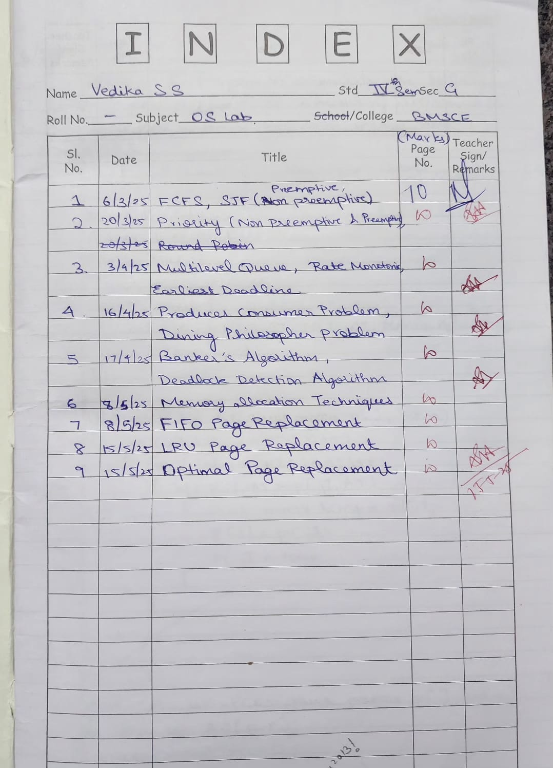

**Program -1**

**Question:**  Write a C program to simulate the following non-pre-emptive CPU scheduling algorithm to find turnaround time and waiting time.

→**FCFS**

**→ SJF (pre-emptive & Non-preemptive)**

**Code:**

#include <stdio.h>

#include <stdlib.h>

struct process {

int id, AT, BT, CT, TAT, WT, RT, remaining_BT;

int completed;

};

void sort_by_AT(struct process p[], int n) {

for (int i = 0; i < n - 1; i++) {

for (int j = i + 1; j < n; j++) {

if (p[i].AT > p[j].AT) {

struct process temp = p[i];

p[i] = p[j];

p[j] = temp;

}

}

}

}

void calculate_FCFS(struct process p[], int n) {

sort_by_AT(p, n);

int currentTime = 0;

for (int i = 0; i < n; i++) {

if (currentTime < p[i].AT)

currentTime = p[i].AT;

p[i].RT = currentTime - p[i].AT;

p[i].CT = currentTime + p[i].BT;

currentTime = p[i].CT;

p[i].TAT = p[i].CT - p[i].AT;

p[i].WT = p[i].TAT - p[i].BT;

}

}

void calculate_SJF_NonPreemptive(struct process p[], int n) {

int completed = 0, currentTime = 0;

while (completed < n) {

int shortest = -1, minBT = 10000;

for (int i = 0; i < n; i++) {

if (!p[i].completed && p[i].AT <= currentTime && p[i].BT < minBT) {

minBT = p[i].BT;

shortest = i;

}

}

if (shortest == -1) {

currentTime++;

} else {

p[shortest].RT = currentTime - p[shortest].AT;

p[shortest].CT = currentTime + p[shortest].BT;

currentTime = p[shortest].CT;

p[shortest].TAT = p[shortest].CT - p[shortest].AT;

p[shortest].WT = p[shortest].TAT - p[shortest].BT;

p[shortest].completed = 1;

completed++;

}

}

}

void calculate_SJF_Preemptive(struct process p[], int n) {

int completed = 0, currentTime = 0;

for (int i = 0; i < n; i++) {

p[i].remaining_BT = p[i].BT;

}

while (completed < n) {

int shortest = -1, minBT = 10000;

for (int i = 0; i < n; i++) {

if (!p[i].completed && p[i].AT <= currentTime && p[i].remaining_BT < minBT) {

minBT = p[i].remaining_BT;

shortest = i;

}

}

if (shortest == -1) {

currentTime++;

} else {

if (p[shortest].remaining_BT == p[shortest].BT)

p[shortest].RT = currentTime - p[shortest].AT;

p[shortest].remaining_BT--;

currentTime++;

if (p[shortest].remaining_BT == 0) {

p[shortest].CT = currentTime;

p[shortest].TAT = p[shortest].CT - p[shortest].AT;

p[shortest].WT = p[shortest].TAT - p[shortest].BT;

p[shortest].completed = 1;

completed++;

}

}

}

}

void display(struct process p[], int n) {

printf("\nProcess\tAT\tBT\tCT\tTAT\tWT\tRT\n");

for (int i = 0; i < n; i++) {

printf("%d\t%d\t%d\t%d\t%d\t%d\t%d\n", p[i].id, p[i].AT, p[i].BT, p[i].CT, p[i].TAT, p[i].WT, p[i].RT);

}

}

int main() {

int n, choice;

printf("Enter number of processes: ");

scanf("%d", &n);

struct process p[n];

for (int i = 0; i < n; i++) {

p[i].id = i + 1;

printf("Enter Arrival Time (AT) for process %d: ", i + 1);

scanf("%d", &p[i].AT);

printf("Enter Burst Time (BT) for process %d: ", i + 1);

scanf("%d", &p[i].BT);

p[i].completed = 0;

}

while (1) {

printf("\nMenu:\n");

printf("1. First Come First Serve (FCFS)\n");

printf("2. Shortest Job First (SJF) - Non Preemptive\n");

printf("3. Shortest Job First (SJF) - Preemptive\n");

printf("4. Exit\n");

printf("Enter choice: ");

scanf("%d", &choice);

switch (choice) {

case 1:

calculate_FCFS(p, n);

display(p, n);

break;

case 2:

calculate_SJF_NonPreemptive(p, n);

display(p, n);

break;

case 3:

calculate_SJF_Preemptive(p, n);

display(p, n);

break;

case 4:

exit(0);

default:

printf("Invalid choice. Try again.\n");

}

}

return 0;

}

**OUTPUT:**

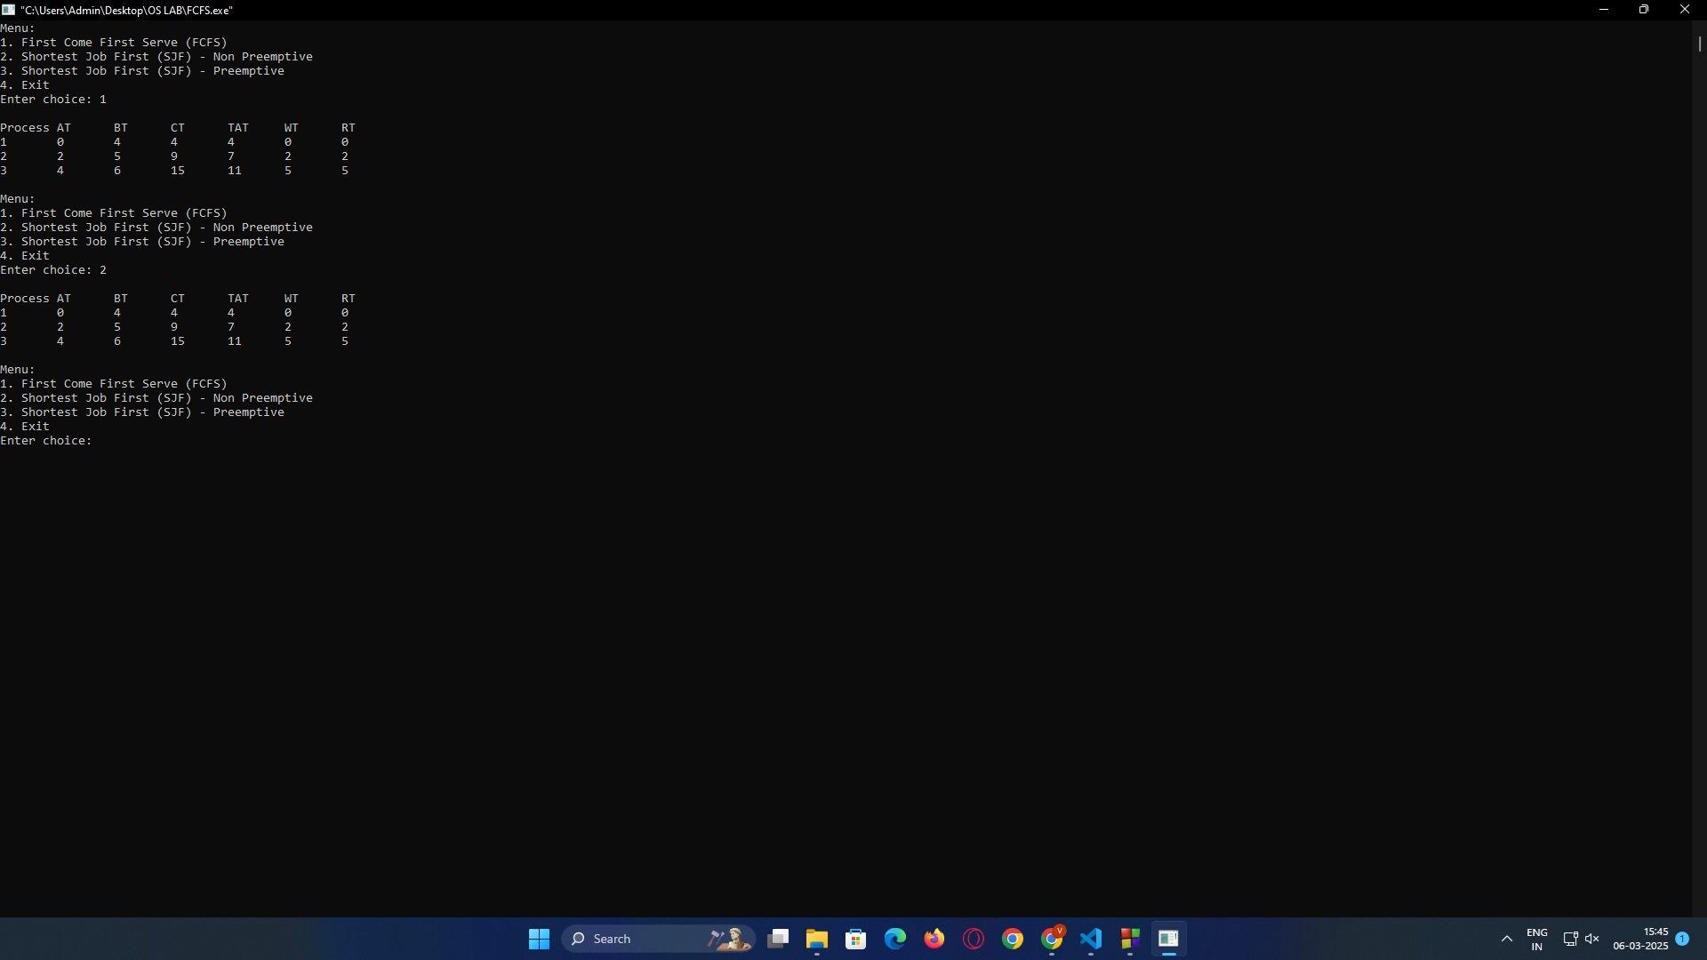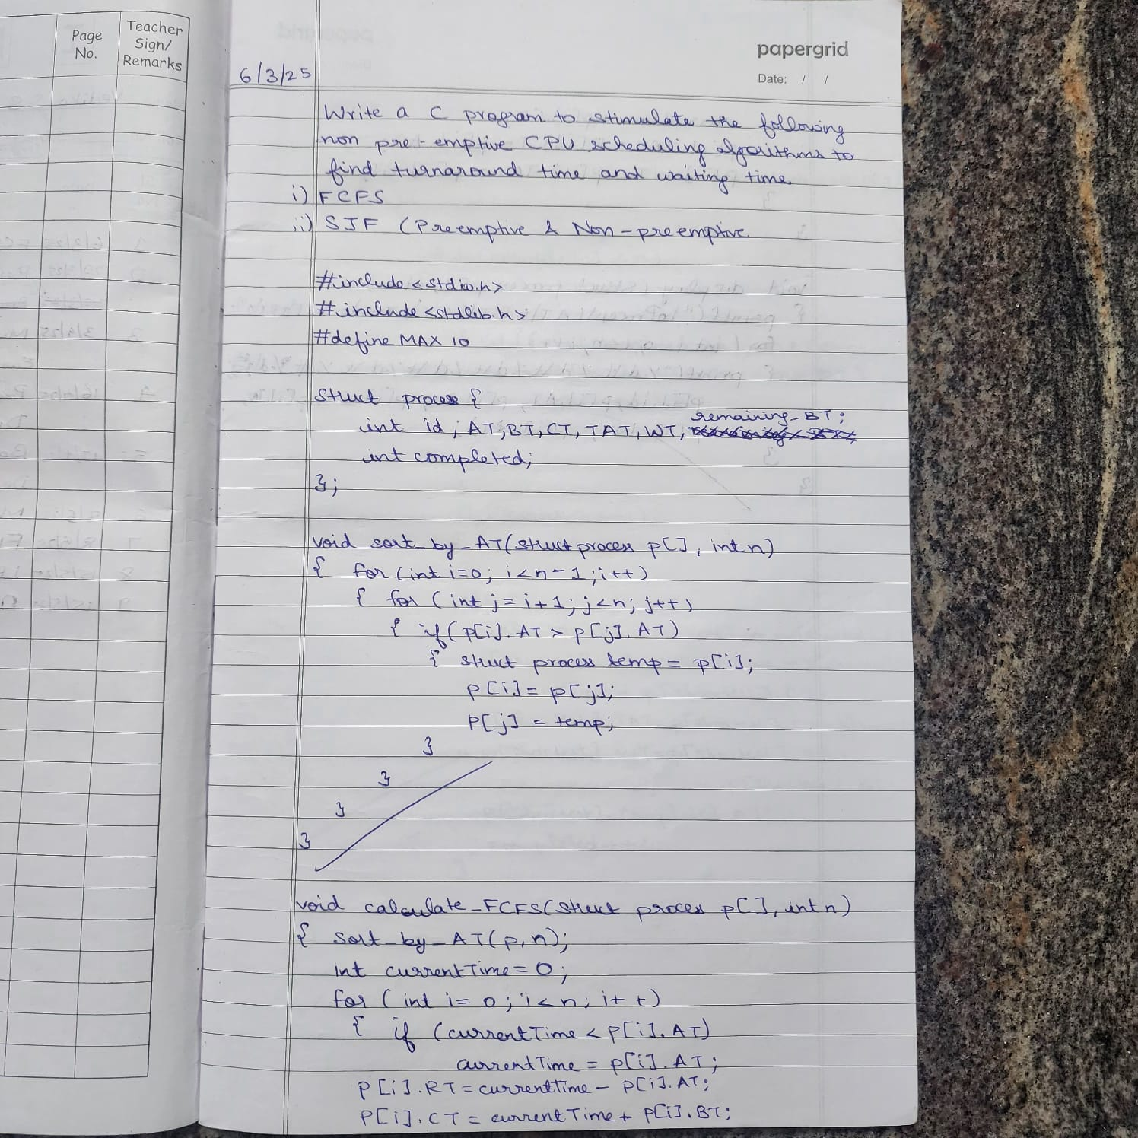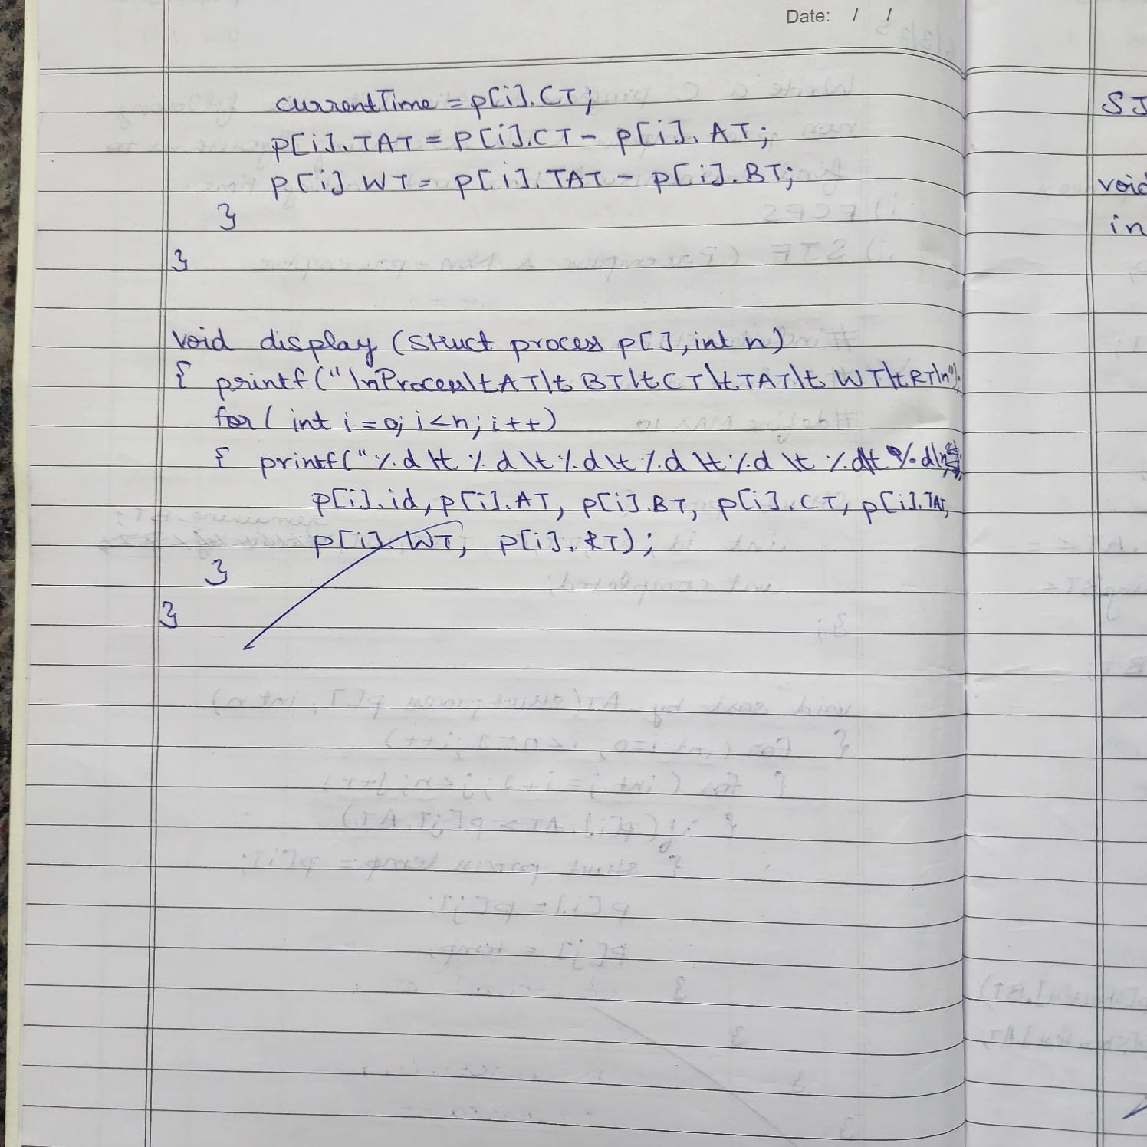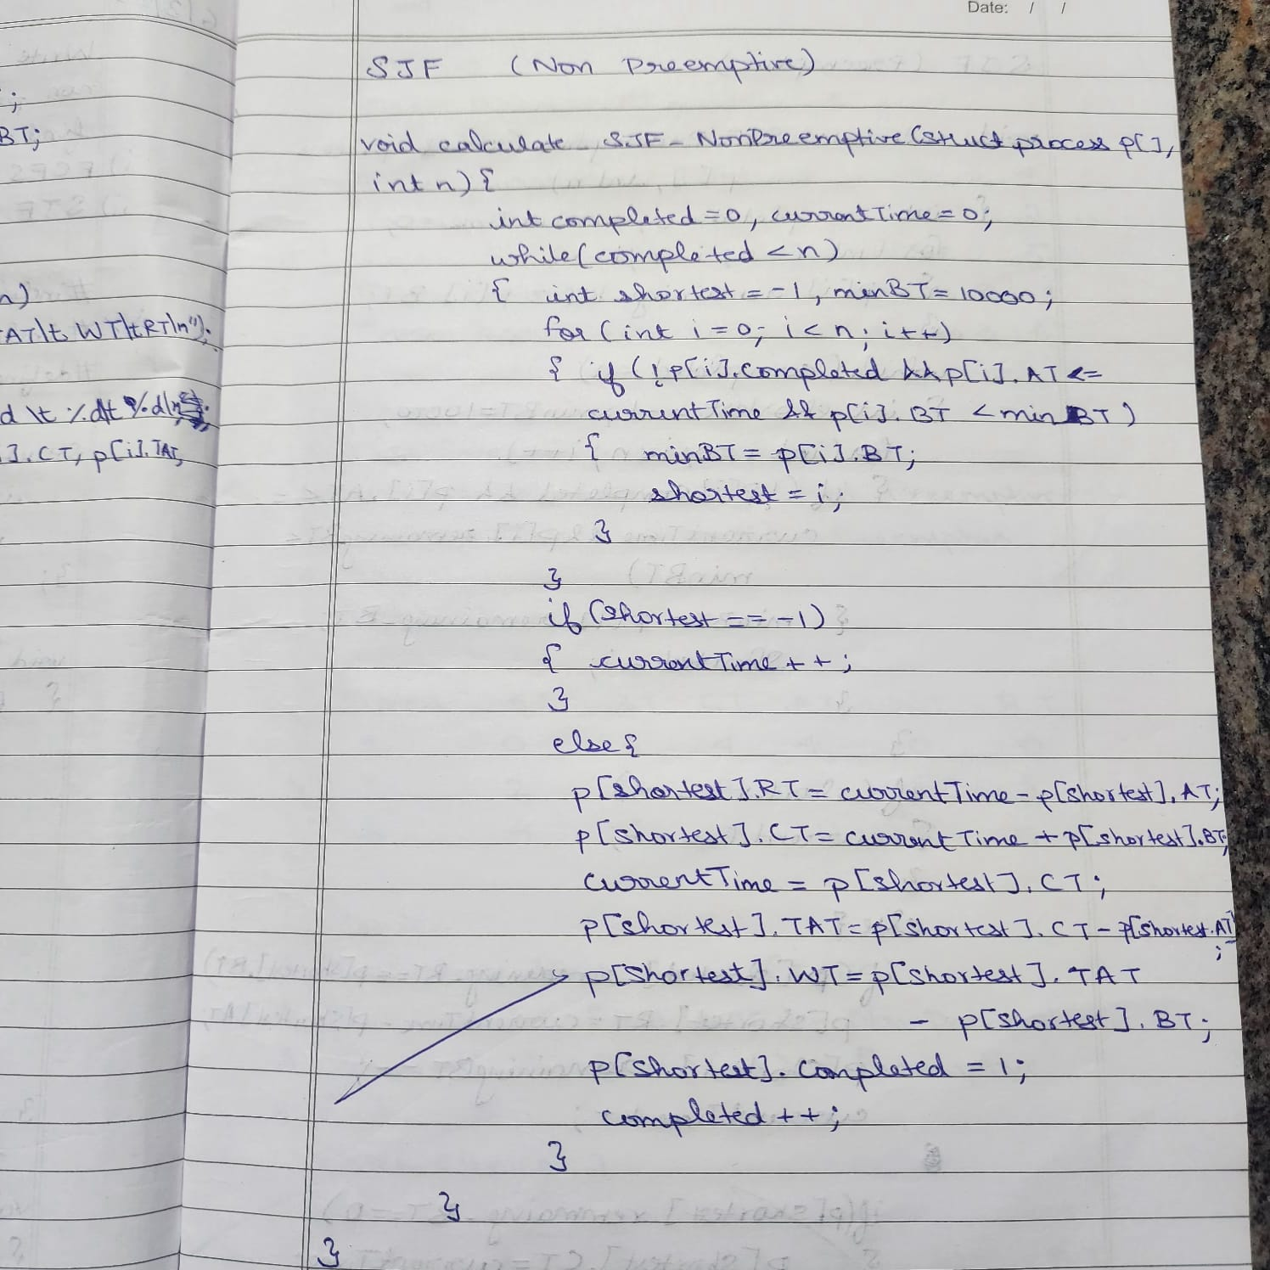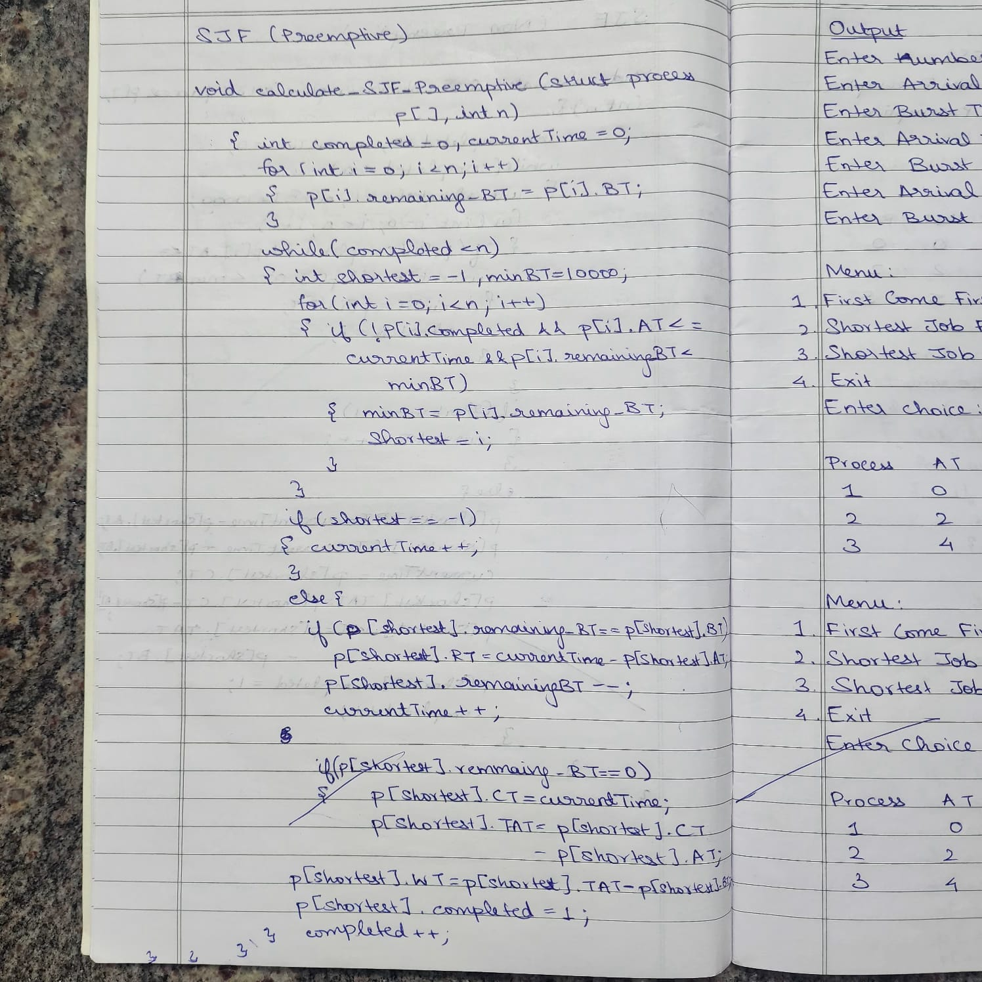

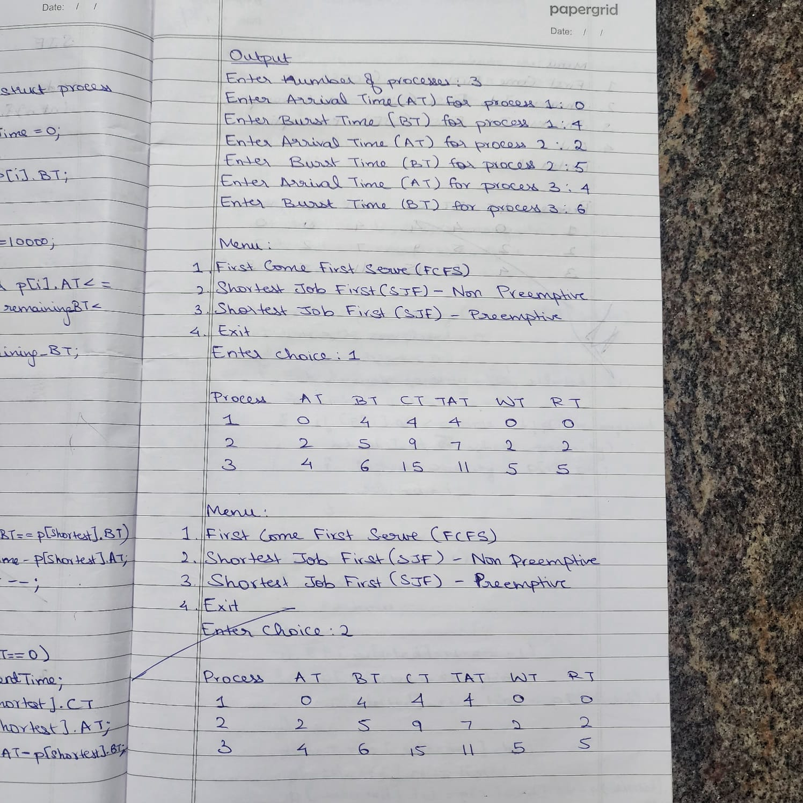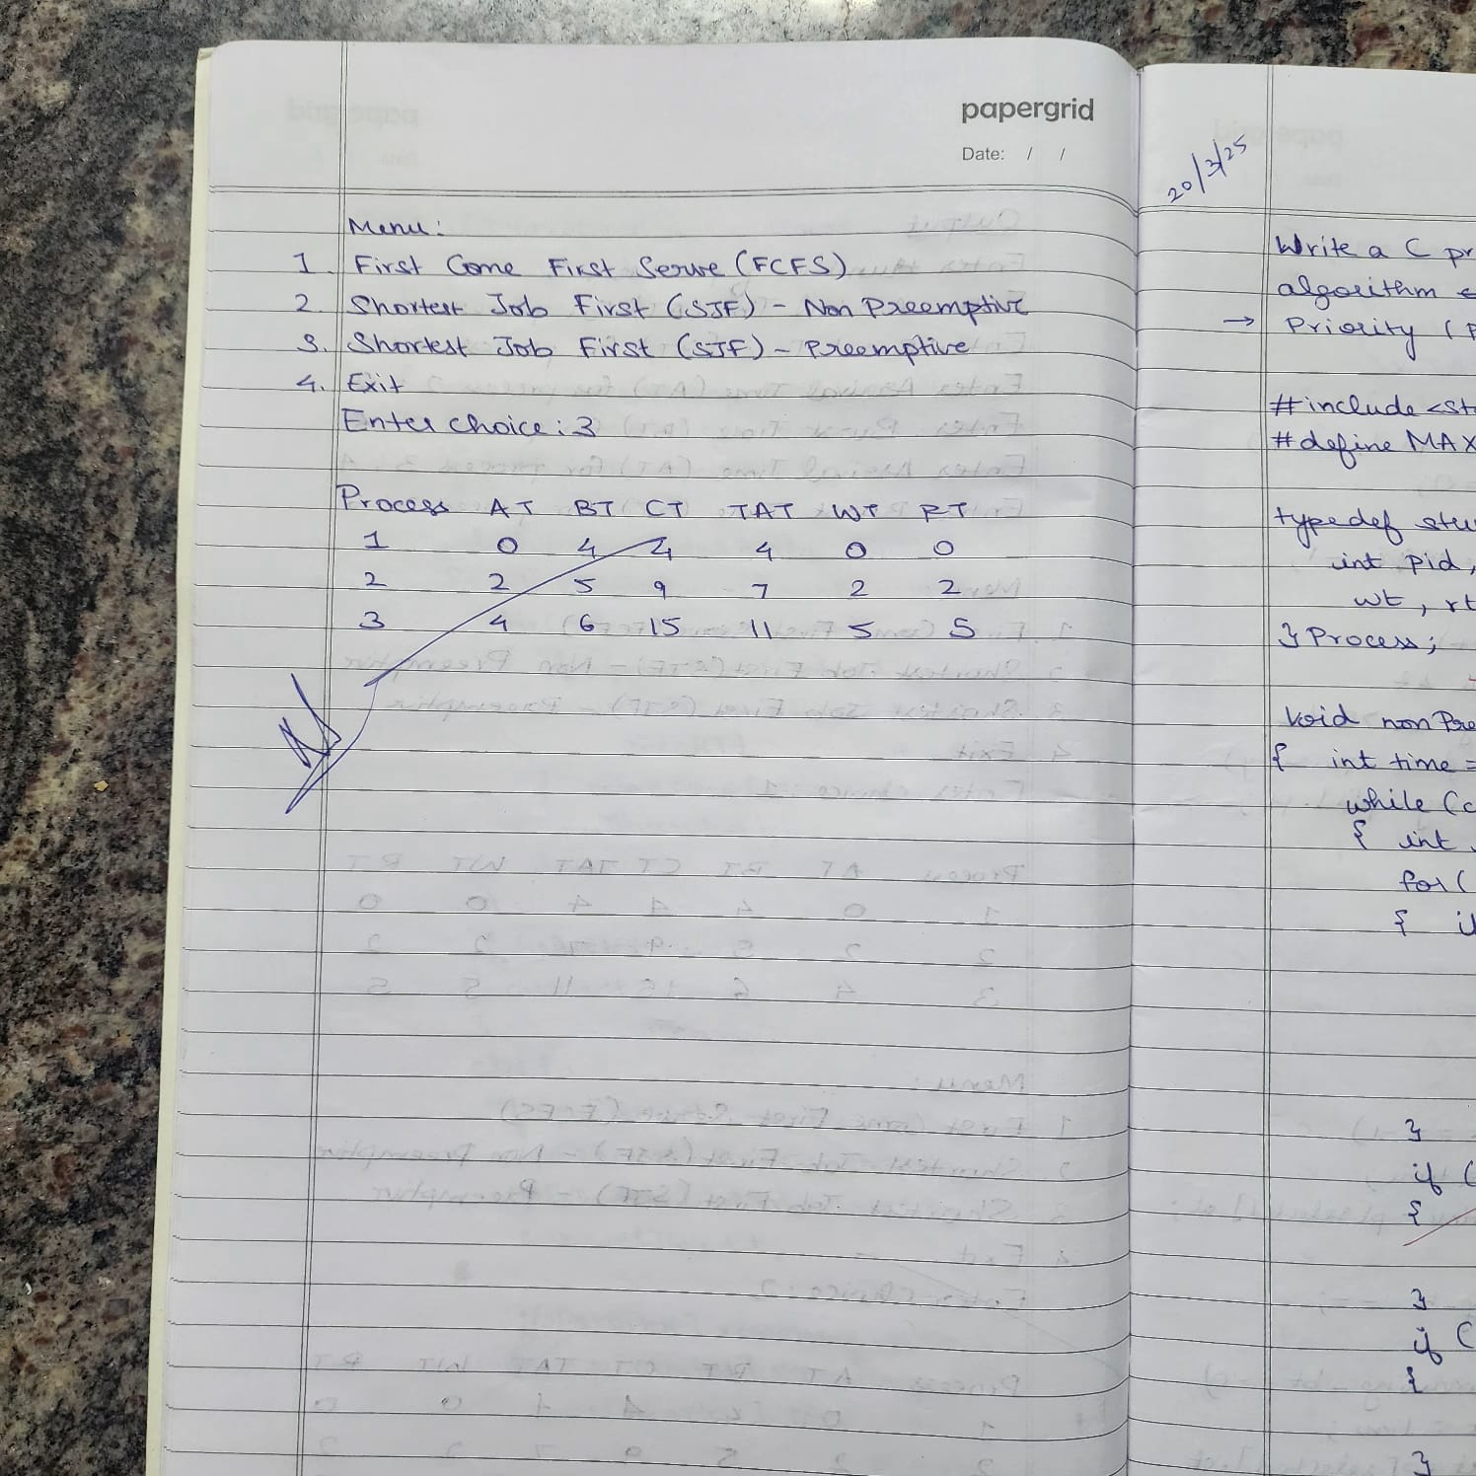

**Program -2**

**Question:**  Write a C program to simulate the following CPU scheduling algorithm to find turnaround time and waiting time.

→ **Priority (pre-emptive & Non-pre-emptive)**

**Code:**

#include <stdio.h>

#define MAX 10

typedef struct {

int pid, at, bt, pt, remaining_bt, ct, tat, wt, rt, is_completed, st;

} Process;

void nonPreemptivePriority(Process p[], int n) {

int time = 0, completed = 0;

while (completed < n) {

int highest_priority = -1, selected = -1;

for (int i = 0; i < n; i++) {

if (p[i].at <= time && !p[i].is_completed && p[i].pt > highest_priority) {

highest_priority = p[i].pt;

selected = i;

}

}

if (selected == -1) {

time++;

continue;

}

if (p[selected].rt == -1) {

p[selected].st = time; // Start time

p[selected].rt = time - p[selected].at; // Response Time = Start Time - Arrival Time }

time += p[selected].bt;

p[selected].ct = time;

p[selected].tat = p[selected].ct - p[selected].at;

p[selected].wt = p[selected].tat - p[selected].bt;

p[selected].is_completed = 1;

completed++;

}

}

void preemptivePriority(Process p[], int n) {

int time = 0, completed = 0;

while (completed < n) {

int highest_priority = -1, selected = -1;

for (int i = 0; i < n; i++) {

if (p[i].at <= time && p[i].remaining_bt > 0 && p[i].pt > highest_priority) {

highest_priority = p[i].pt;

selected = i;

}

}

if (selected == -1) {

time++;

continue;

}

if (p[selected].rt == -1) {

p[selected].st = time; // Start time

p[selected].rt = time - p[selected].at; // Response Time = Start Time - Arrival Time

}

p[selected].remaining_bt--;

time++;

if (p[selected].remaining_bt == 0) {

p[selected].ct = time;

p[selected].tat = p[selected].ct - p[selected].at;

p[selected].wt = p[selected].tat - p[selected].bt;

completed++;

}

}

}

void displayProcesses(Process p[], int n) {

float avg_tat = 0, avg_wt = 0, avg_rt = 0;

printf("\nPID\tAT\tBT\tPriority\tCT\tTAT\tWT\tRT\n");

for (int i = 0; i < n; i++) {

printf("%d\t%d\t%d\t%d\t\t%d\t%d\t%d\t%d\n",

p[i].pid, p[i].at, p[i].bt, p[i].pt, p[i].ct, p[i].tat, p[i].wt, p[i].rt);

avg_tat += p[i].tat;

avg_wt += p[i].wt;

avg_rt += p[i].rt;

}

printf("\nAverage TAT: %.2f", avg_tat / n);

printf("\nAverage WT: %.2f", avg_wt / n);

printf("\nAverage RT: %.2f\n", avg_rt / n);

}

int main() {

Process p[MAX];

int n, choice;

printf("Enter the number of processes: ");

scanf("%d", &n);

for (int i = 0; i < n; i++) {

p[i].pid = i + 1;

printf("\nEnter Arrival Time, Burst Time, and Priority for Process %d:\n", p[i].pid);

printf("Arrival Time: ");

scanf("%d", &p[i].at);

printf("Burst Time: ");

scanf("%d", &p[i].bt);

printf("Priority (higher number means higher priority): ");

scanf("%d", &p[i].pt);

p[i].remaining_bt = p[i].bt;

p[i].is_completed = 0;

p[i].rt = -1;

}

while (1) {

printf("\nPriority Scheduling Menu:\n");

printf("1. Non-Preemptive Priority Scheduling\n");

printf("2. Preemptive Priority Scheduling\n");

printf("3. Exit\n");

printf("Enter your choice: ");

scanf("%d", &choice);

switch (choice) {

case 1:

nonPreemptivePriority(p, n);

printf("Non-Preemptive Scheduling Completed!\n");

displayProcesses(p, n);

break;

case 2:

preemptivePriority(p, n);

printf("Preemptive Scheduling Completed!\n");

displayProcesses(p, n);

break;

case 3:

printf("Exiting...\n");

return 0;

default:

printf("Invalid choice! Try again.\n");

}

}

return 0;

}

OUTPUT:

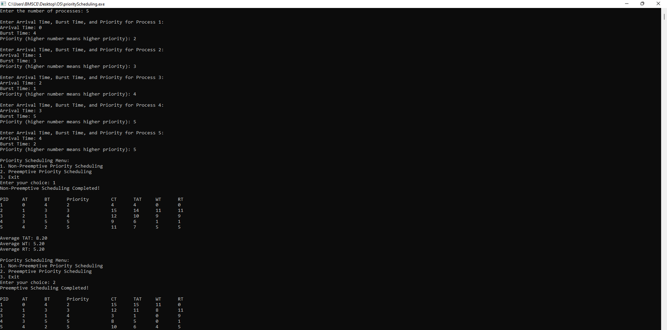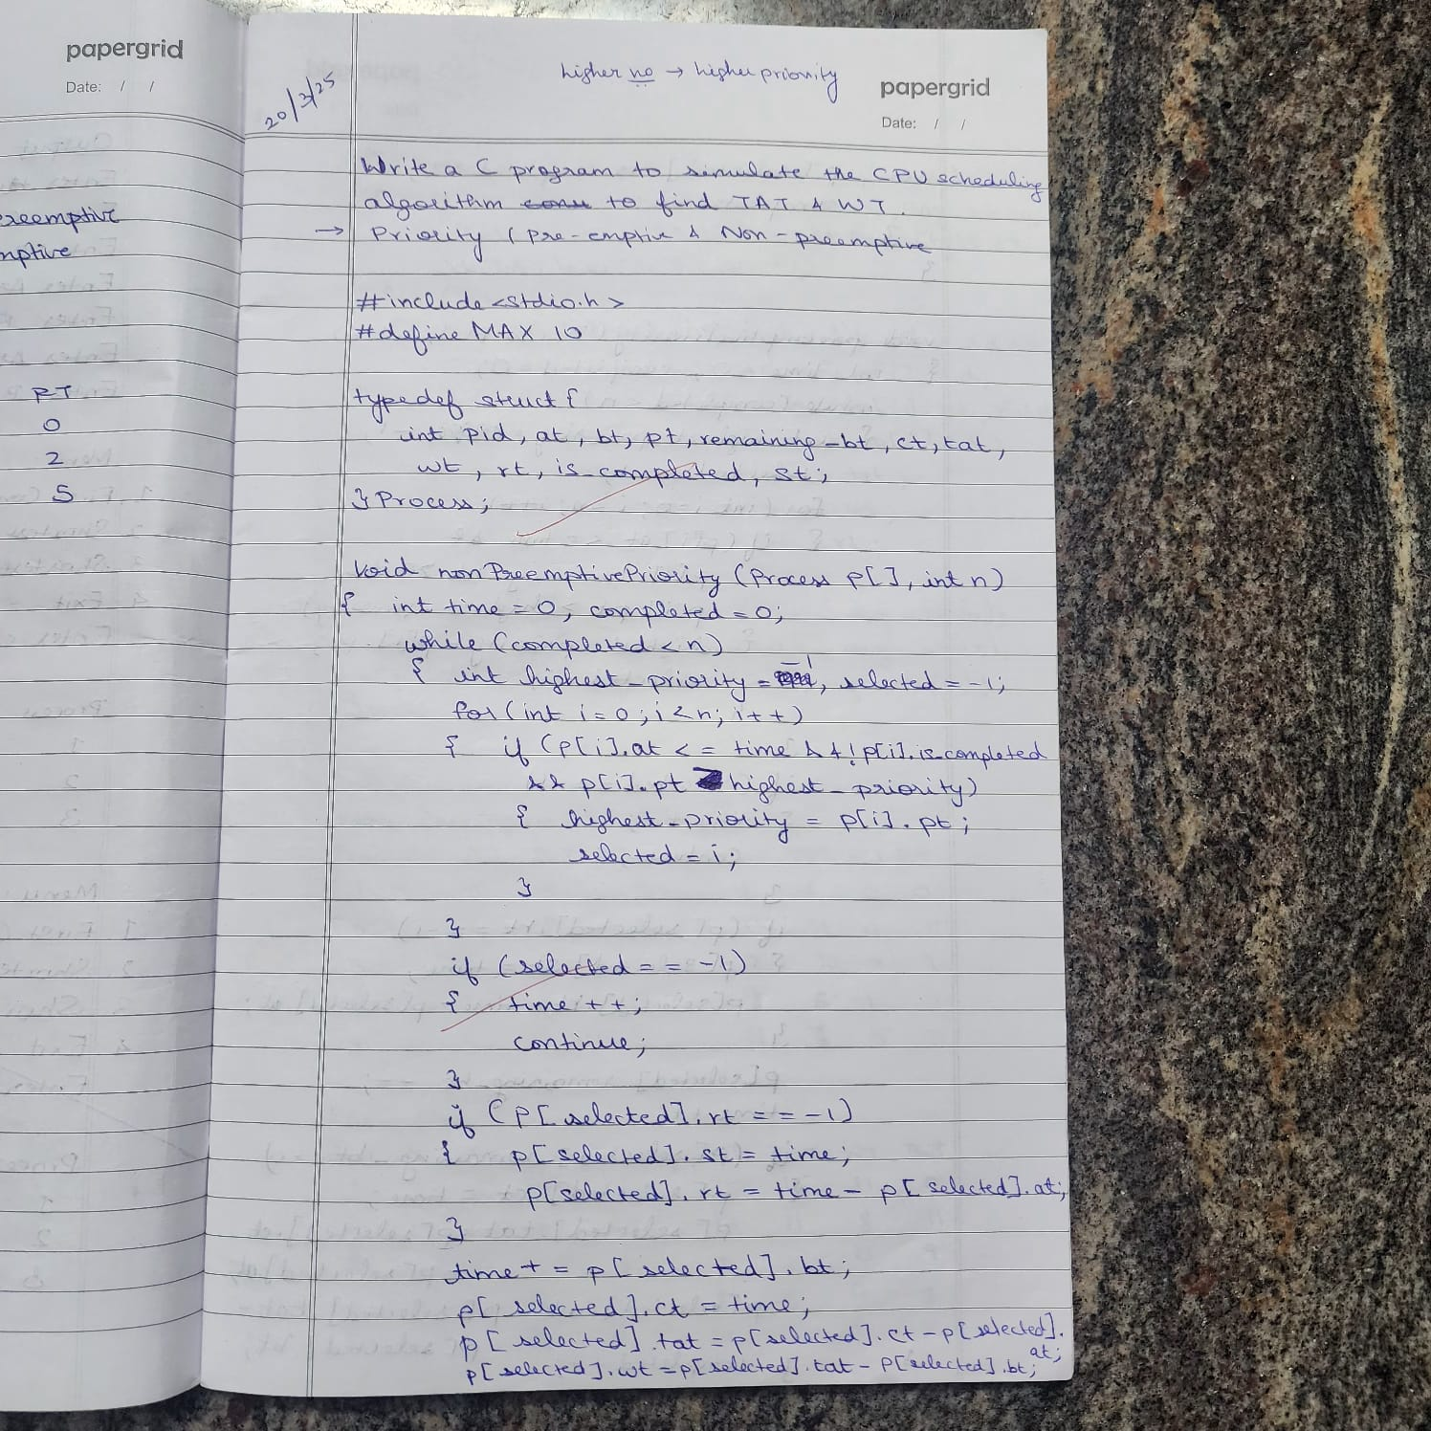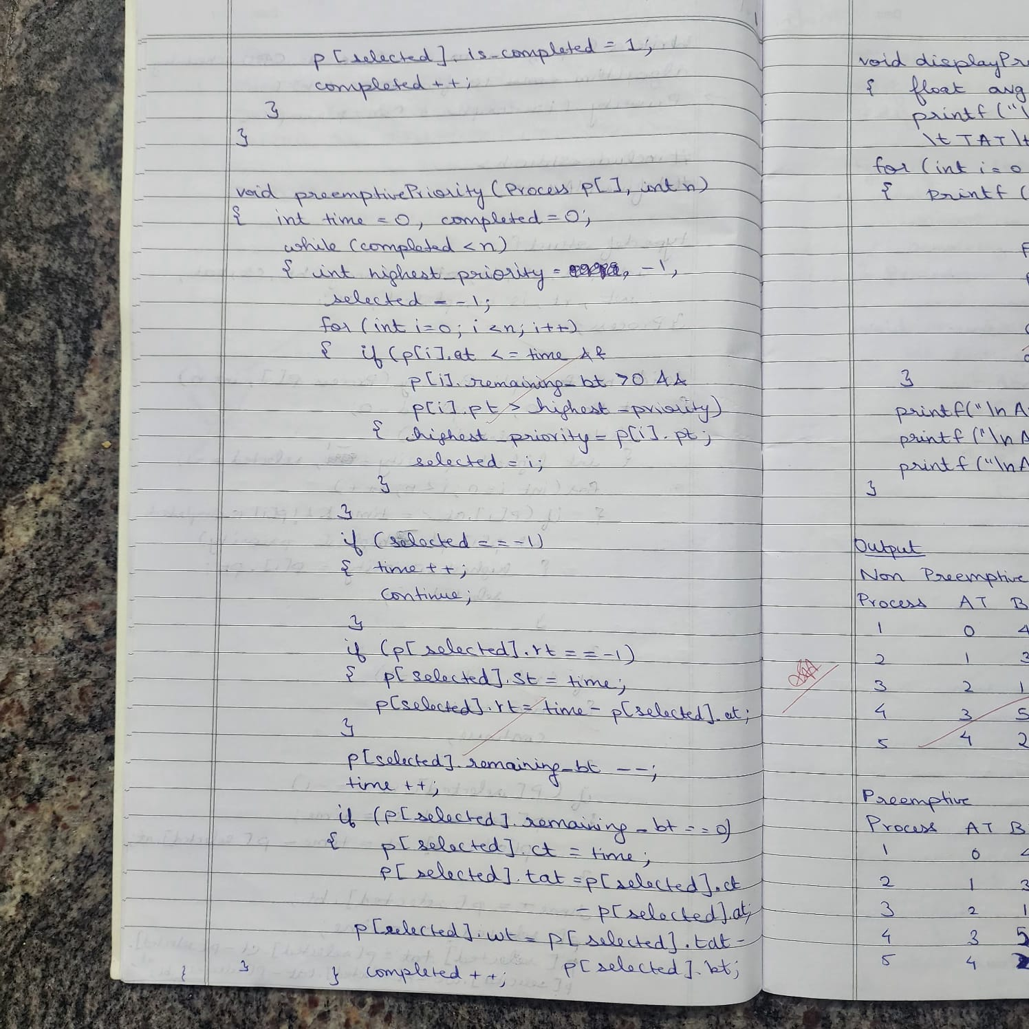

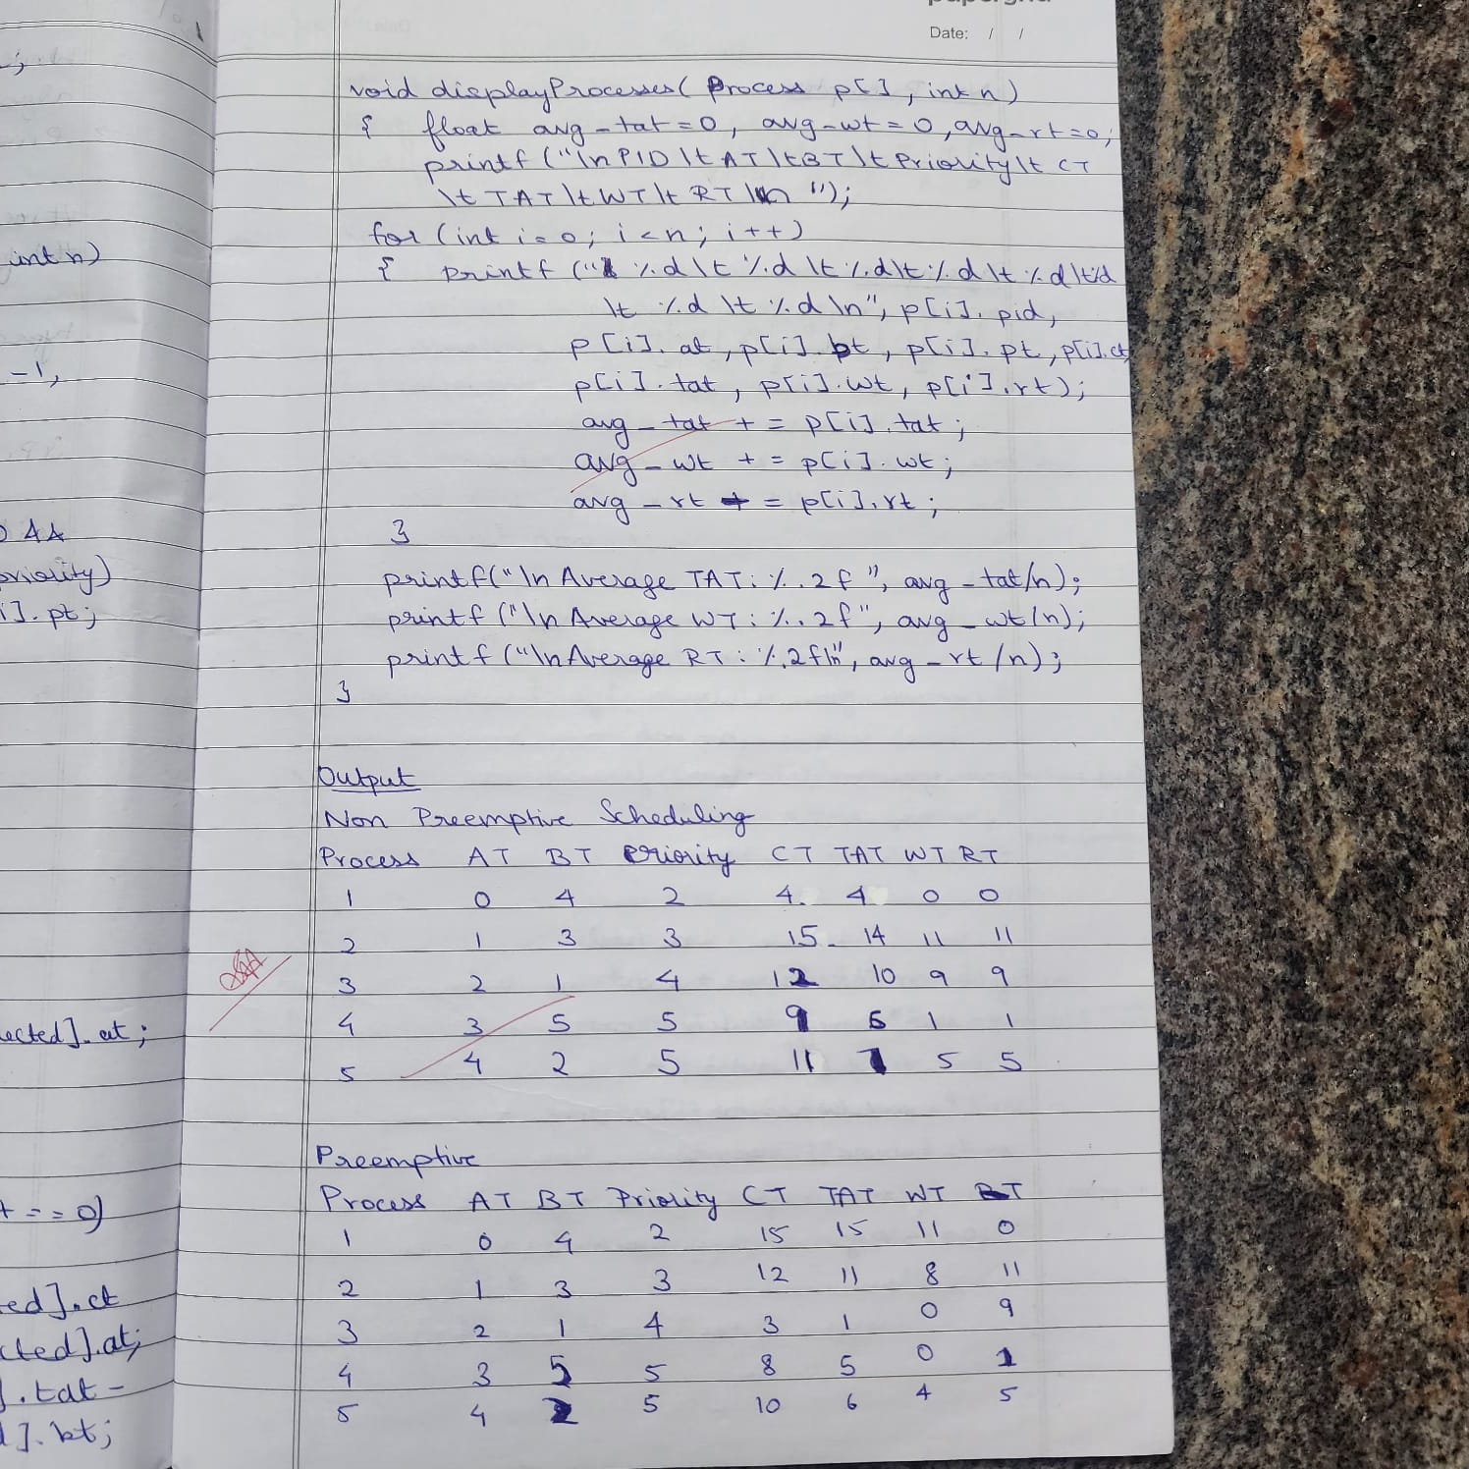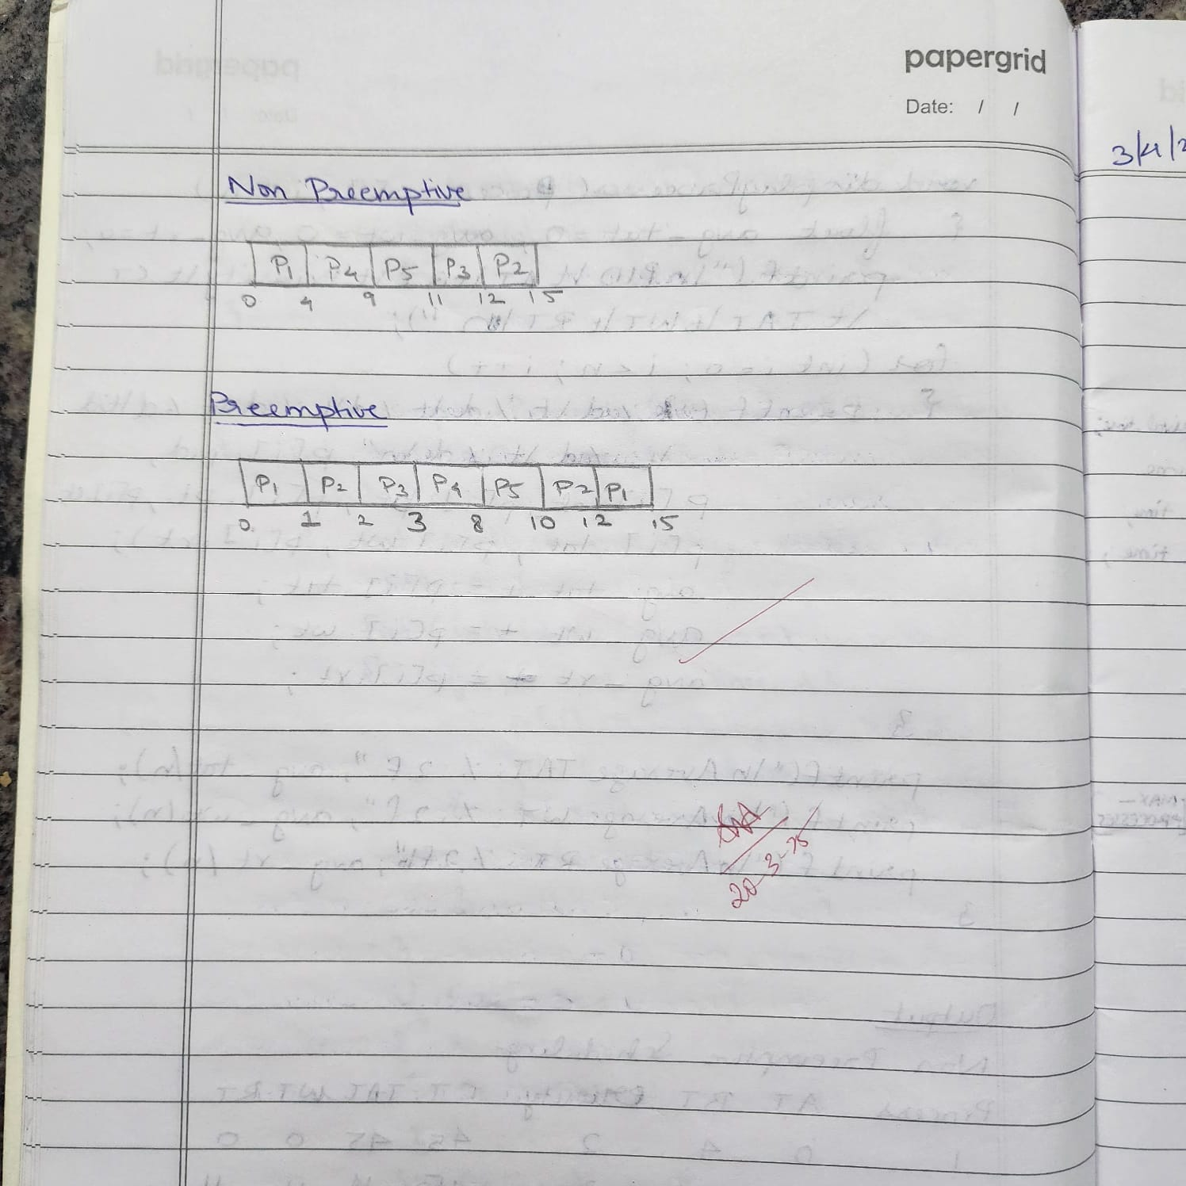

**Program -3**

**Question:**Write a C program to simulate **multi-level queue scheduling algorithm** considering the following scenario. All the processes in the system are divided into two categories – system processes and user processes. System processes are to be given higher priority than user processes. Use RR and FCFS scheduling for the processes in each queue.

**Code:**

#include <stdio.h>

#define MAX_PROCESSES 10

#define TIME_QUANTUM 2

typedef struct {

int burst_time, arrival_time, queue_type, waiting_time, turnaround_time, response_time, remaining_time;

} Process;

void round_robin(Process processes[], int n, int time_quantum, int *time) {

int done, i;

do {

done = 1;

for (i = 0; i < n; i++) {

if (processes[i].remaining_time > 0) {

done = 0;

if (processes[i].remaining_time > time_quantum) {

*time += time_quantum;

processes[i].remaining_time -= time_quantum;

} else {

*time += processes[i].remaining_time;

processes[i].waiting_time = *time - processes[i].arrival_time - processes[i].burst_time;

processes[i].turnaround_time = *time - processes[i].arrival_time;

processes[i].response_time = processes[i].waiting_time;

processes[i].remaining_time = 0;

}

}

}

} while (!done);

}

void fcfs(Process processes[], int n, int *time) {

for (int i = 0; i < n; i++) {

if (*time < processes[i].arrival_time) {

*time = processes[i].arrival_time;

}

processes[i].waiting_time = *time - processes[i].arrival_time;

processes[i].turnaround_time = processes[i].waiting_time + processes[i].burst_time;

processes[i].response_time = processes[i].waiting_time;

*time += processes[i].burst_time;

}

}

int main() {

Process processes[MAX_PROCESSES], system_queue[MAX_PROCESSES], user_queue[MAX_PROCESSES];

int n, sys_count = 0, user_count = 0, time = 0;

float avg_waiting = 0, avg_turnaround = 0, avg_response = 0, throughput;

printf("Enter number of processes: ");

scanf("%d", &n);

for (int i = 0; i < n; i++) {

printf("Enter Burst Time, Arrival Time and Queue of P%d: ", i + 1);

scanf("%d %d %d", &processes[i].burst_time, &processes[i].arrival_time, &processes[i].queue_type);

processes[i].remaining_time = processes[i].burst_time;

if (processes[i].queue_type == 1) {

system_queue[sys_count++] = processes[i];

} else {

user_queue[user_count++] = processes[i];

}

}

// Sort user processes by arrival time for FCFS

for (int i = 0; i < user_count - 1; i++) {

for (int j = 0; j < user_count - i - 1; j++) {

if (user_queue[j].arrival_time > user_queue[j + 1].arrival_time) {

Process temp = user_queue[j];

user_queue[j] = user_queue[j + 1];

user_queue[j + 1] = temp;

}

}

}

printf("\nQueue 1 is System Process\nQueue 2 is User Process\n");

round_robin(system_queue, sys_count, TIME_QUANTUM, &time);

fcfs(user_queue, user_count, &time);

printf("\nProcess Waiting Time Turn Around Time Response Time\n");

for (int i = 0; i < sys_count; i++) {

avg_waiting += system_queue[i].waiting_time;

avg_turnaround += system_queue[i].turnaround_time;

avg_response += system_queue[i].response_time;

printf("%d %d %d %d\n", i + 1, system_queue[i].waiting_time, system_queue[i].turnaround_time, system_queue[i].response_time);

}

for (int i = 0; i < user_count; i++) {

avg_waiting += user_queue[i].waiting_time;

avg_turnaround += user_queue[i].turnaround_time;

avg_response += user_queue[i].response_time;

printf("%d %d %d %d\n", i + 1 + sys_count, user_queue[i].waiting_time, user_queue[i].turnaround_time, user_queue[i].response_time);

}

avg_waiting /= n;

avg_turnaround /= n;

avg_response /= n;

throughput = (float)n / time;

printf("\nAverage Waiting Time: %.2f", avg_waiting);

printf("\nAverage Turn Around Time: %.2f", avg_turnaround);

printf("\nAverage Response Time: %.2f", avg_response);

printf("\nThroughput: %.2f", throughput);

printf("\nProcess returned %d (0x%d) execution time: %.3f s\n", time, time, (float)time);

return 0;

}

**OUTPUT:**

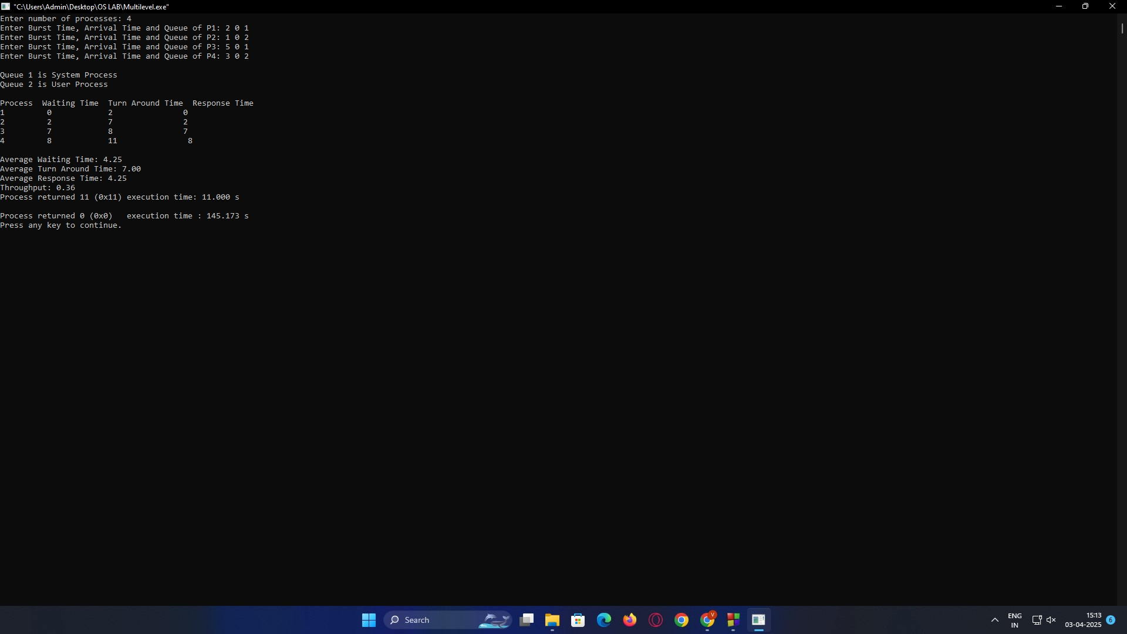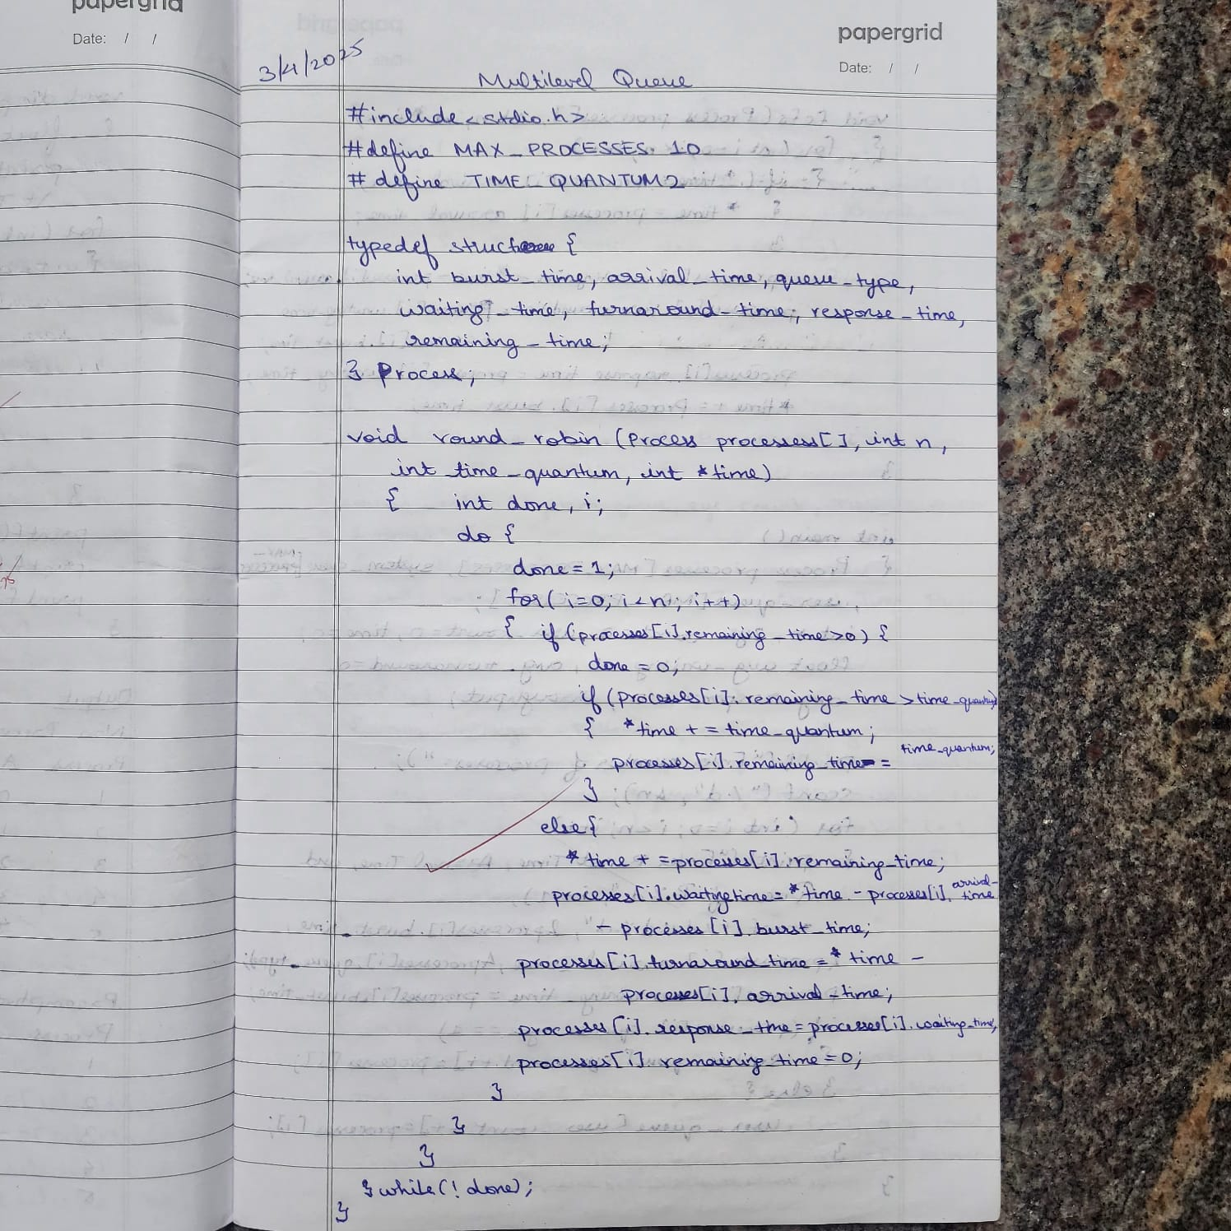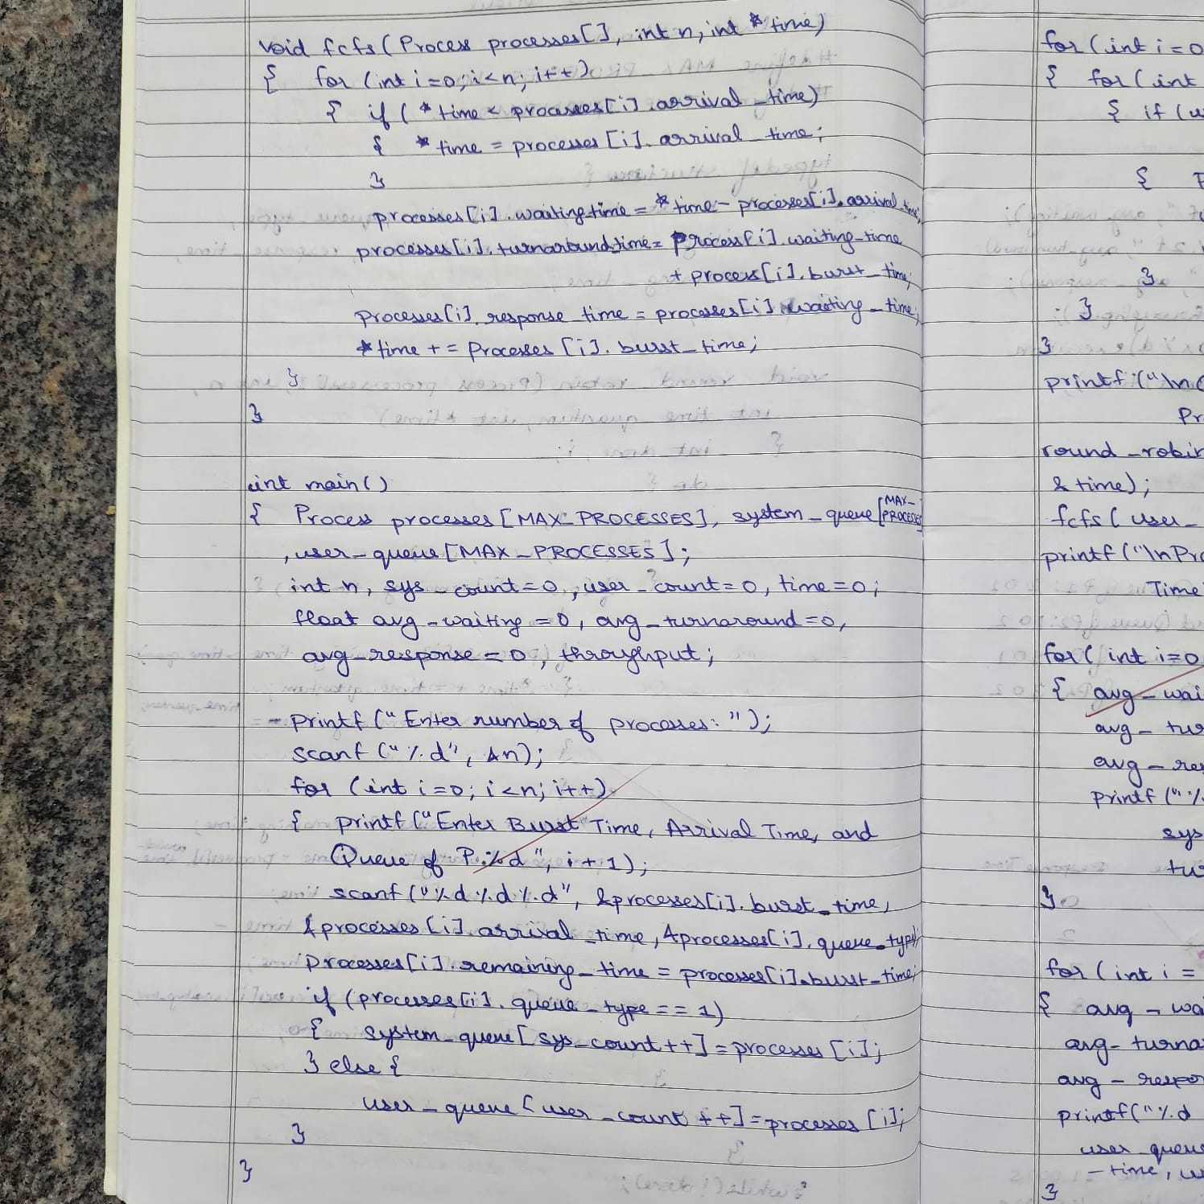

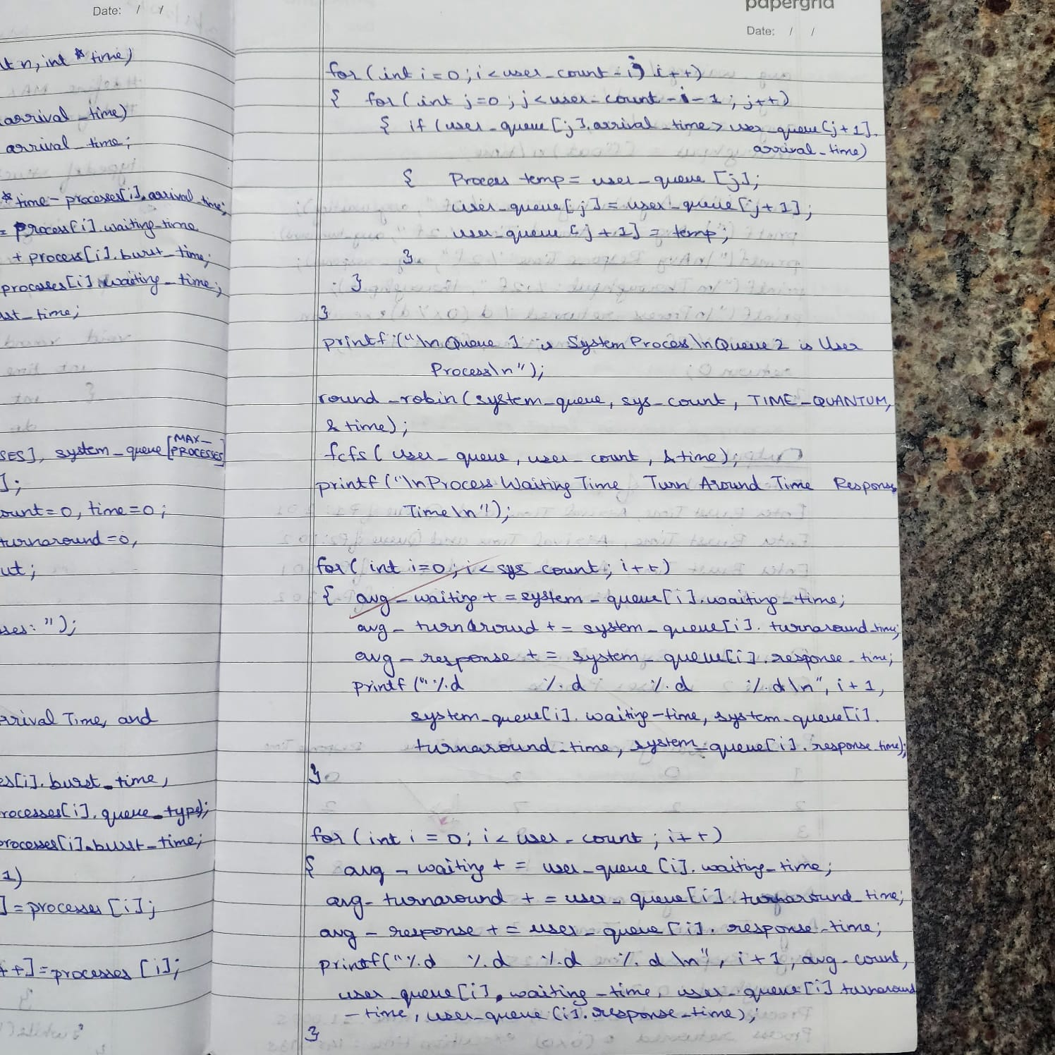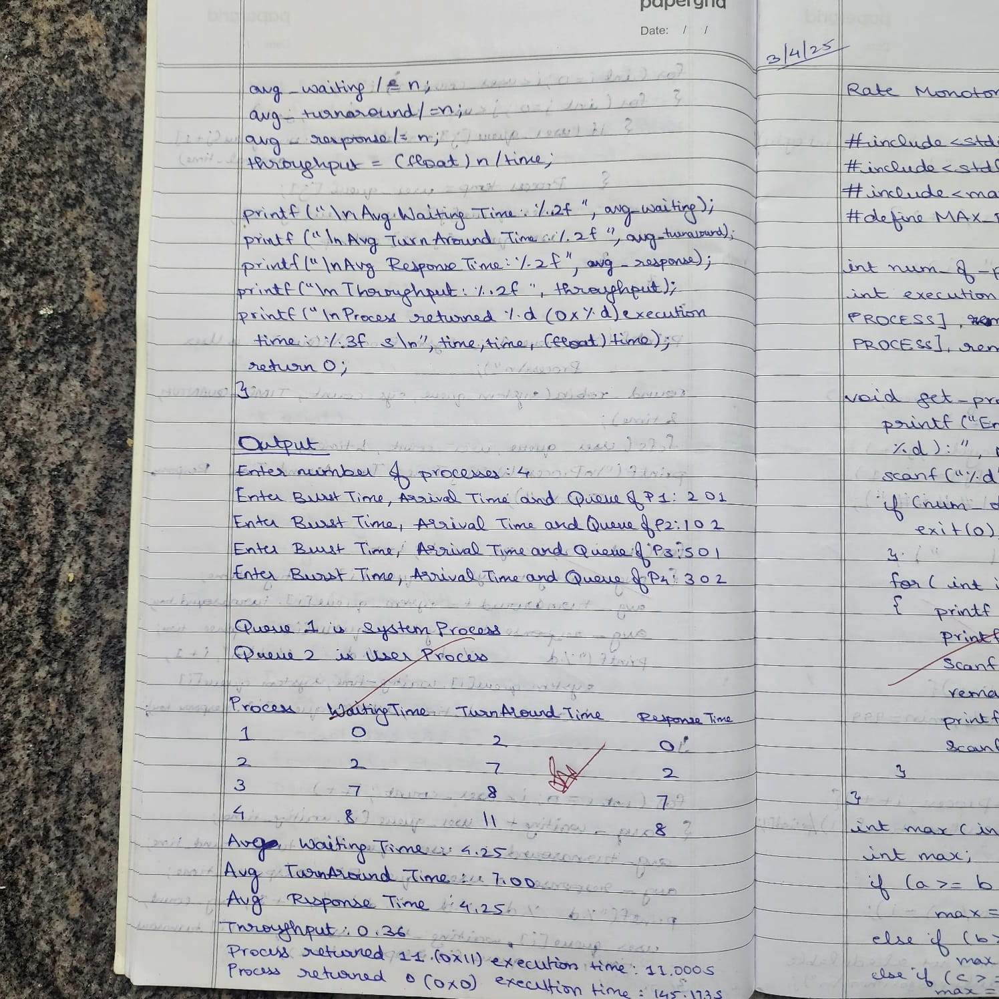

**Question:**Write a C program to simulate Real-Time CPU Scheduling algorithms:

a) Rate- Monotonic

b) Earliest-deadline First

**Code:**

**a)Rate Monotonic**

#include <stdio.h>

#include <stdlib.h>

#include <math.h>

#include <stdbool.h>

#define MAX_PROCESS 10

int num_of_process;

int execution_time[MAX_PROCESS], period[MAX_PROCESS],

remain_time[MAX_PROCESS], deadline[MAX_PROCESS],

remain_deadline[MAX_PROCESS];

void get_process_info() {

printf("Enter total number of processes (maximum %d): ", MAX_PROCESS);

scanf("%d", &num_of_process);

if (num_of_process < 1) {

exit(0);

}

for (int i = 0; i < num_of_process; i++) {

printf("\nProcess %d:\n", i + 1);

printf("==> Execution time: ");

scanf("%d", &execution_time[i]);

remain_time[i] = execution_time[i];

printf("==> Period: ");

scanf("%d", &period[i]);

}

}

int max(int a, int b, int c) {

int max;

if (a >= b && a >= c)

max = a;

else if (b >= a && b >= c)

max = b;

else if (c >= a && c >= b)

max = c;

return max;

}

void print_schedule(int process_list[], int cycles) {

printf("\nScheduling:\n\n");

printf("Time: ");

for (int i = 0; i < cycles; i++) {

if (i < 10)

printf("| 0%d ", i);

else

printf("| %d ", i);

}

printf("|\n");

for (int i = 0; i < num_of_process; i++) {

printf("P[%d]: ", i + 1);

for (int j = 0; j < cycles; j++) {

if (process_list[j] == i + 1)

printf("|####");

else

printf("| ");

}

printf("|\n");

}

}

void rate_monotonic(int time) {

int process_list[100] = {0}, min = 999, next_process = 0;

float utilization = 0;

for (int i = 0; i < num_of_process; i++) {

utilization += (1.0 * execution_time[i]) / period[i];

}

int n = num_of_process;

float m = n * (pow(2, 1.0 / n) - 1);

if (utilization > m) {

printf("\nGiven problem is not schedulable under the said scheduling algorithm.\n");

}

for (int i = 0; i < time; i++) {

min = 1000;

for (int j = 0; j < num_of_process; j++) {

if (remain_time[j] > 0) {

if (min > period[j]) {

min = period[j];

next_process = j;

}

}

}

if (remain_time[next_process] > 0) {

process_list[i] = next_process + 1;

remain_time[next_process] -= 1;

}

for (int k = 0; k < num_of_process; k++) {

if ((i + 1) % period[k] == 0) {

remain_time[k] = execution_time[k];

next_process = k;

}

}

}

print_schedule(process_list, time);

}

int main() {

int observation_time;

get_process_info();

observation_time = max(period[0], period[1], period[2]);

rate_monotonic(observation_time);

return 0;

}

**OUTPUT:**

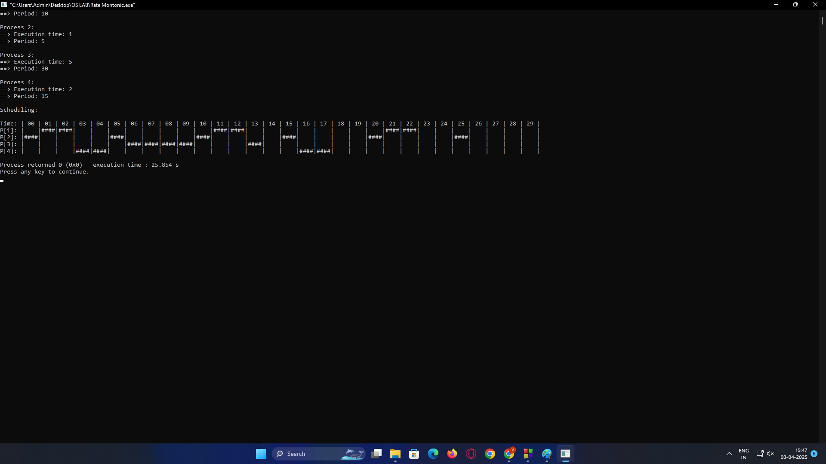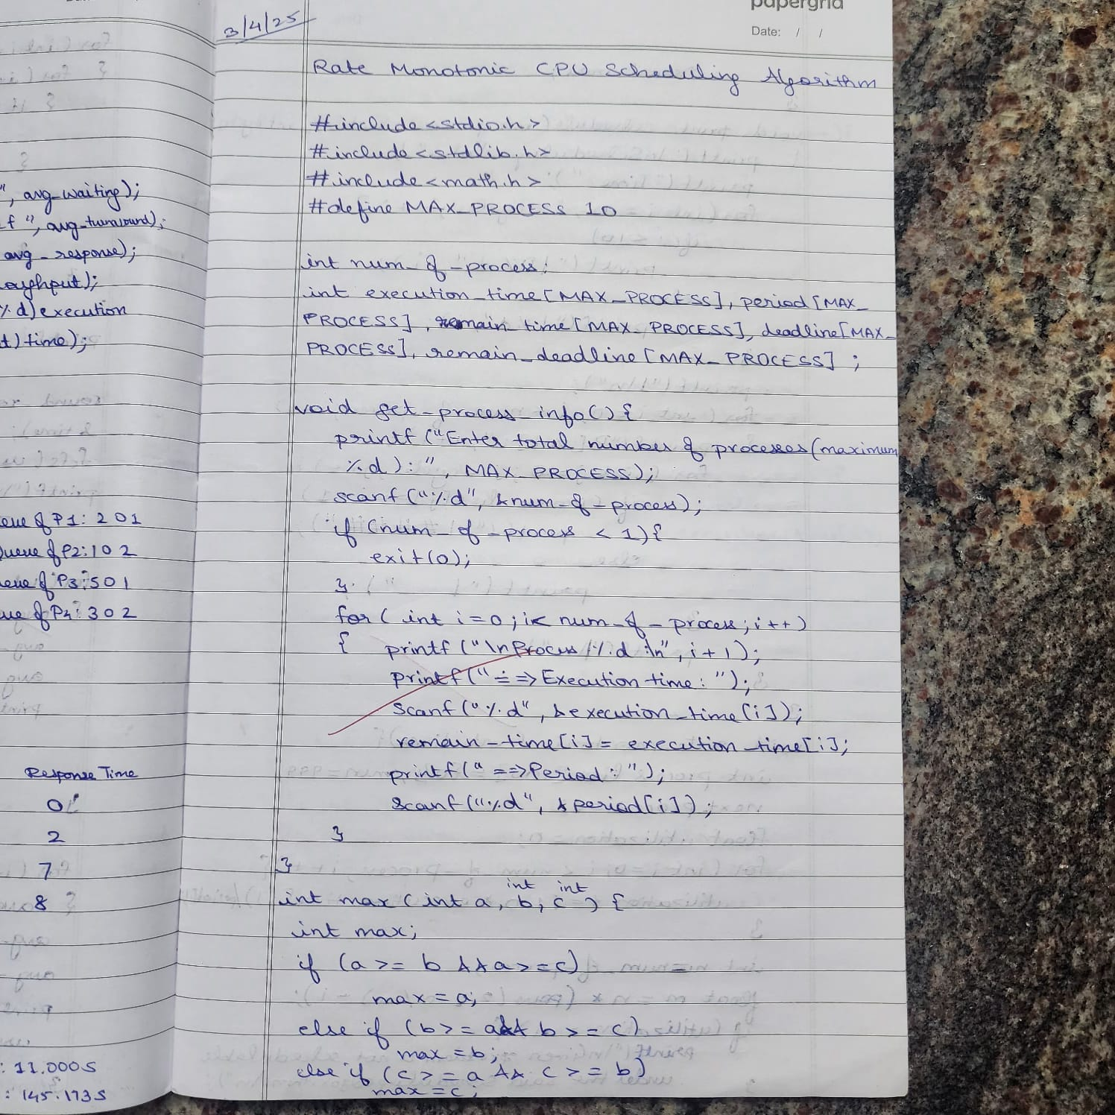

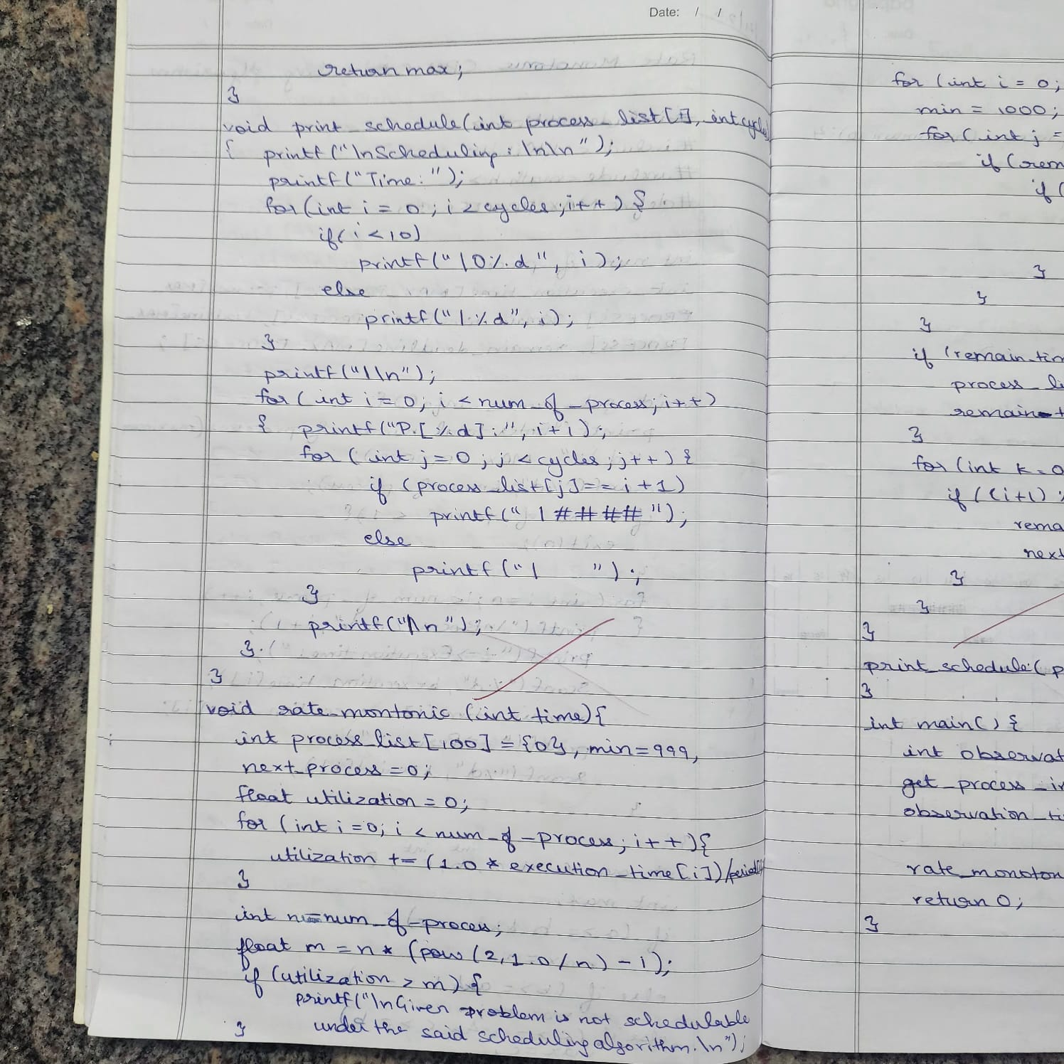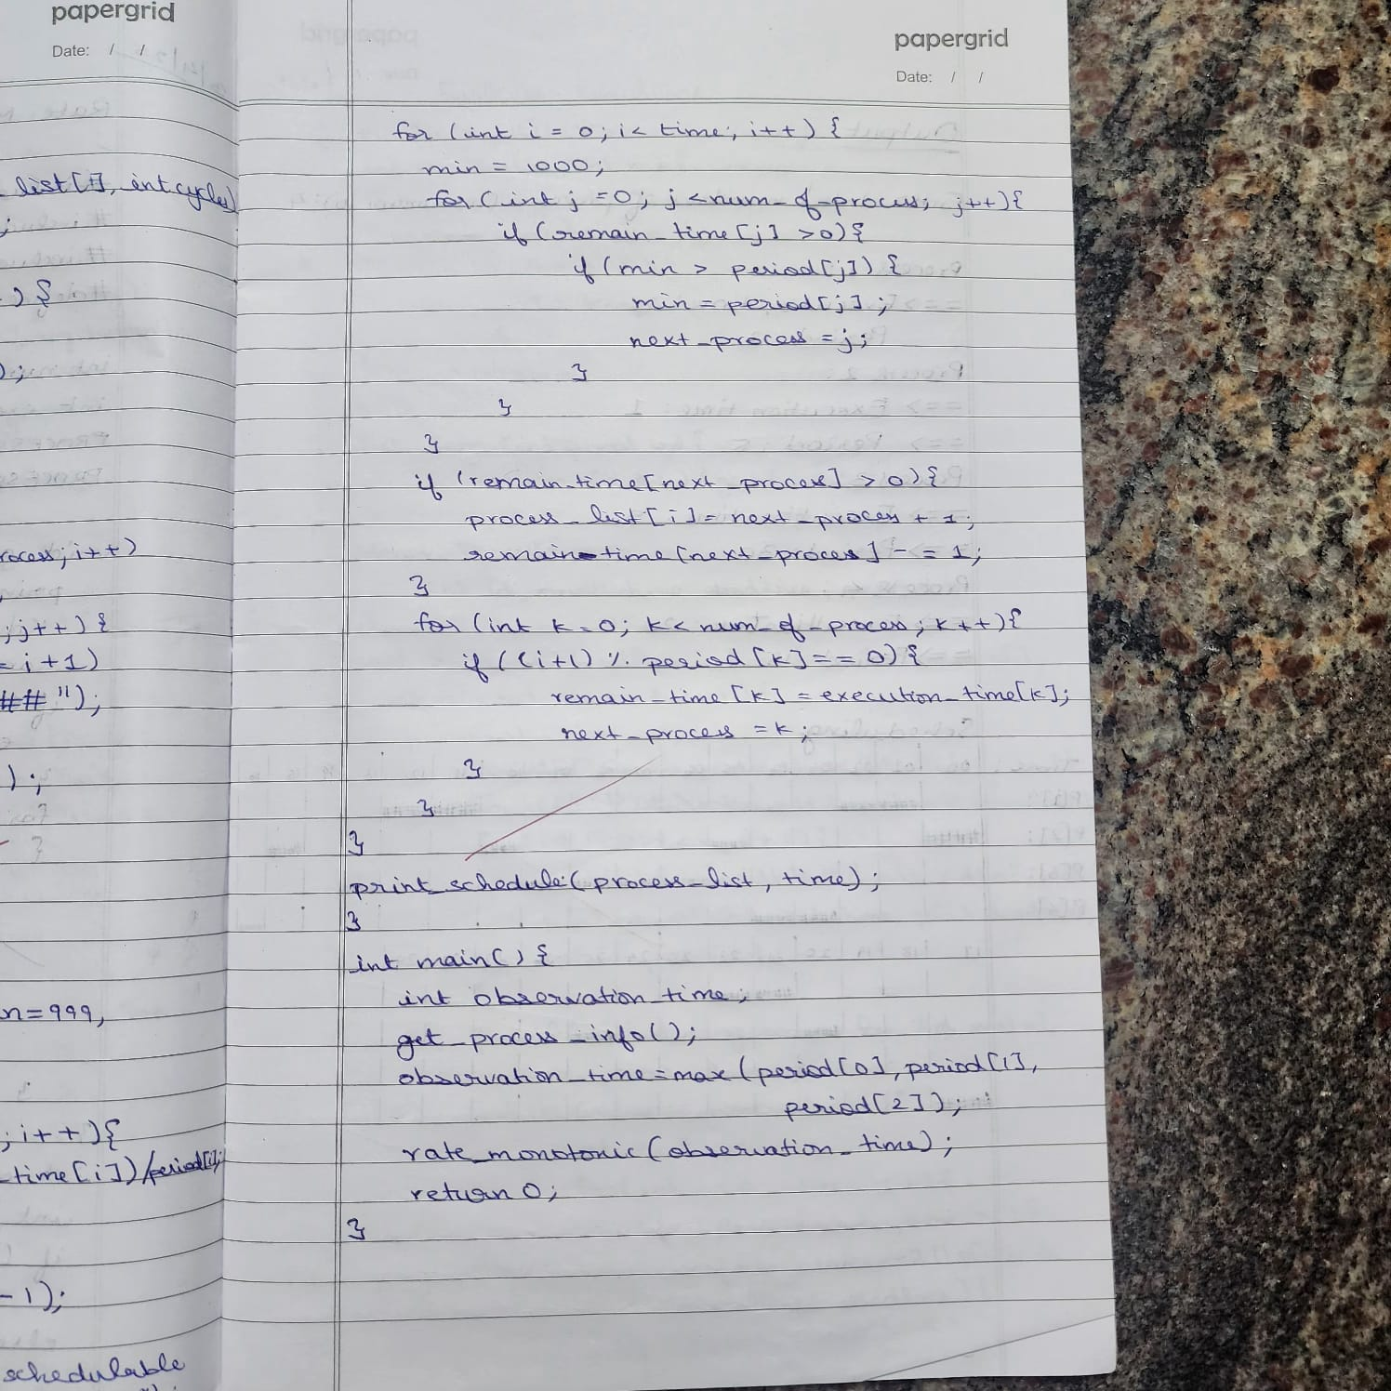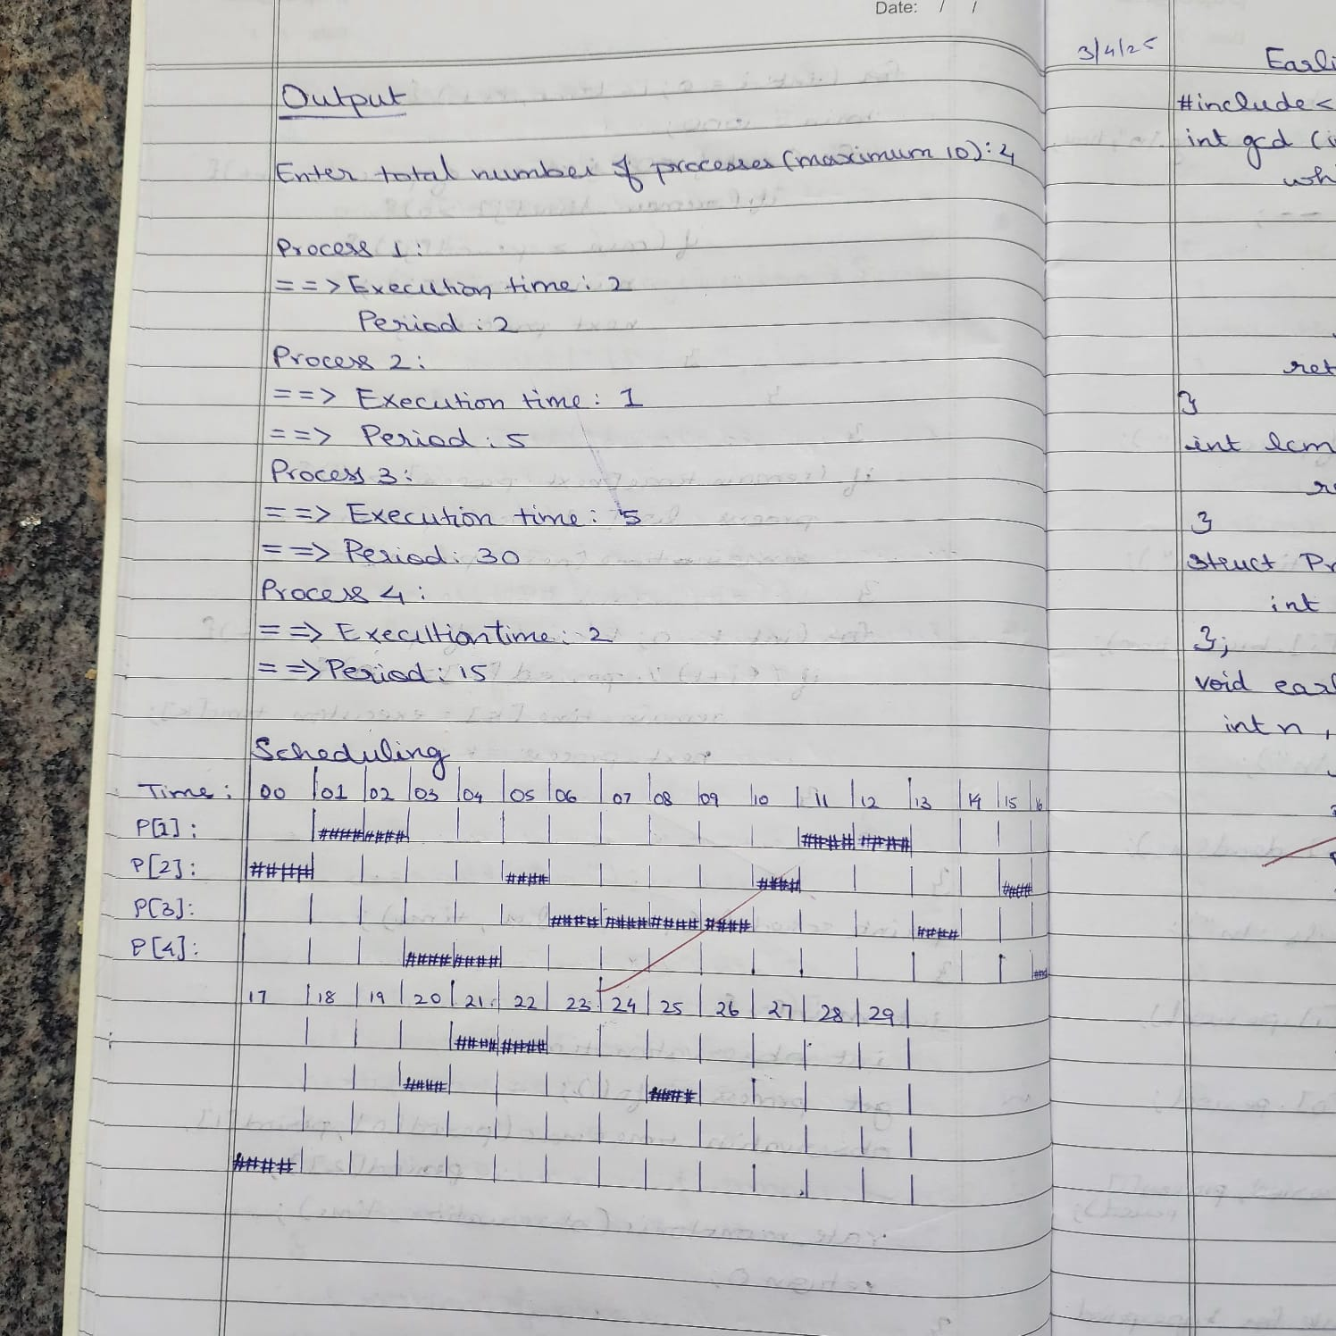

**b)Earliest Deadline**

#include <stdio.h>

int gcd(int a, int b) {

while (b != 0) {

int temp = b;

b = a % b;

a = temp;

}

return a;

}

int lcm(int a, int b) {

return (a * b) / gcd(a, b);

}

struct Process {

int id, burst_time, deadline, period;

};

void earliest_deadline_first(struct Process p[], int n, int time_limit) {

int time = 0;

printf("Earliest Deadline Scheduling:\n");

printf("PID\tBurst\tDeadline\tPeriod\n");

for (int i = 0; i < n; i++) {

printf("%d\t%d\t\t%d\t\t%d\n", p[i].id, p[i].burst_time, p[i].deadline, p[i].period);

}

printf("\nScheduling occurs for %d ms\n", time_limit);

while (time < time_limit) {

int earliest = -1;

for (int i = 0; i < n; i++) {

if (p[i].burst_time > 0) {

if (earliest == -1 || p[i].deadline < p[earliest].deadline) {

earliest = i;

}

}

}

if (earliest == -1) break;

printf("%dms: Task %d is running.\n", time, p[earliest].id);

p[earliest].burst_time--;

time++;

}

}

int main() {

int n;

printf("Enter the number of processes: ");

scanf("%d", &n);

struct Process processes[n];

printf("Enter the CPU burst times:\n");

for (int i = 0; i < n; i++) {

scanf("%d", &processes[i].burst_time);

processes[i].id = i + 1;

}

printf("Enter the deadlines:\n");

for (int i = 0; i < n; i++) {

scanf("%d", &processes[i].deadline);

}

printf("Enter the time periods:\n");

for (int i = 0; i < n; i++) {

scanf("%d", &processes[i].period);

}

int hyperperiod = processes[0].period;

for (int i = 1; i < n; i++) {

hyperperiod = lcm(hyperperiod, processes[i].period);

}

printf("\nSystem will execute for hyperperiod (LCM of periods): %d ms\n", hyperperiod);

earliest_deadline_first(processes, n, hyperperiod);

return 0;

}

**OUTPUT:**

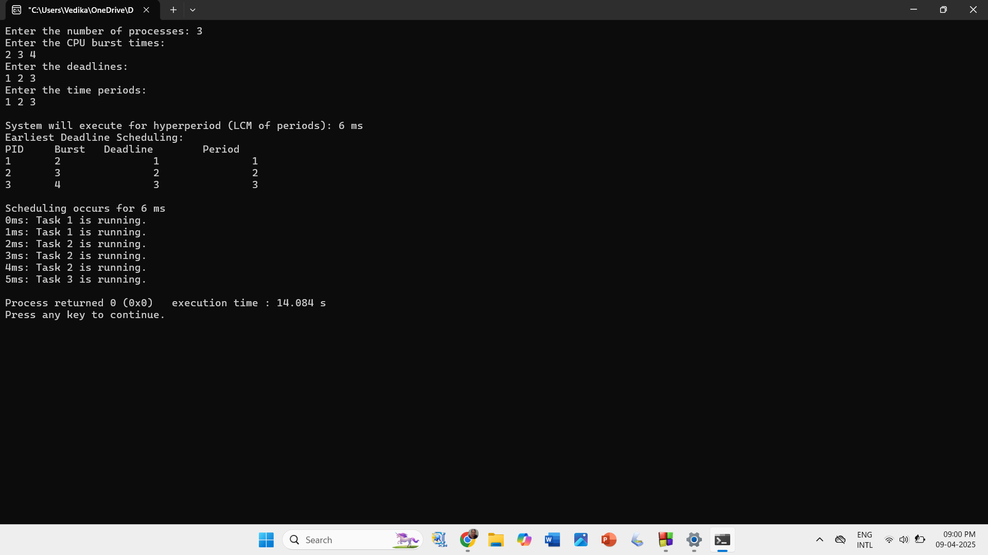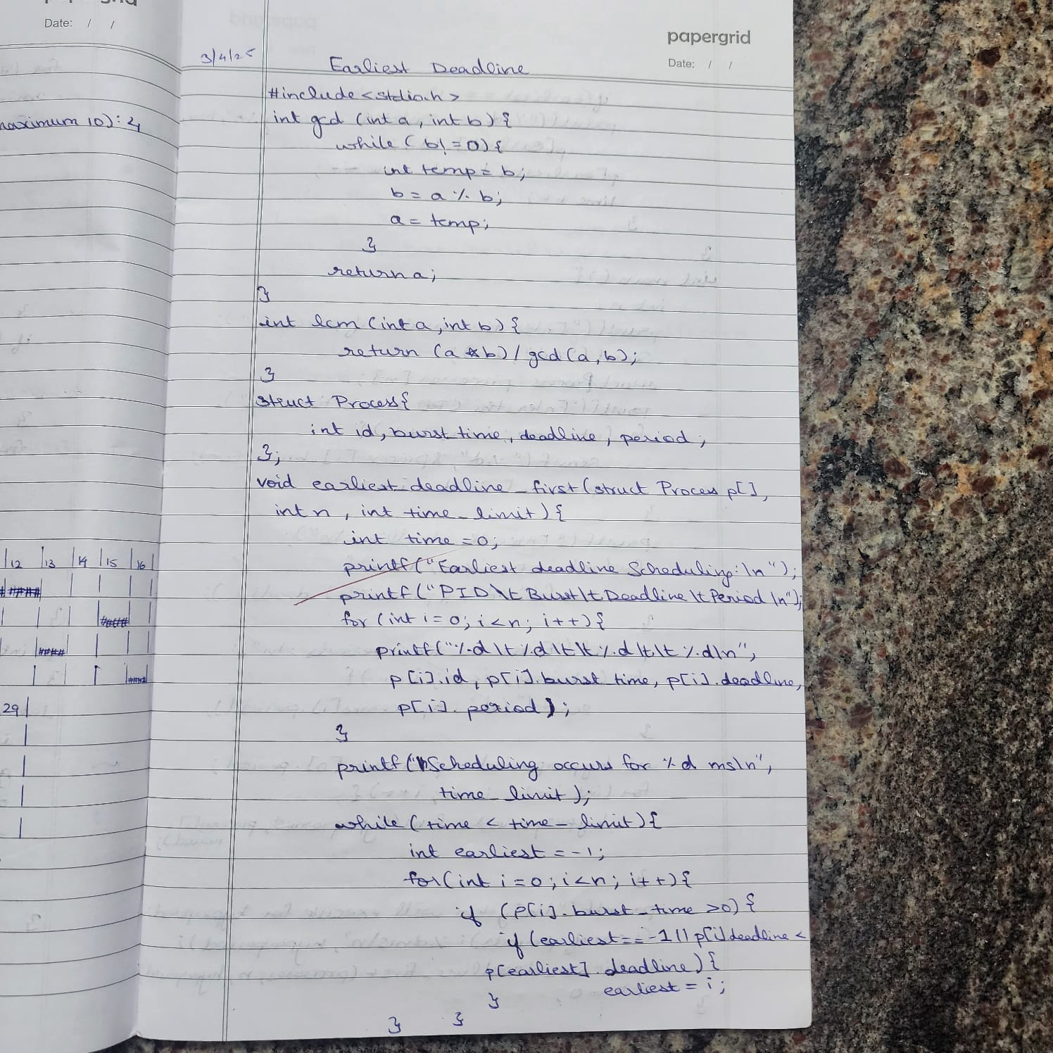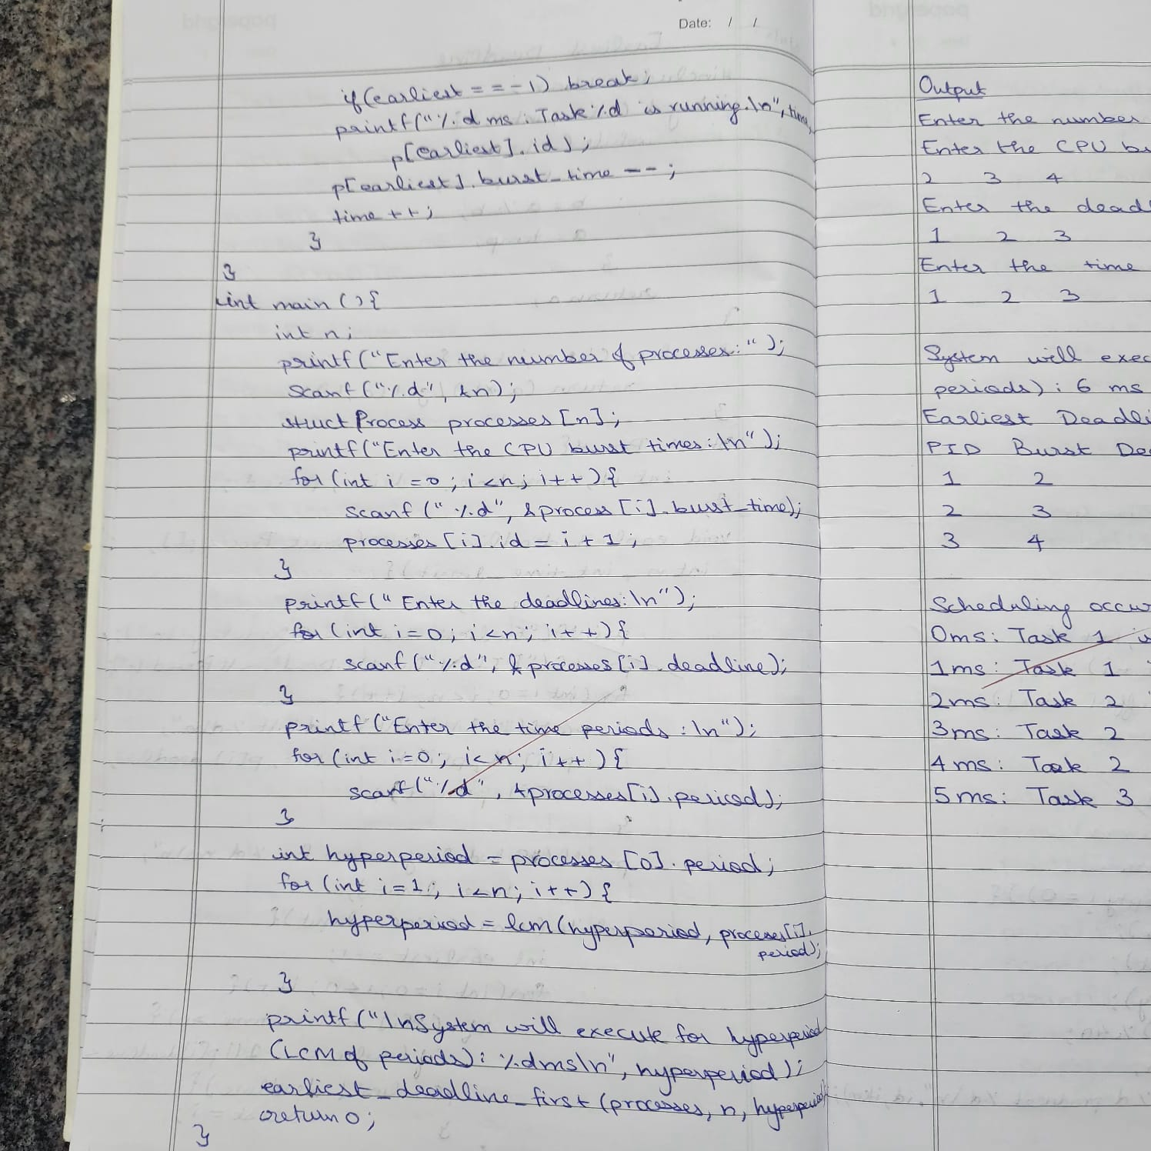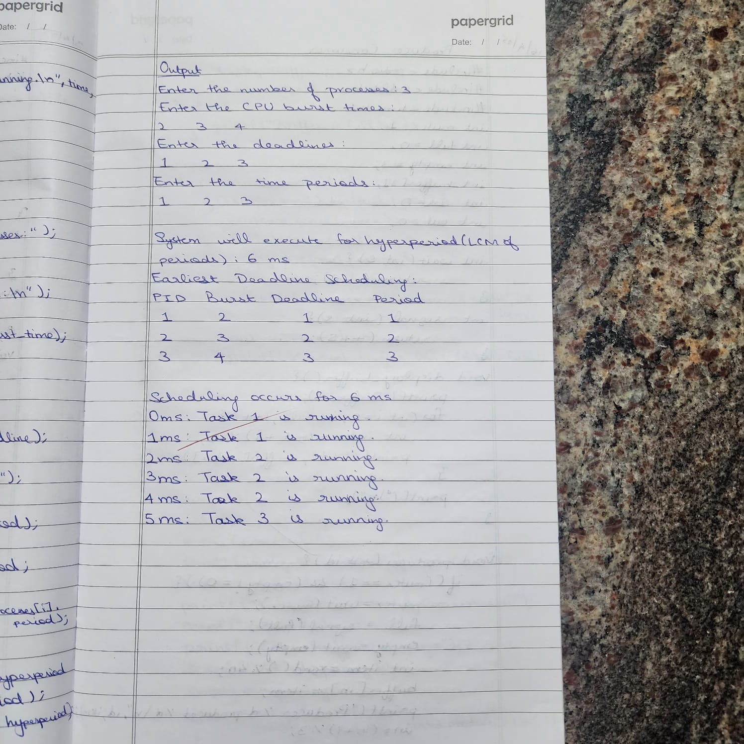

**Program -4**

**Question:**Write a C program to simulate **producer-consumer problem using semaphores**

**Code:**

#include <stdio.h>

#include <stdlib.h>

#include <time.h>

int mutex = 1;

int full = 0;

int empty = 3;

int buffer[3];

int in = 0;

int out = 0;

int wait(int s) {

return (--s);

}

int signal(int s) {

return (++s);

}

void display_buffer() {

printf("Buffer:");

for (int i = 0; i < full; i++) {

int index = (out + i) % 3;

printf("%d ", buffer[index]);

}

printf("\n");

}

void producer(int id) {

if ((mutex == 1) && (empty != 0)) {

mutex = wait(mutex);

full = signal(full);

empty = wait(empty);

int item = rand() % 40;

buffer[in] = item;

printf("Producer %d produced %d\n", id, item);

in = (in + 1) % 3;

display_buffer();

mutex = signal(mutex);

} else {

printf("Buffer is full\n");

}

}

void consumer(int id) {

if ((mutex == 1) && (full != 0)) {

mutex = wait(mutex);

full = wait(full);

empty = signal(empty);

int item = buffer[out];

printf("Consumer %d consumed %d\n", id, item);

out = (out + 1) % 3;

printf("Current buffer len: %d\n", full);

mutex = signal(mutex);

} else {

printf("Buffer is empty\n");

}

}

int main() {

int p, c, capacity, choice;

srand(time(NULL));

printf("Enter the number of Producers:");

scanf("%d", &p);

printf("Enter the number of Consumers:");

scanf("%d", &c);

printf("Enter buffer capacity:");

scanf("%d", &capacity);

empty = capacity;

for (int i = 1; i <= p; i++) {

printf("Successfully created producer %d\n", i);

}

for (int i = 1; i <= c; i++) {

printf("Successfully created consumer %d\n", i);

}

while (1) {

printf("\n1. Produce\n2. Consume\n3. Exit\n");

printf("Enter your choice: ");

scanf("%d", &choice);

switch (choice) {

case 1:

producer(1);

break;

case 2:

consumer(2);

break;

case 3:

exit(0);

default:

printf("Invalid choice\n");

}

}

return 0;

}

**OUTPUT:**

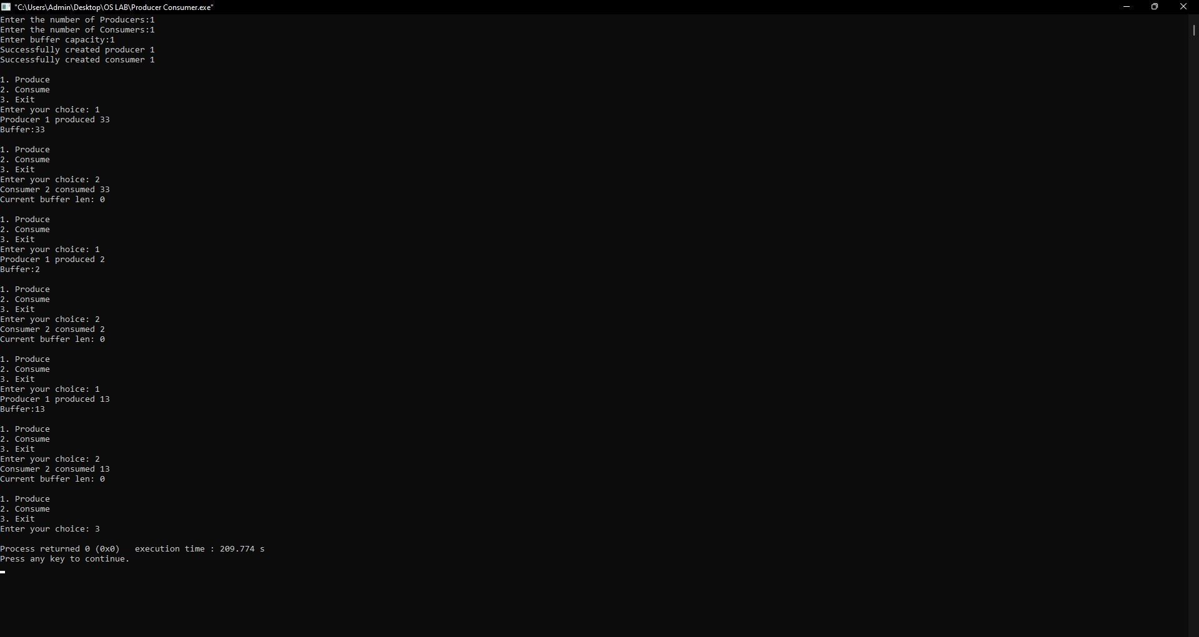

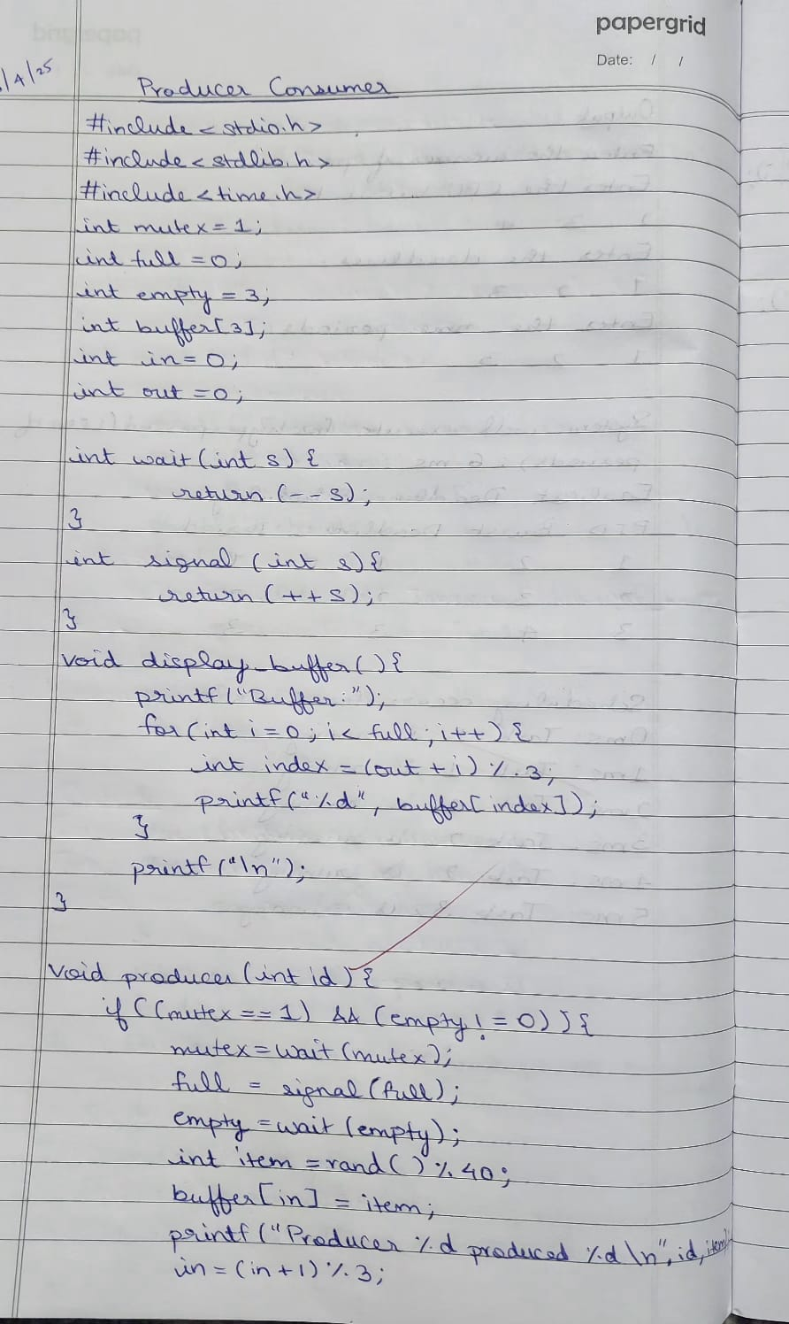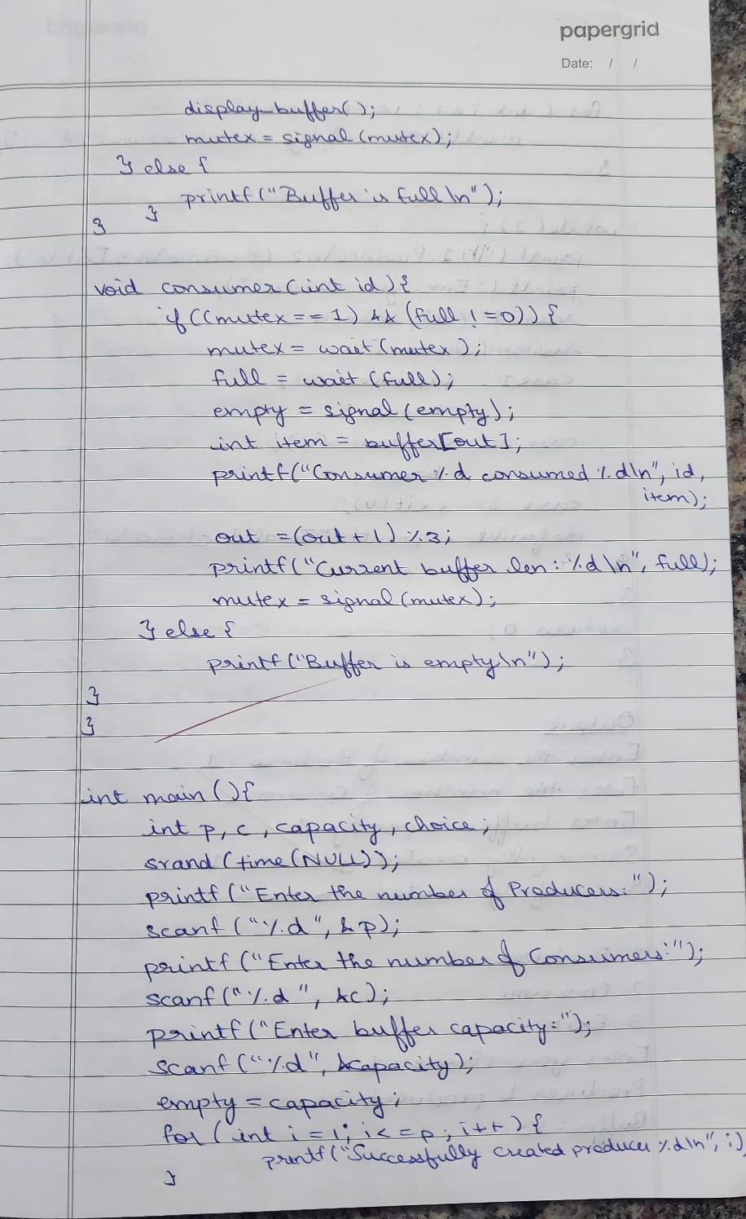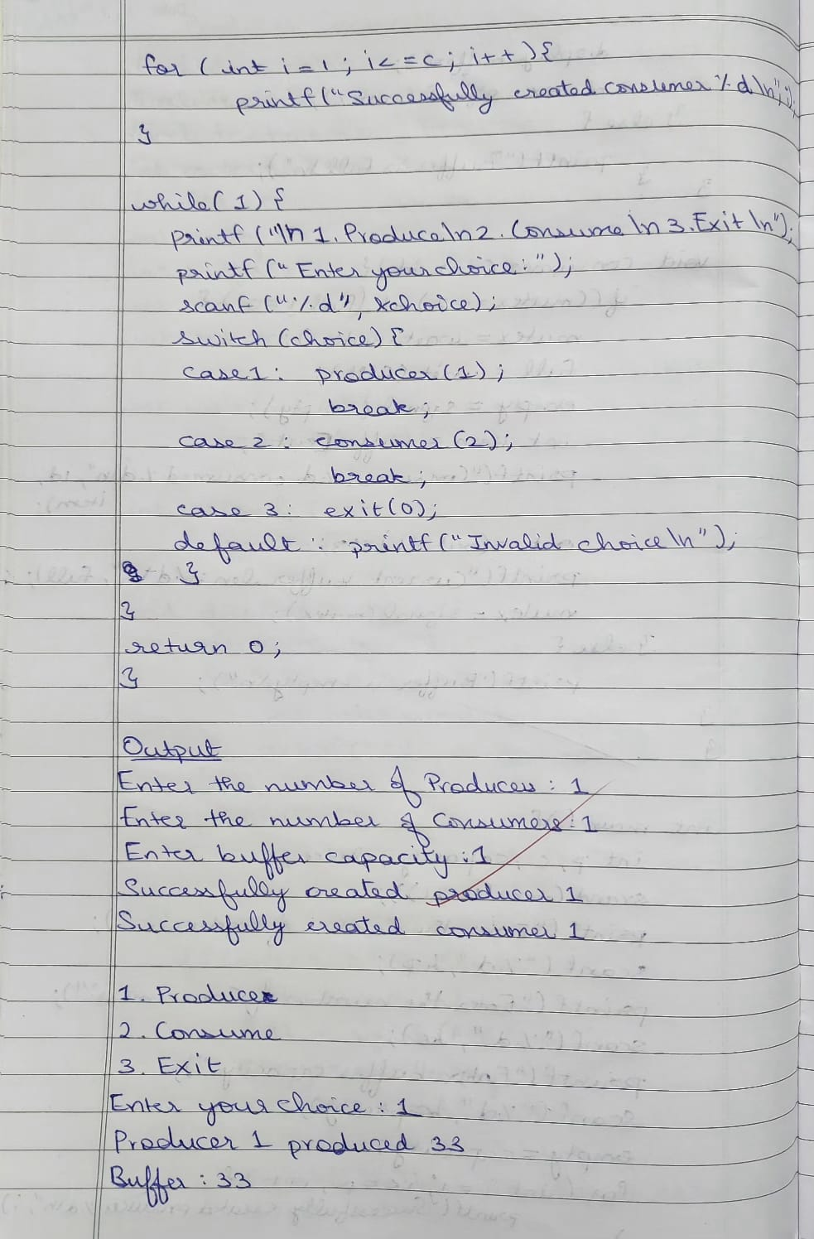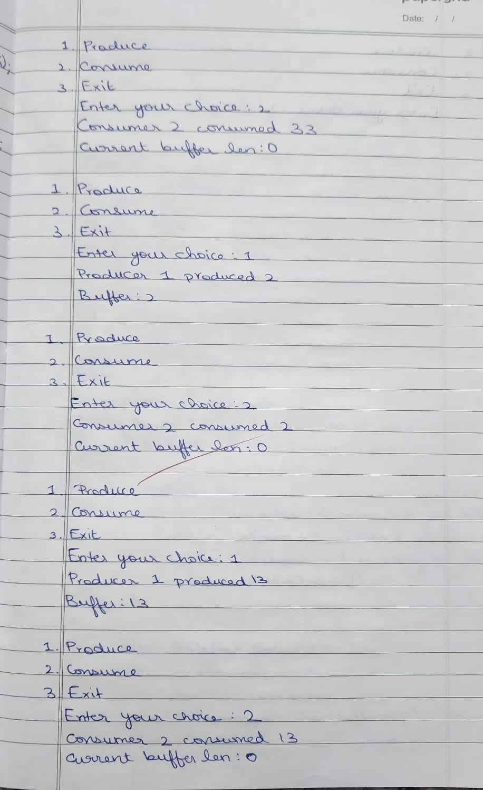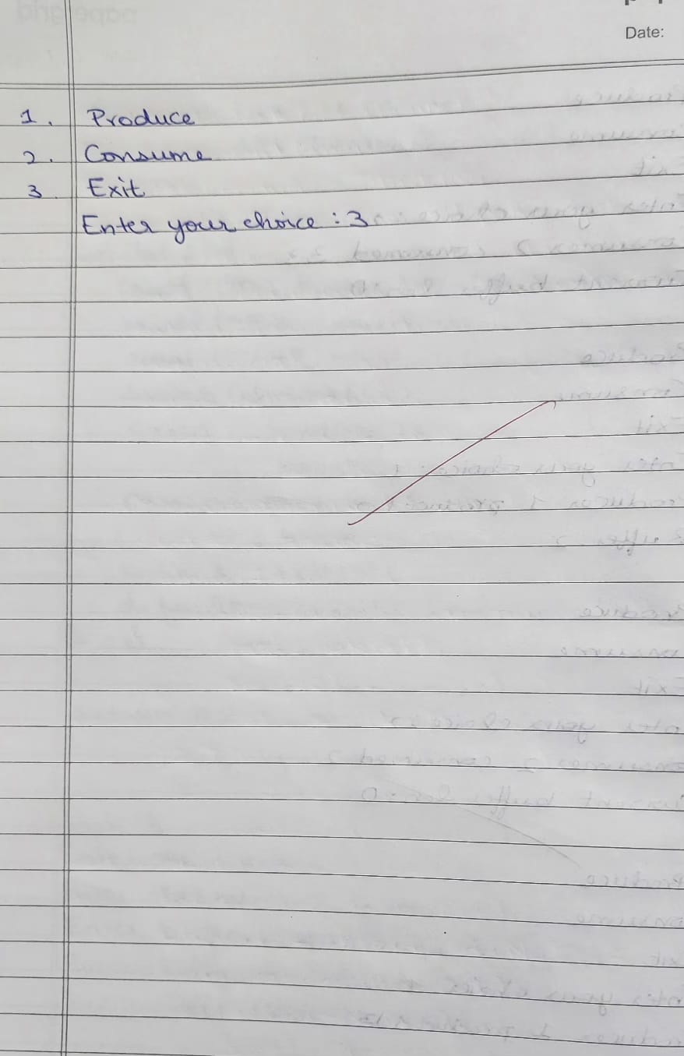

**Question:**Write a C program to simulate the concept of **Dining Philosophers** problem.

**Code:**

#include <pthread.h>

#include <semaphore.h>

#include <stdio.h>

#include <unistd.h>

#define N 5 // Number of philosophers

#define THINKING 2

#define HUNGRY 1

#define EATING 0

#define LEFT (phnum + 4) % N

#define RIGHT (phnum + 1) % N

int state[N];

int phil[N] = { 0, 1, 2, 3, 4 };

sem_t mutex;

sem_t S[N];

// Function to test if a philosopher can start eating

void test(int phnum)

{

if (state[phnum] == HUNGRY && state[LEFT] != EATING && state[RIGHT] != EATING) {

state[phnum] = EATING;

sleep(2); // Simulate time spent eating

printf("Philosopher %d takes fork %d and %d\n", phnum + 1, LEFT + 1, phnum + 1);

printf("Philosopher %d is Eating\n", phnum + 1);

sem_post(&S[phnum]); // Signal that the philosopher can start eating

}

}

void take_fork(int phnum)

{

sem_wait(&mutex);

state[phnum] = HUNGRY;

printf("Philosopher %d is Hungry\n", phnum + 1);

test(phnum);

sem_post(&mutex);

sem_wait(&S[phnum]);

sleep(1);

}

void put_fork(int phnum)

{

sem_wait(&mutex);

state[phnum] = THINKING;

printf("Philosopher %d putting fork %d and %d down\n", phnum + 1, LEFT + 1, phnum + 1);

printf("Philosopher %d is thinking\n", phnum + 1);

test(LEFT);

test(RIGHT);

sem_post(&mutex); }

void* philosopher(void* num)

{

int* i = num;

while (1) {

sleep(1);

take_fork(*i);

sleep(0);

put_fork(*i);

}

}

int main()

{

int i;

pthread_t thread_id[N];

sem_init(&mutex, 0, 1);

for (i = 0; i < N; i++) {

sem_init(&S[i], 0, 0);

}

for (i = 0; i < N; i++) {

pthread_create(&thread_id[i], NULL, philosopher, &phil[i]);

printf("Philosopher %d is thinking\n", i + 1);

}

for (i = 0; i < N; i++) {

pthread_join(thread_id[i], NULL);

}

return 0;

}

**OUTPUT:**

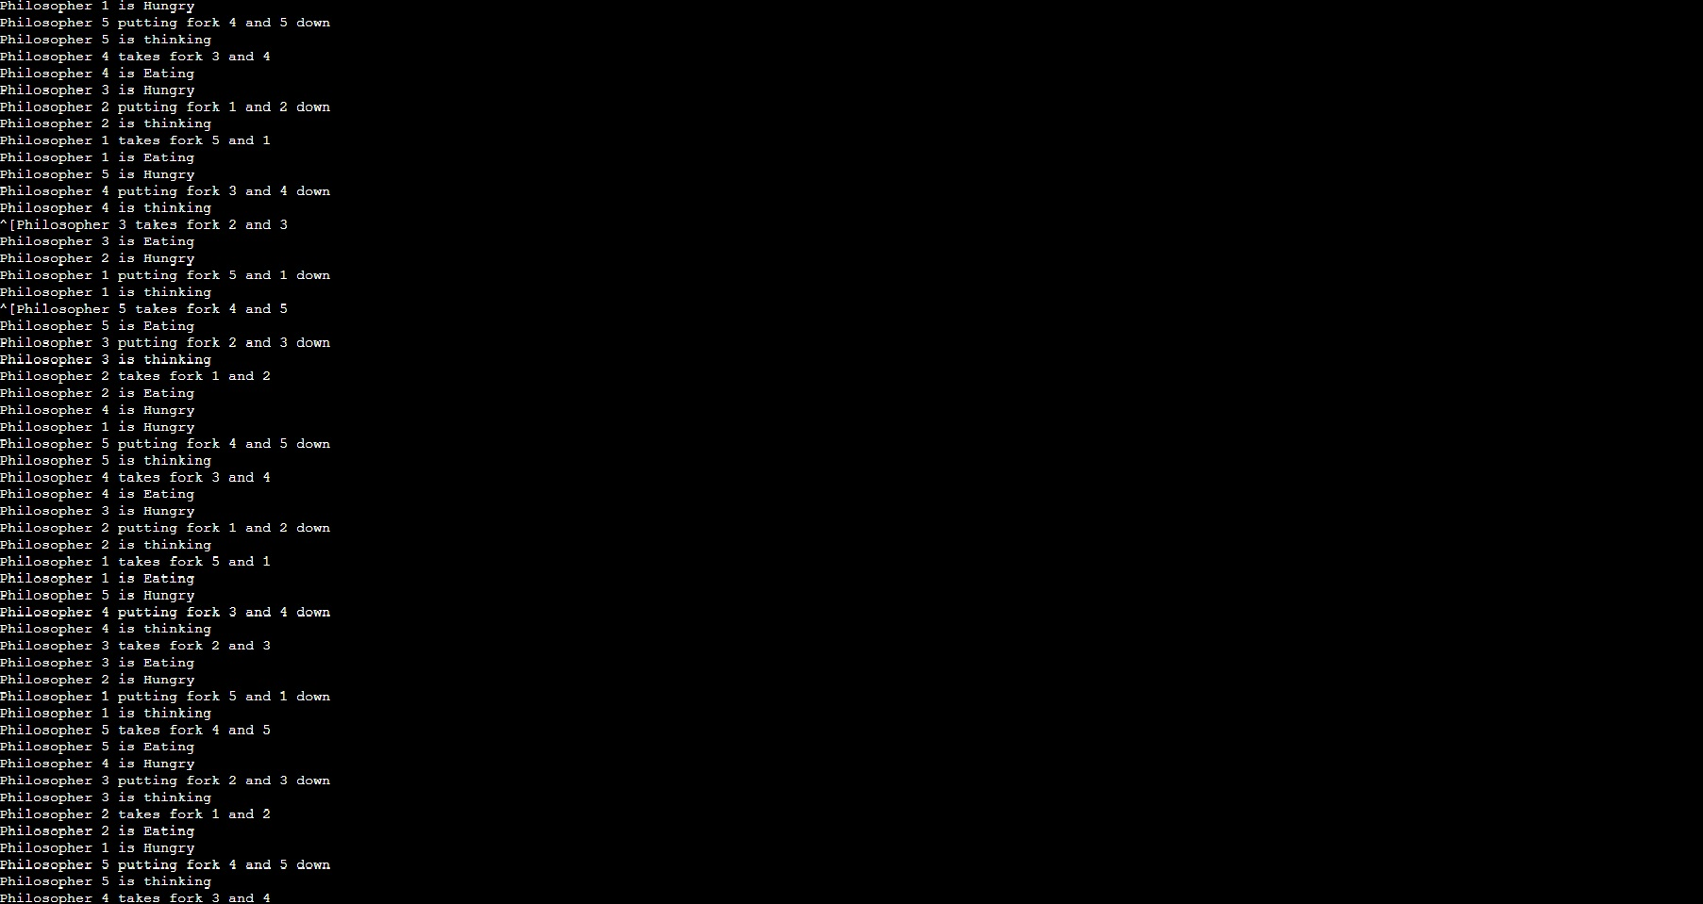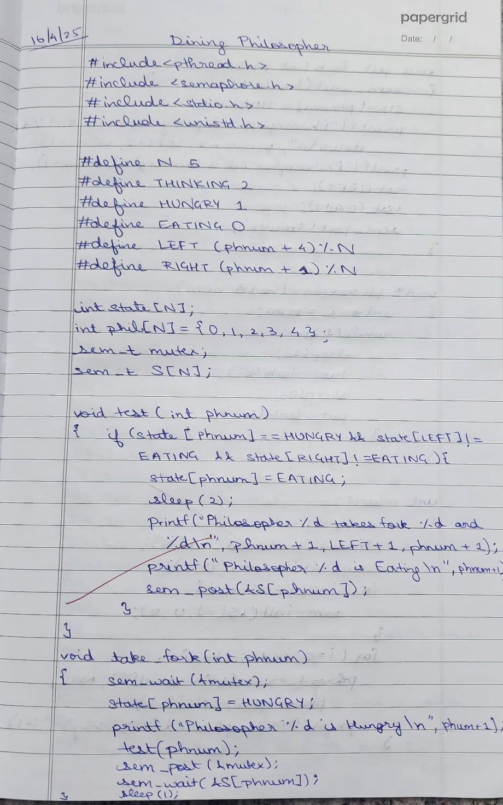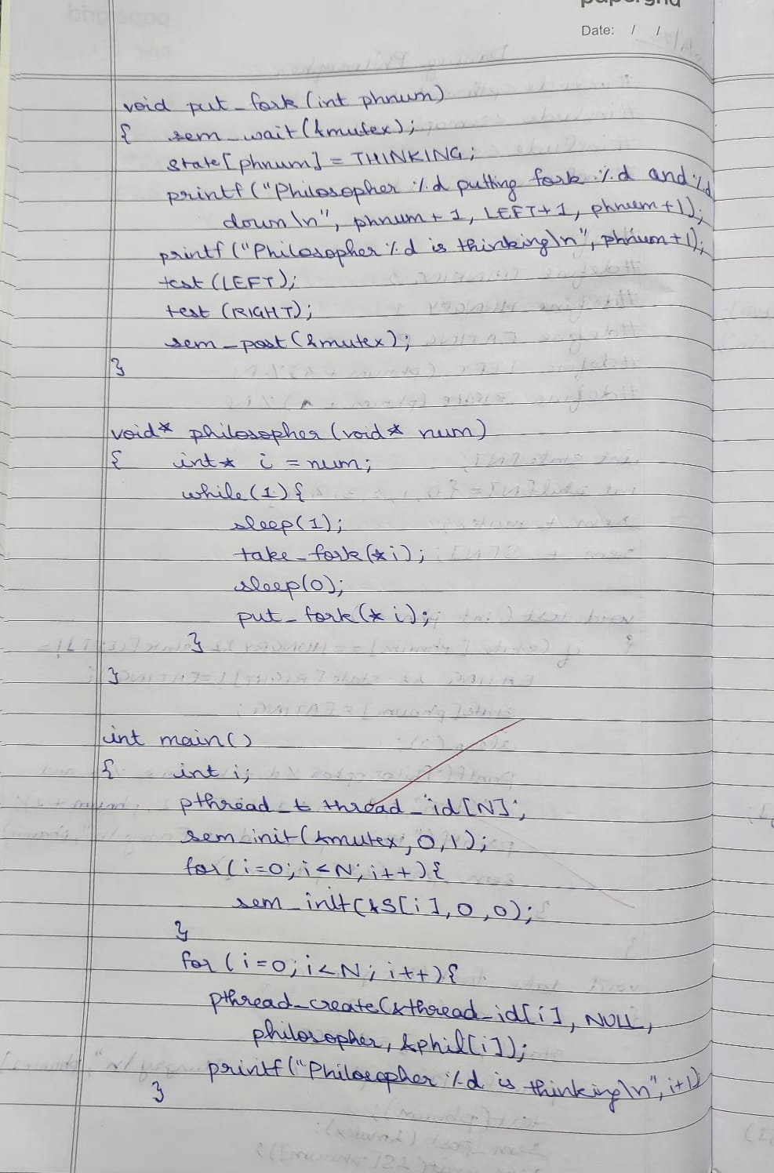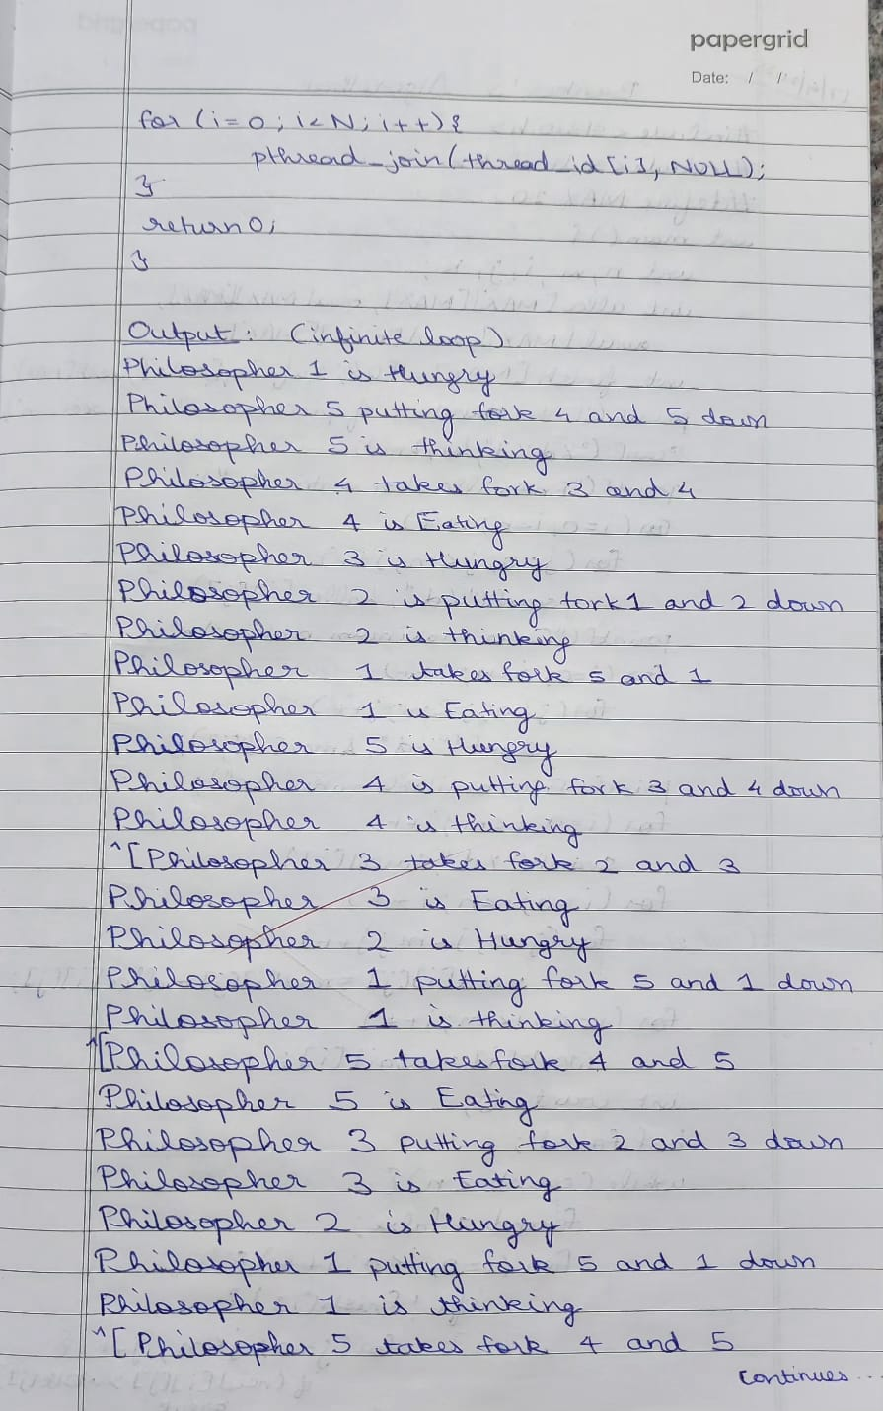

**Program -5**

**Question:**Write a C program to simulate Bankers algorithm for the purpose of deadlock avoidance.

**Code:**

#include <stdio.h>

#include <stdbool.h>

#define MAX 10

int main() {

int n, m, i, j, k;

int alloc[MAX][MAX], max[MAX][MAX], avail[MAX], need[MAX][MAX];

int finish[MAX] = {0}, safeSeq[MAX], work[MAX];

printf("Enter number of processes and resources:\n");

scanf("%d %d", &n, &m);

printf("Enter allocation matrix:\n");

for (i = 0; i < n; i++)

for (j = 0; j < m; j++)

scanf("%d", &alloc[i][j]);

printf("Enter maximum matrix:\n");

for (i = 0; i < n; i++)

for (j = 0; j < m; j++)

scanf("%d", &max[i][j]);

printf("Enter available matrix:\n");

for (i = 0; i < m; i++)

scanf("%d", &avail[i]);

for (i = 0; i < n; i++)

for (j = 0; j < m; j++)

need[i][j] = max[i][j] - alloc[i][j];

for (i = 0; i < m; i++)

work[i] = avail[i];

int count = 0;

bool found;

while (count < n) {

found = false;

for (i = 0; i < n; i++) {

if (!finish[i]) {

for (j = 0; j < m; j++) {

if (need[i][j] > work[j])

break;

}

if (j == m) {

for (k = 0; k < m; k++)

work[k] += alloc[i][k];

safeSeq[count++] = i;

finish[i] = 1;

found = true;

}

}

}

if (!found)

break;

}

if (count == n) {

printf("System is in safe state\n");

printf("Safe sequence is: ");

for (i = 0; i < n; i++) {

printf("P%d", safeSeq[i]);

if (i != n - 1)

printf(" -> ");

}

printf("\n");

} else {

printf("System is in unsafe state\n");

}

return 0;

}

**OUTPUT:**

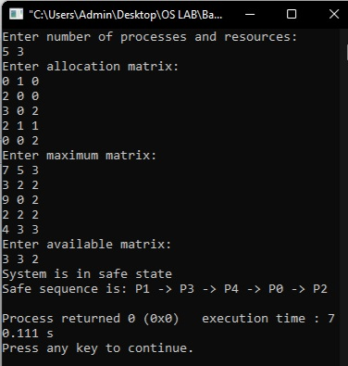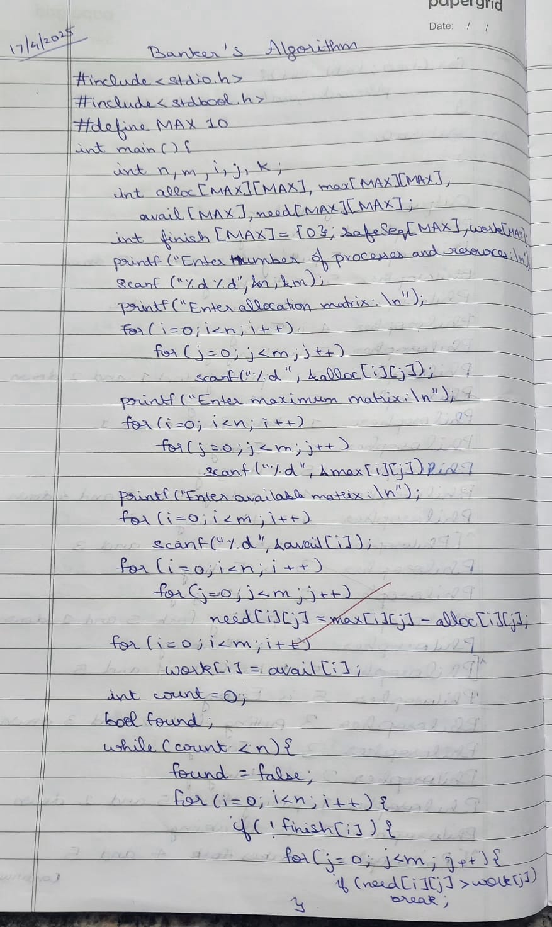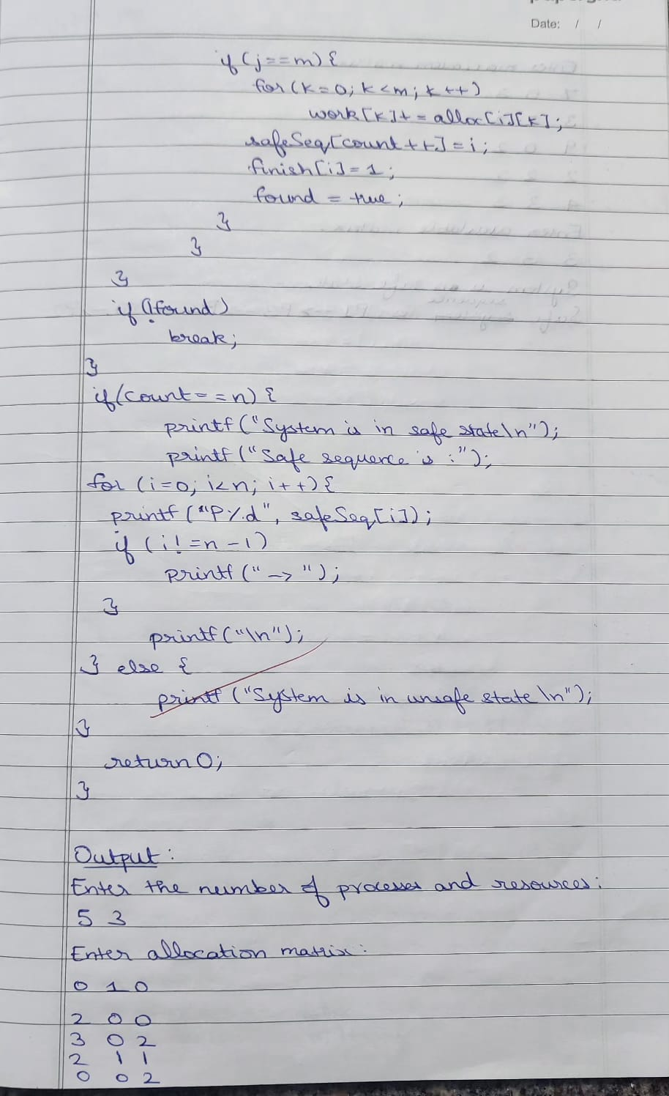

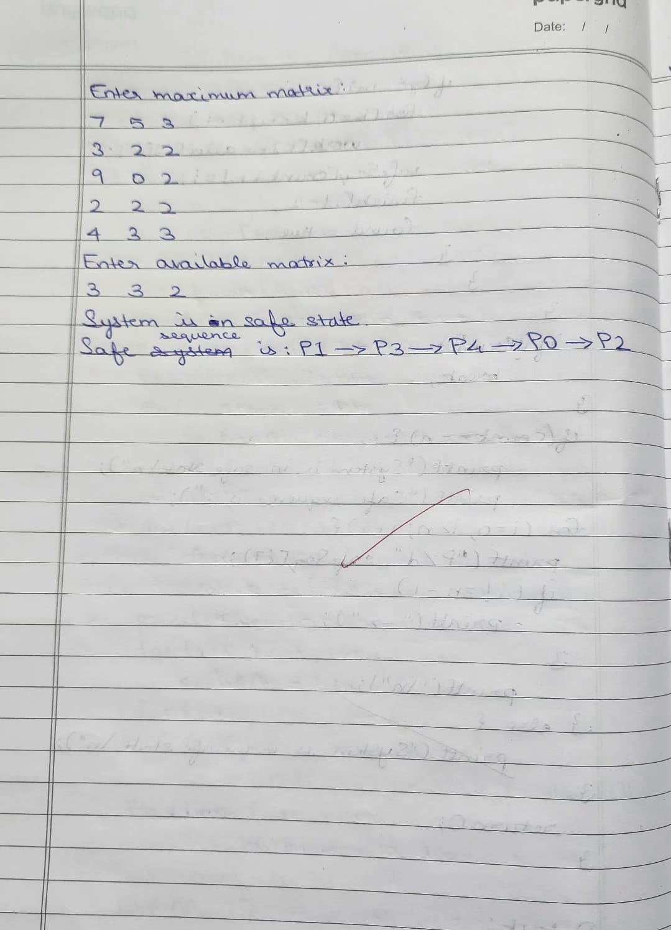

**Question:**Write a C program to simulate deadlock detection

**Code:**

#include <stdio.h>

#include <stdbool.h>

int main() {

int n, m, i, j, k;

printf("Enter number of processes and resources:\n");

scanf("%d %d", &n, &m);

int alloc[n][m], request[n][m], avail[m];

bool finish[n];

printf("Enter allocation matrix:\n");

for (i = 0; i < n; i++)

for (j = 0; j < m; j++)

scanf("%d", &alloc[i][j]);

printf("Enter request matrix:\n");

for (i = 0; i < n; i++)

for (j = 0; j < m; j++)

scanf("%d", &request[i][j]);

printf("Enter available matrix:\n");

for (i = 0; i < m; i++)

scanf("%d", &avail[i]);

for (i = 0; i < n; i++) {

bool is_zero = true;

for (j = 0; j < m; j++) {

if (alloc[i][j] != 0) {

is_zero = false;

break;

}

}

finish[i] = is_zero;

}

bool changed;

do {

changed = false;

for (i = 0; i < n; i++) {

if (!finish[i]) {

bool can_finish = true;

for (j = 0; j < m; j++) {

if (request[i][j] > avail[j]) {

can_finish = false;

break;

}

}

if (can_finish) {

for (k = 0; k < m; k++)

avail[k] += alloc[i][k];

finish[i] = true;

changed = true;

printf("Process %d can finish.\n", i);

}

}

}

} while (changed);

bool deadlock = false;

for (i = 0; i < n; i++) {

if (!finish[i]) {

deadlock = true;

break;

}

}

if (deadlock)

printf("System is in a deadlock state.\n");

else

printf("System is not in a deadlock state.\n");

return 0;

}

**OUTPUT:**

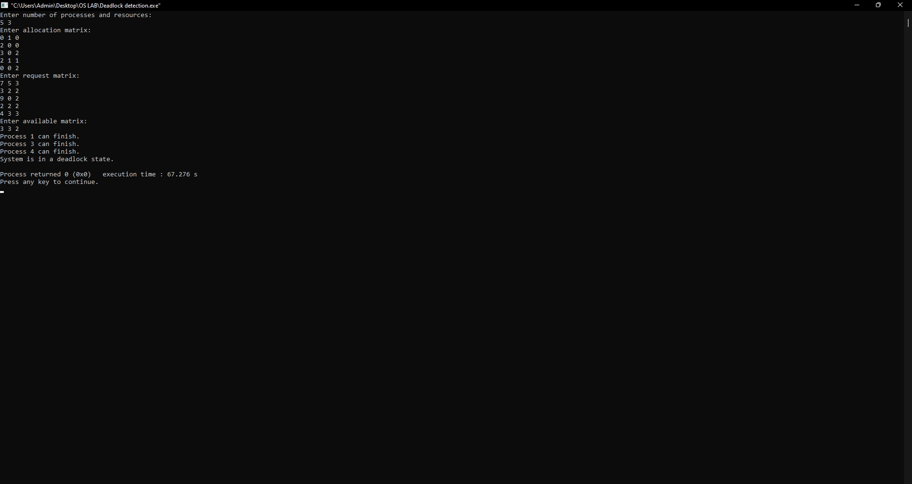

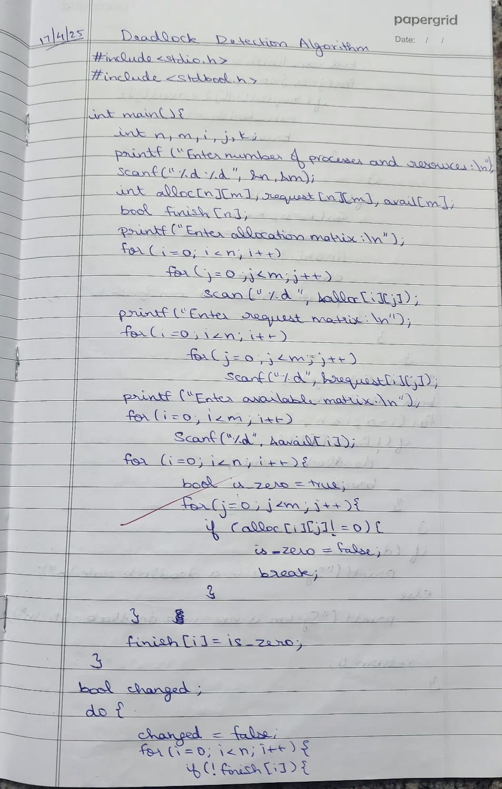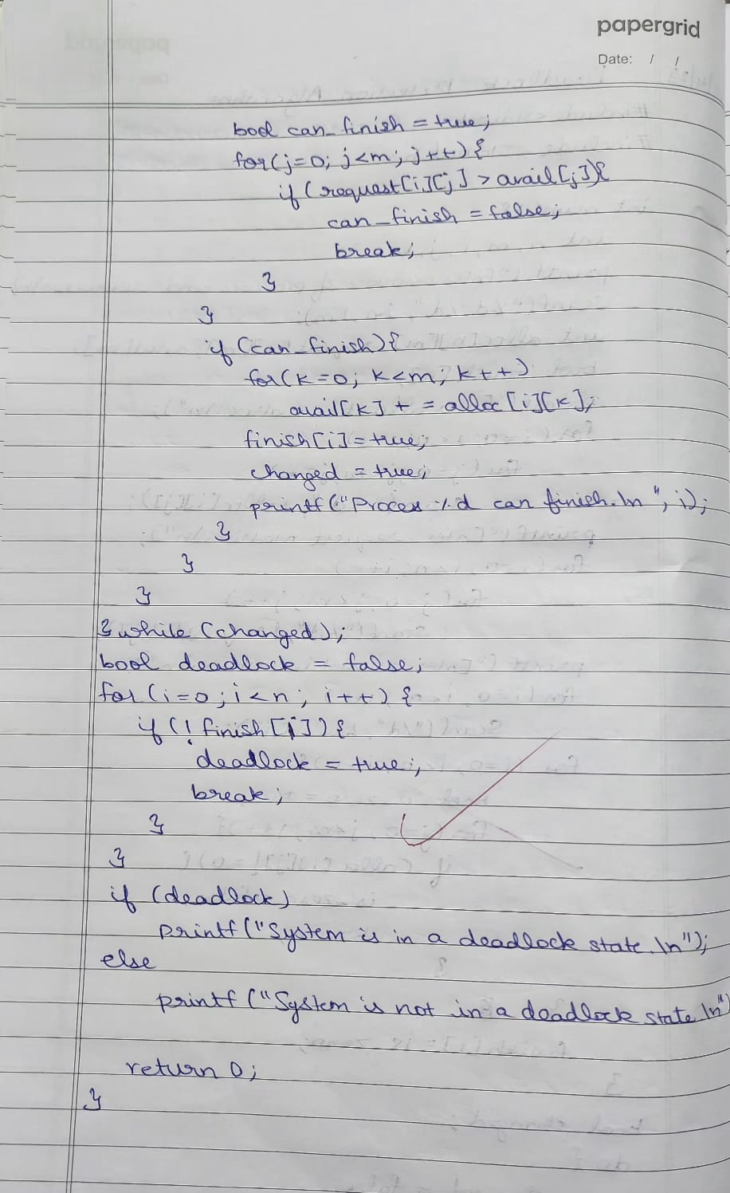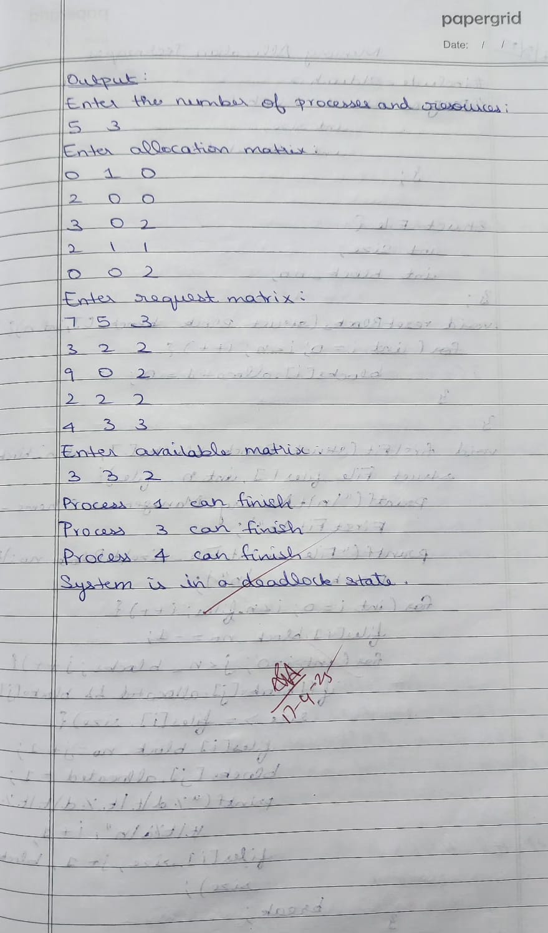

**Program -6**

**Question:**Write a C program to simulate the following contiguous memory allocation techniques a) Worst-fit

b)Best-fit

c)First-fit

**Code:**

#include <stdio.h>

struct Block {

int size;

int allocated;

};

struct File {

int size;

int block_no;

};

void resetBlocks(struct Block blocks[], int n) {

for (int i = 0; i < n; i++) {

blocks[i].allocated = 0;

}

}

void firstFit(struct Block blocks[], int n_blocks, struct File files[], int n_files) {

printf("\n\tMemory Management Scheme – First Fit\n");

printf("File_no:\tFile_size\tBlock_no:\tBlock_size:\n");

for (int i = 0; i < n_files; i++) {

files[i].block_no = -1;

for (int j = 0; j < n_blocks; j++) {

if (!blocks[j].allocated && blocks[j].size >= files[i].size) {

files[i].block_no = j + 1;

blocks[j].allocated = 1;

printf("%d\t\t%d\t\t%d\t\t%d\n", i + 1, files[i].size, j + 1, blocks[j].size);

break;

}

}

if (files[i].block_no == -1) {

printf("%d\t\t%d\t\t_\t\t_\n", i + 1, files[i].size);

}

}

}

void bestFit(struct Block blocks[], int n_blocks, struct File files[], int n_files) {

printf("\n\tMemory Management Scheme – Best Fit\n");

printf("File_no:\tFile_size\tBlock_no:\tBlock_size:\n");

for (int i = 0; i < n_files; i++) {

int bestIdx = -1;

for (int j = 0; j < n_blocks; j++) {

if (!blocks[j].allocated && blocks[j].size >= files[i].size) {

if (bestIdx == -1 || blocks[j].size < blocks[bestIdx].size) {

bestIdx = j;

}

}

}

if (bestIdx != -1) {

blocks[bestIdx].allocated = 1;

files[i].block_no = bestIdx + 1;

printf("%d\t\t%d\t\t%d\t\t%d\n", i + 1, files[i].size, bestIdx + 1, blocks[bestIdx].size);

} else {

printf("%d\t\t%d\t\t_\t\t_\n", i + 1, files[i].size);

}

}

}

void worstFit(struct Block blocks[], int n_blocks, struct File files[], int n_files) {

printf("\n\tMemory Management Scheme – Worst Fit\n");

printf("File_no:\tFile_size\tBlock_no:\tBlock_size:\n");

for (int i = 0; i < n_files; i++) {

int worstIdx = -1;

for (int j = 0; j < n_blocks; j++) {

if (!blocks[j].allocated && blocks[j].size >= files[i].size) {

if (worstIdx == -1 || blocks[j].size > blocks[worstIdx].size) {

worstIdx = j;

}

}

}

if (worstIdx != -1) {

blocks[worstIdx].allocated = 1;

files[i].block_no = worstIdx + 1;

printf("%d\t\t%d\t\t%d\t\t%d\n", i + 1, files[i].size, worstIdx + 1, blocks[worstIdx].size);

} else {

printf("%d\t\t%d\t\t_\t\t_\n", i + 1, files[i].size);

}

}

}

int main() {

int n_blocks, n_files, choice;

printf("Memory Management Scheme\n");

printf("Enter the number of blocks: ");

scanf("%d", &n_blocks);

printf("Enter the number of files: ");

scanf("%d", &n_files);

struct Block blocks[n_blocks];

struct File files[n_files];

printf("\nEnter the size of the blocks:\n");

for (int i = 0; i < n_blocks; i++) {

printf("Block %d: ", i + 1);

scanf("%d", &blocks[i].size);

blocks[i].allocated = 0;

}

printf("Enter the size of the files:\n");

for (int i = 0; i < n_files; i++) {

printf("File %d: ", i + 1);

scanf("%d", &files[i].size);

}

do {

printf("\n1. First Fit\n2. Best Fit\n3. Worst Fit\n4. Exit\n");

printf("Enter your choice: ");

scanf("%d", &choice);

resetBlocks(blocks, n_blocks);

switch (choice) {

case 1:

firstFit(blocks, n_blocks, files, n_files);

break;

case 2:

bestFit(blocks, n_blocks, files, n_files);

break;

case 3:

worstFit(blocks, n_blocks, files, n_files);

break;

case 4:

printf("\nExiting...\n");

break;

default:

printf("Invalid choice.\n");

}

} while (choice != 4);

return 0;

}

**OUTPUT:**

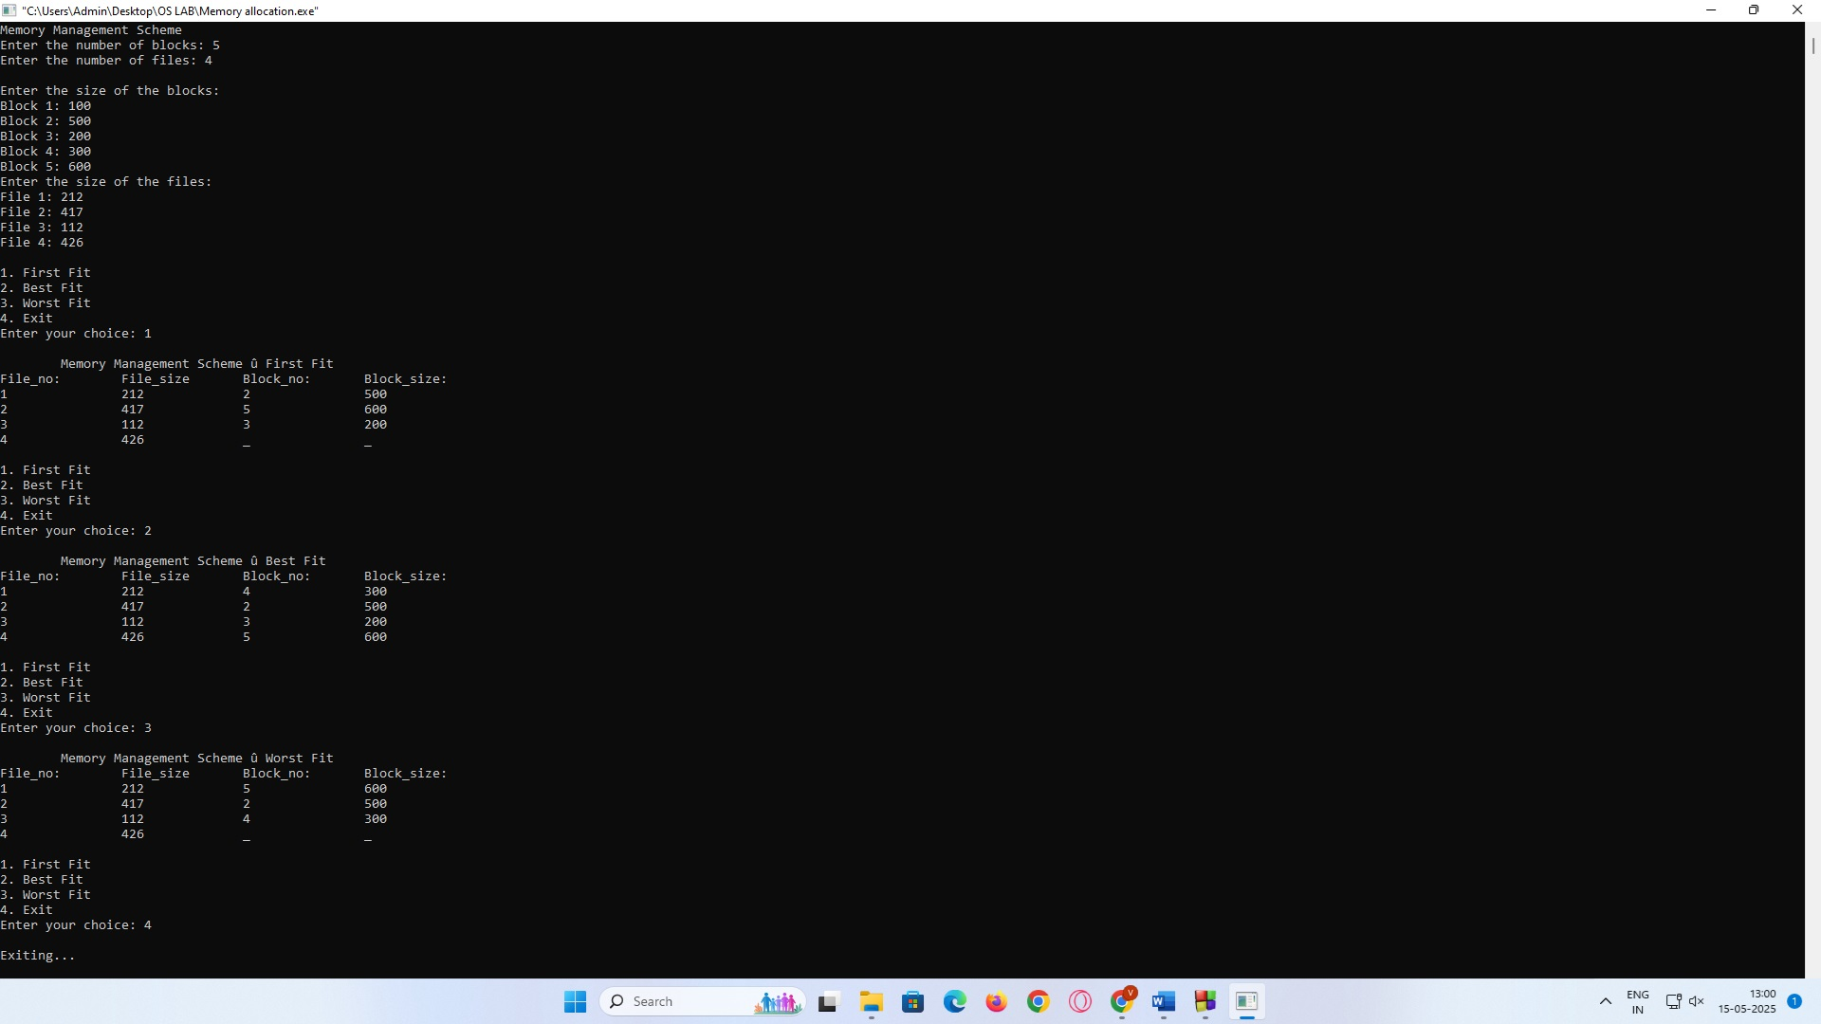

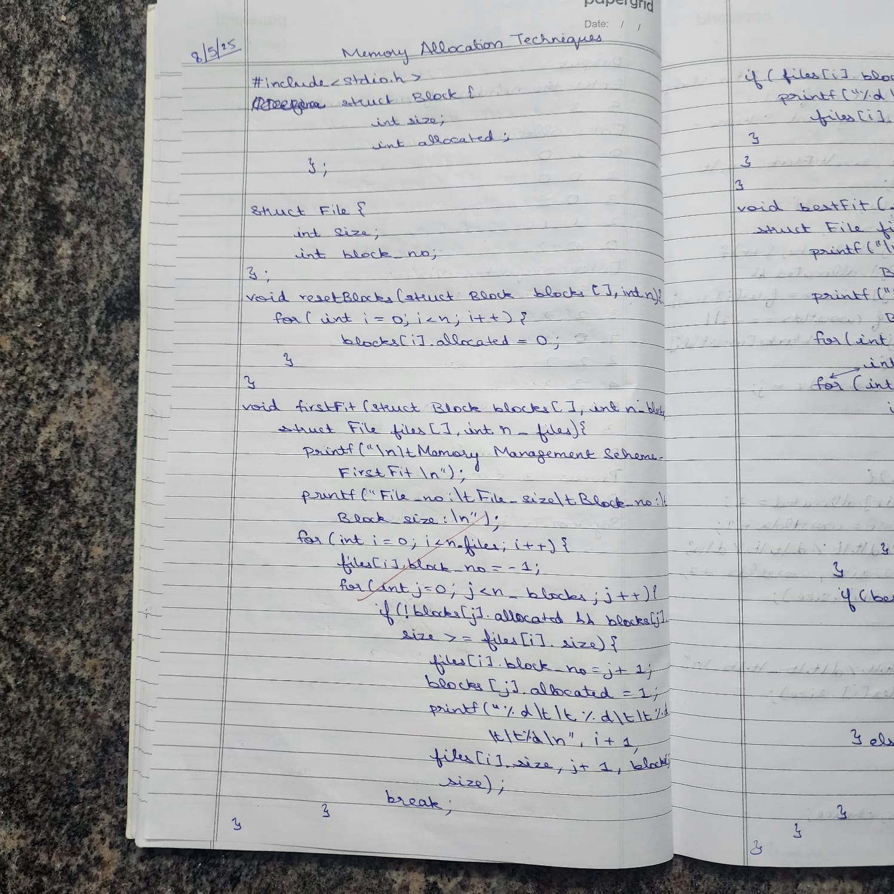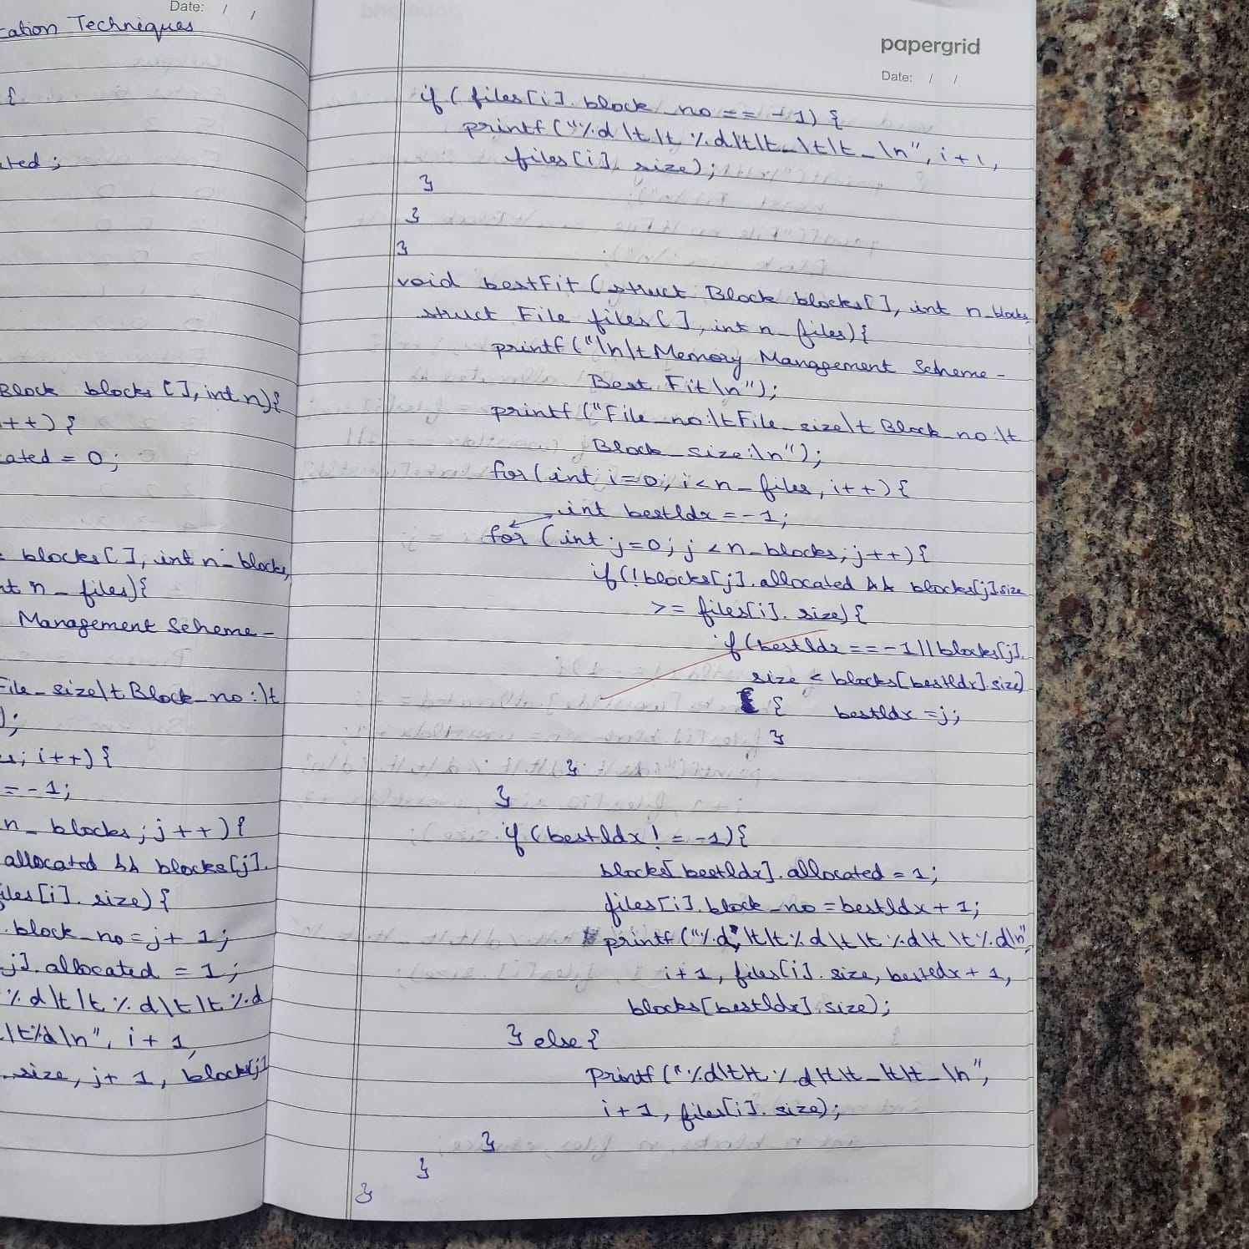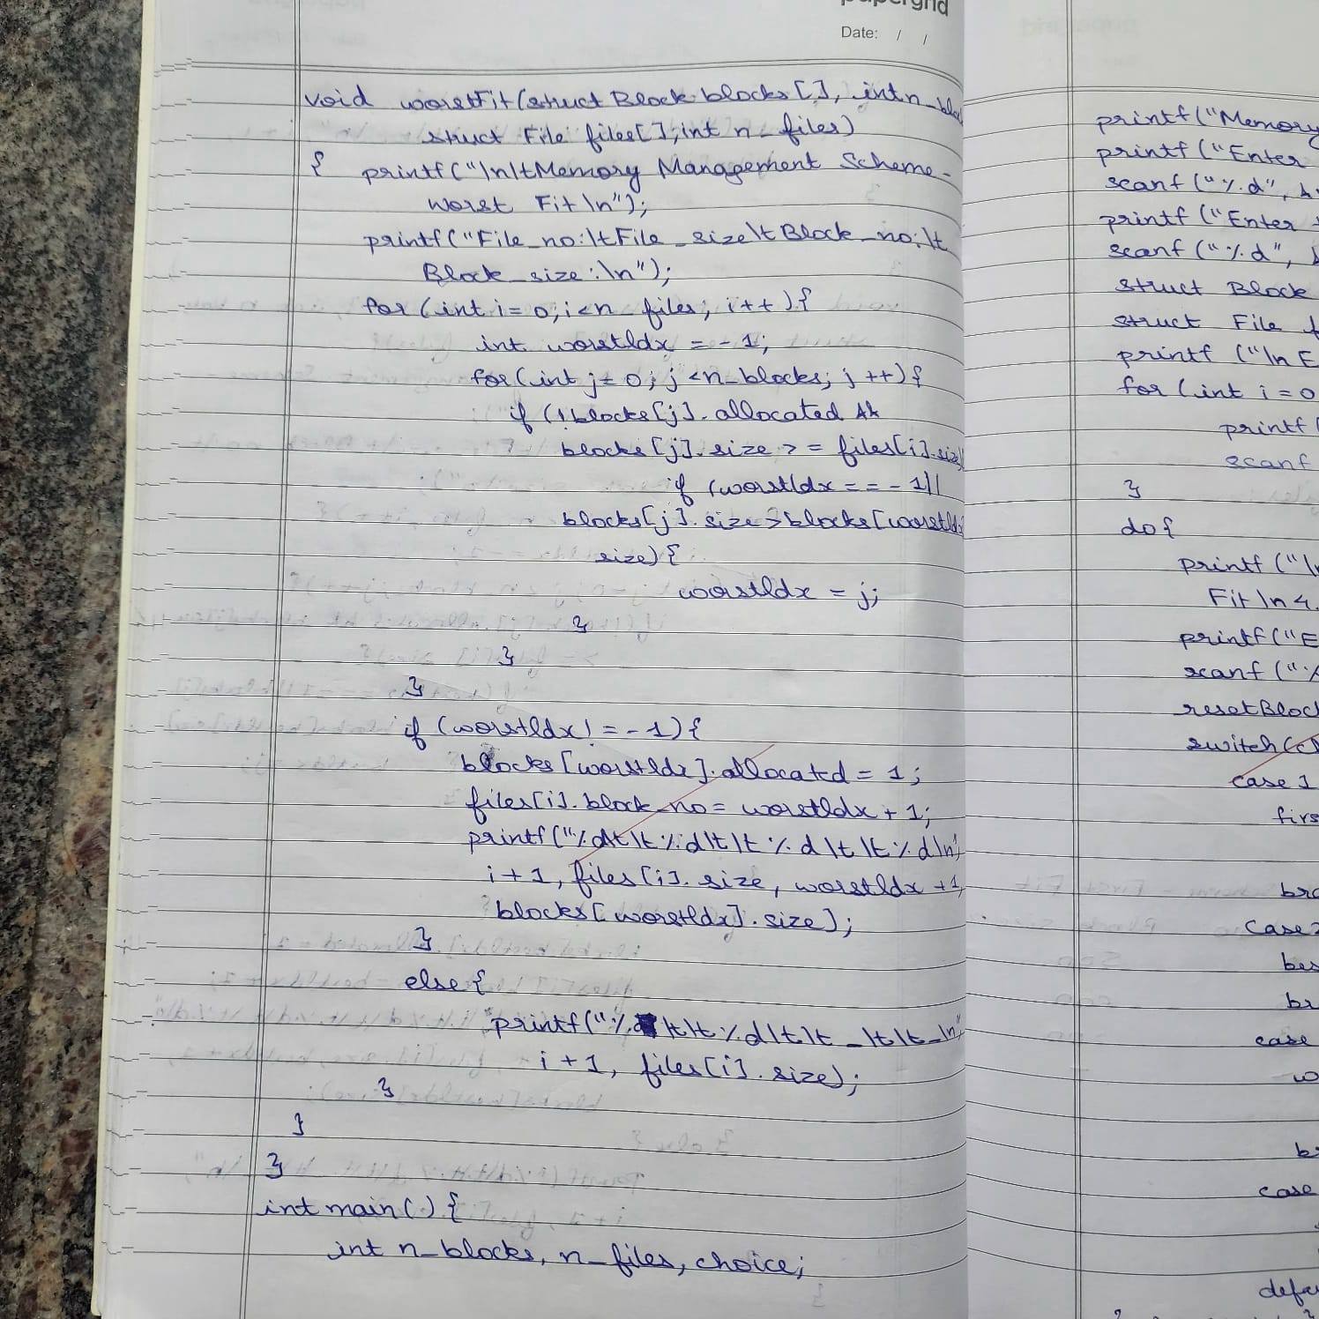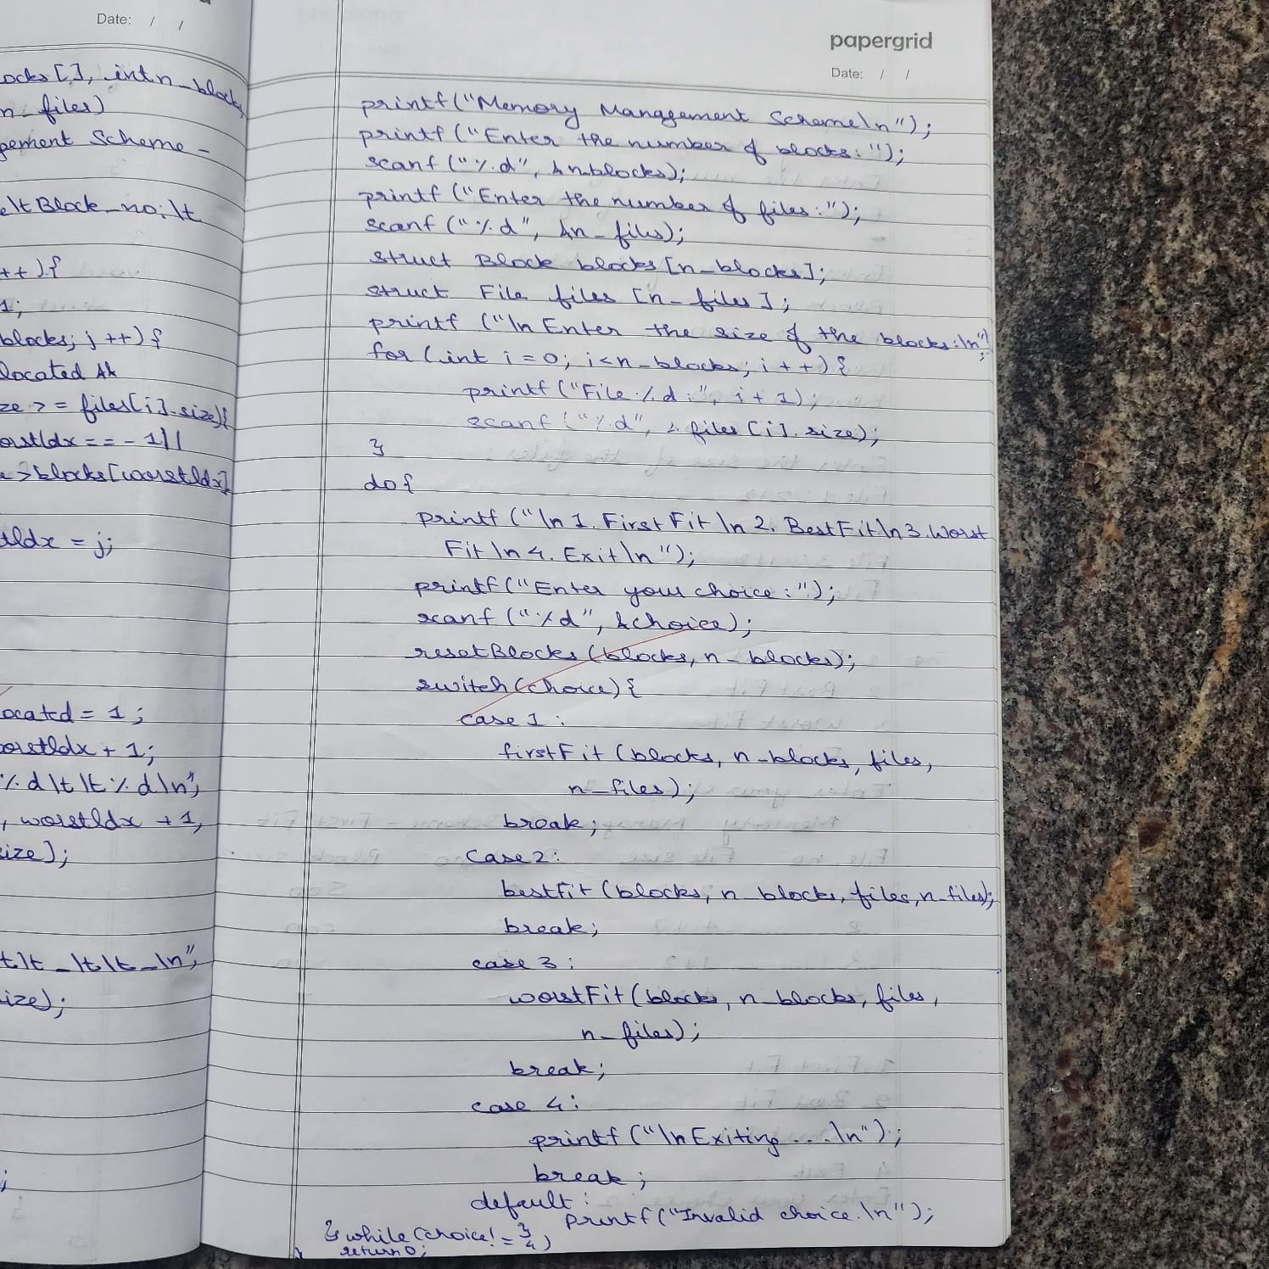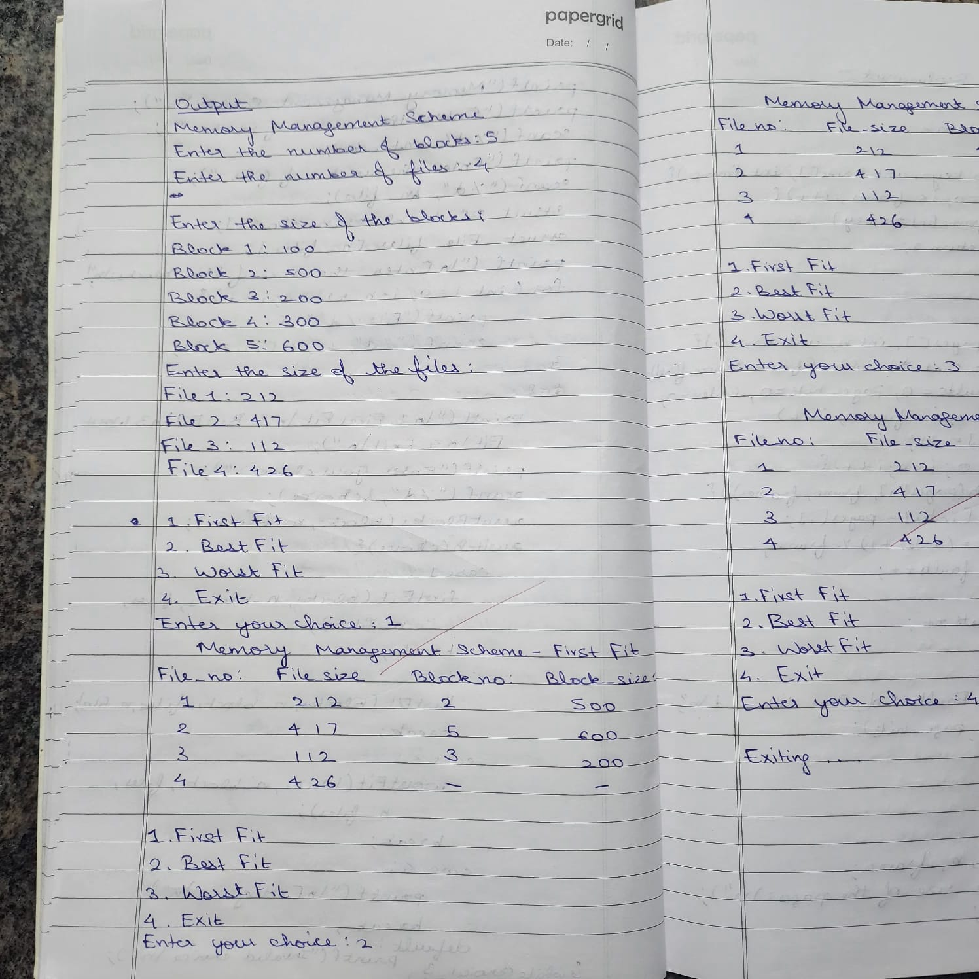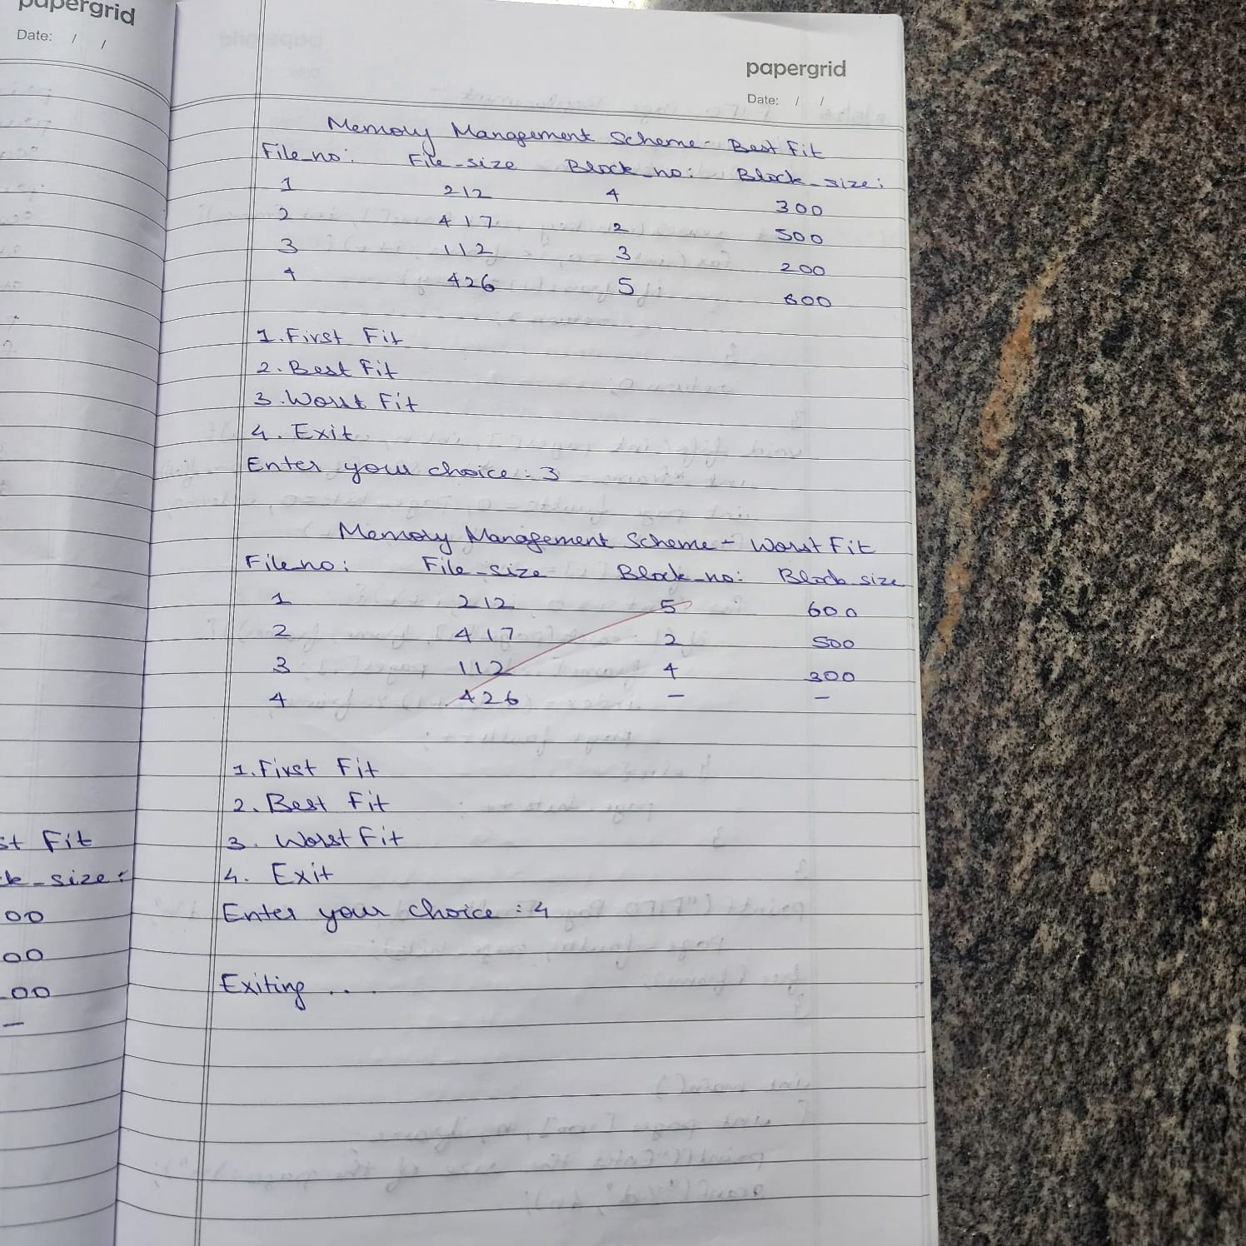

**Question:**

**Code:**

**a)FIFO**

#include <stdio.h>

#include <stdlib.h>

int search(int key, int frame[], int frames) {

for (int i = 0; i < frames; i++) {

if (frame[i] == key)

return 1;

}

return 0;

}

void fifo(int pages[], int n, int frames) {

int *frame = (int *)malloc(frames * sizeof(int));

int page_faults = 0, page_hits = 0, index = 0;

for (int i = 0; i < frames; i++)

frame[i] = -1;

for (int i = 0; i < n; i++) {

if (!search(pages[i], frame, frames)) {

frame[index] = pages[i];

index = (index + 1) % frames;

page_faults++;

} else {

page_hits++;

}

}

printf("FIFO Page Faults: %d, Page Hits: %d\n", page_faults, page_hits);

free(frame);

}

int pages[100], n, frames;

printf("Enter the size of the pages:\n");

scanf("%d", &n);

printf("Enter the page strings:\n");

for (int i = 0; i < n; i++)

scanf("%d", &pages[i]);

printf("Enter the number of page frames:\n");

scanf("%d", &frames);

fifo(pages, n, frames);

return 0;

}

**OUTPUT:**

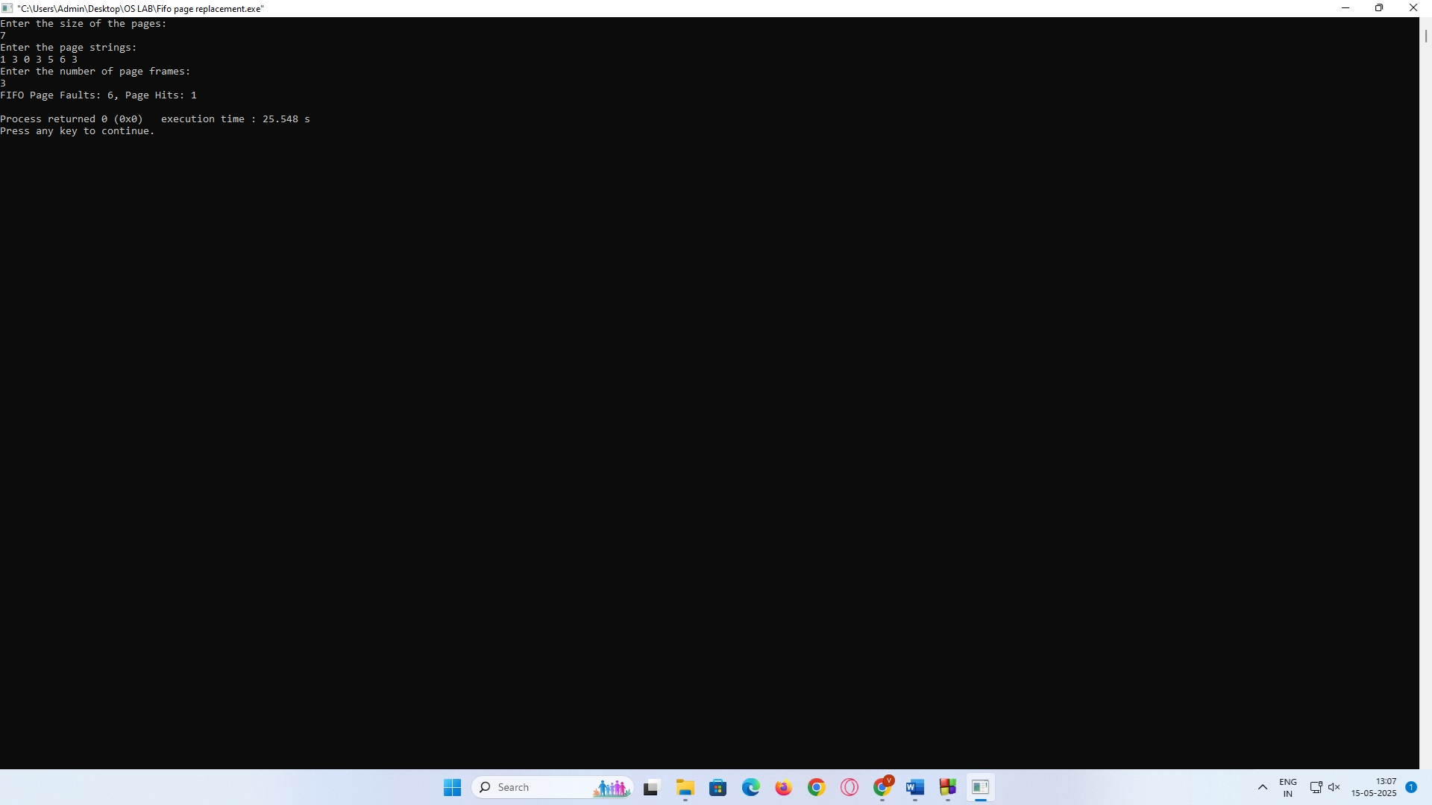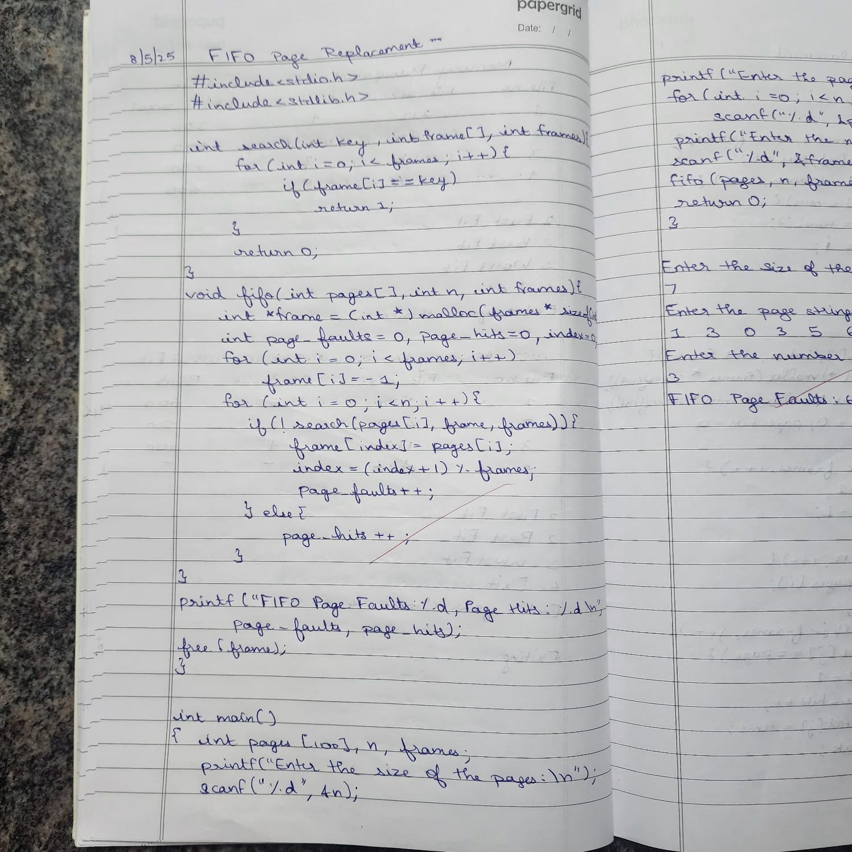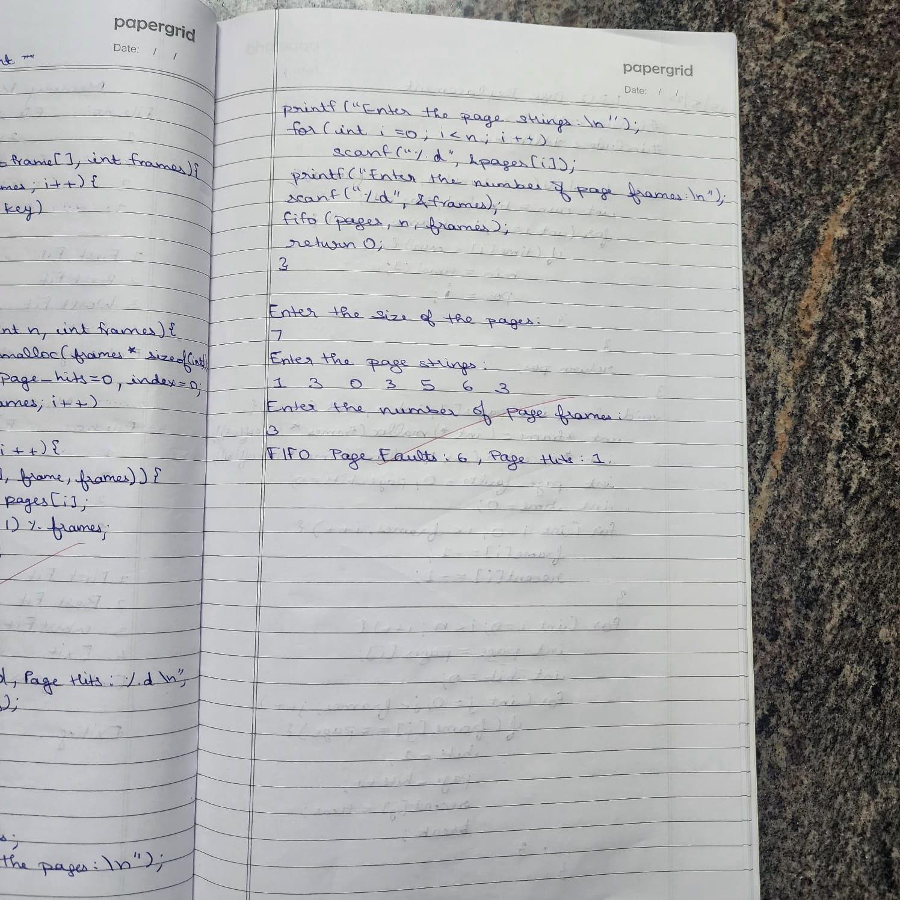

**b)LRU**

#include <stdio.h>

#include <stdlib.h>

int findLRU(int time[], int frames) {

int min = time[0], pos = 0;

for (int i = 1; i < frames; i++) {

if (time[i] < min) {

min = time[i];

pos = i;

}

}

return pos;

}

void lru(int pages[], int n, int frames) {

int *frame = (int *)malloc(frames * sizeof(int));

int *recent = (int *)malloc(frames * sizeof(int));

int page_faults = 0, page_hits = 0;

int time = 0;

for (int i = 0; i < frames; i++) {

frame[i] = -1;

recent[i] = -1;

}

for (int i = 0; i < n; i++) {

int page = pages[i];

int hit = 0;

for (int j = 0; j < frames; j++) {

if (frame[j] == page) {

hit = 1;

page_hits++;

recent[j] = time;

break;

}

}

if (!hit) {

int pos = -1;

for (int j = 0; j < frames; j++) {

if (frame[j] == -1) {

pos = j;

break;

}

}

if (pos == -1)

pos = findLRU(recent, frames);

frame[pos] = page;

recent[pos] = time;

page_faults++;

}

time++;

}

printf("LRU Page Faults: %d, Page Hits: %d\n", page_faults, page_hits);

free(frame);

free(recent);

}

int main() {

int pages[100], n, frames;

printf("Enter the size of the pages:\n");

scanf("%d", &n);

printf("Enter the page strings:\n");

for (int i = 0; i < n; i++)

scanf("%d", &pages[i]);

printf("Enter the number of page frames:\n");

scanf("%d", &frames);

lru(pages, n, frames);

return 0;

}

**OUTPUT:**

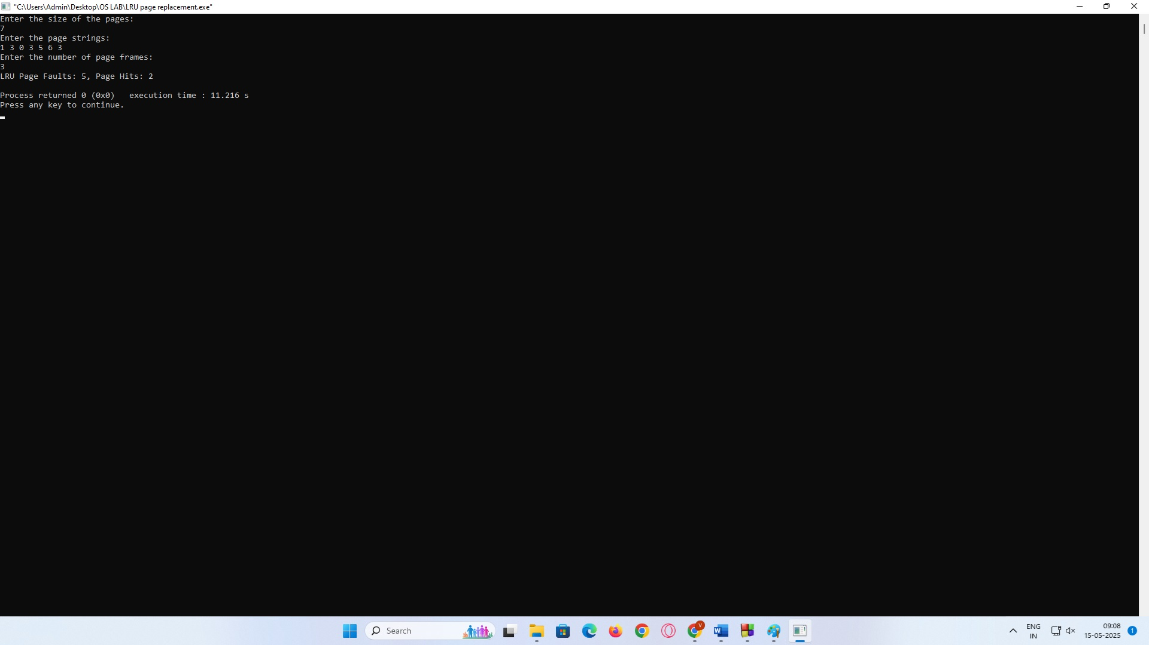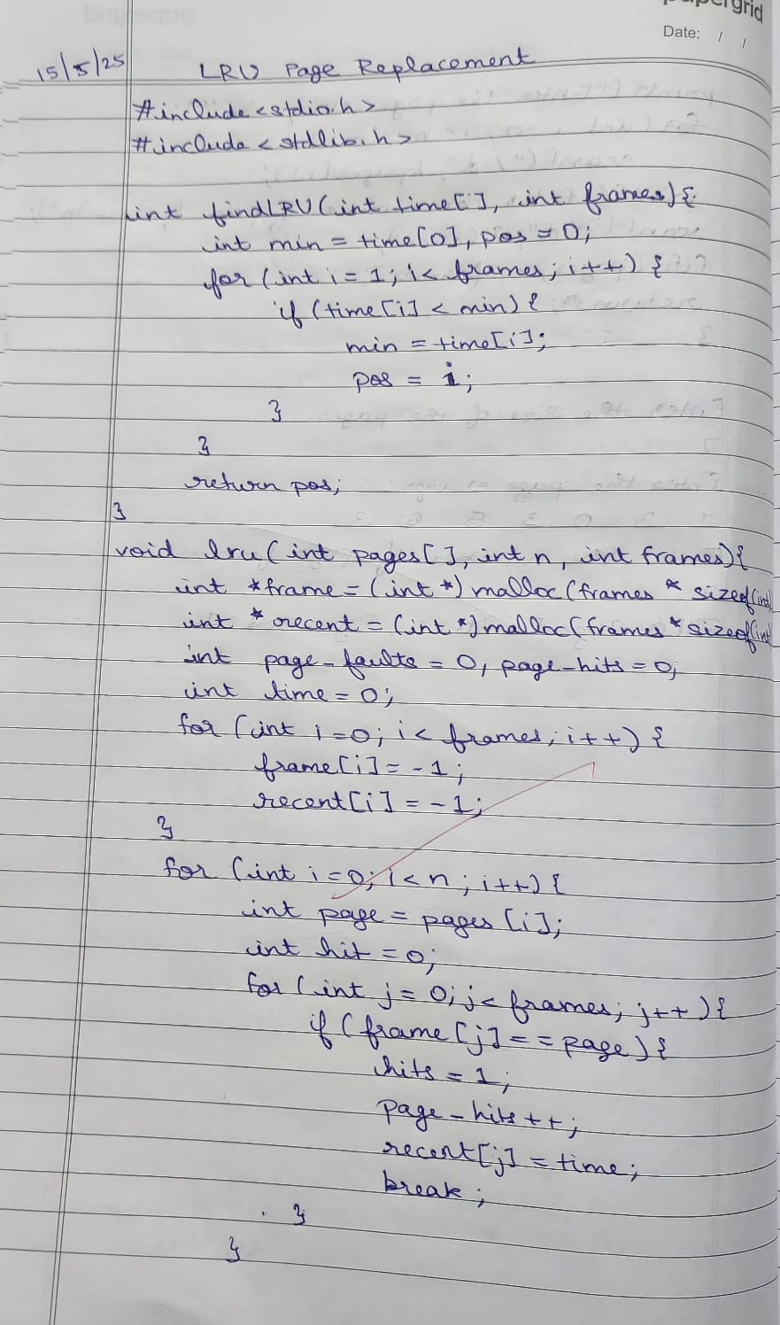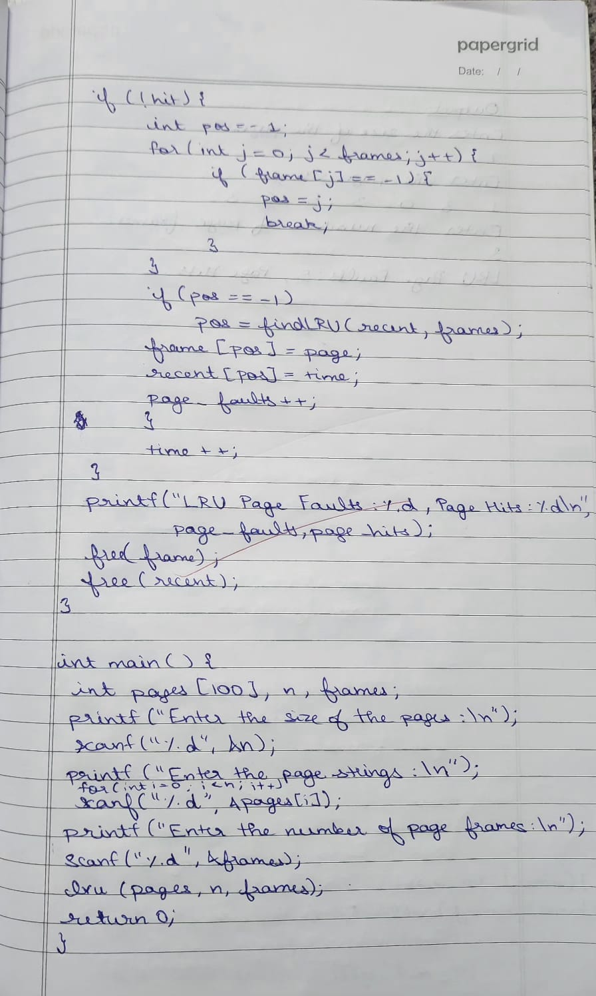

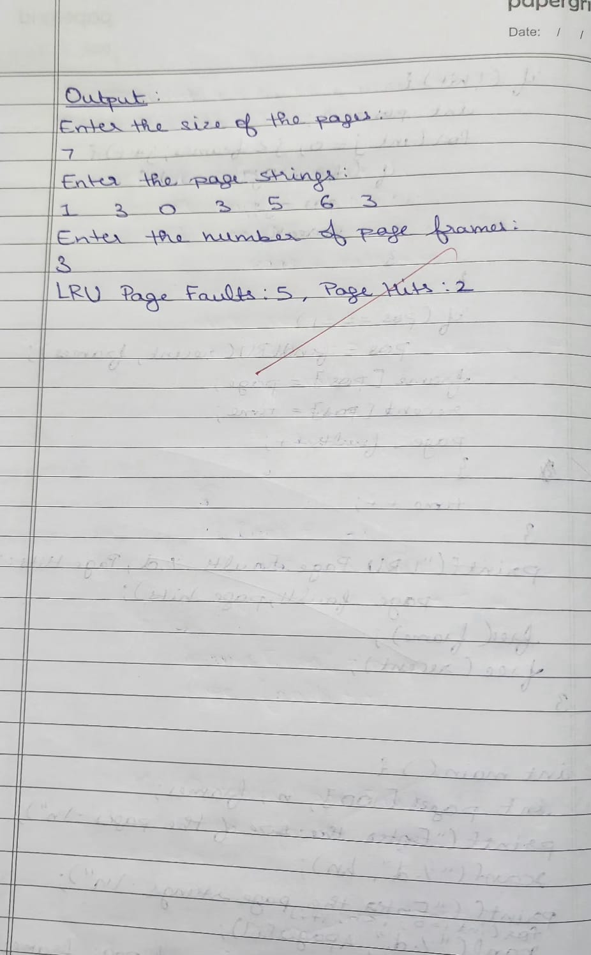

**c)Optimal**

#include <stdio.h>

#include <stdlib.h>

int search(int key, int frame[], int frames) {

for (int i = 0; i < frames; i++) {

if (frame[i] == key) {

return 1;

}

}

return 0;

}

int findOptimal(int pages[], int frame[], int frames, int index, int n) {

int farthest = index, pos = -1, i, j;

for (i = 0; i < frames; i++) {

for (j = index; j < n; j++) {

if (frame[i] == pages[j]) {

if (j > farthest) {

farthest = j;

pos = i;

}

break;

}

}

if (j == n) {

return i;

}

}

return (pos == -1) ? 0 : pos;

}

void optimal(int pages[], int n, int frames) {

int *frame = (int *)malloc(frames * sizeof(int));

int page_faults = 0, page_hits = 0;

for (int i = 0; i < frames; i++) {

frame[i] = -1;

}

for (int i = 0; i < n; i++) {

int page = pages[i];

if (search(page, frame, frames)) {

page_hits++;

} else {

int pos = -1;

for (int j = 0; j < frames; j++) {

if (frame[j] == -1) {

pos = j;

break;

}

}

if (pos == -1) {

pos = findOptimal(pages, frame, frames, i + 1, n);

}

frame[pos] = page;

page_faults++;

}

}

printf("Optimal Page Faults: %d, Page Hits: %d\n", page_faults, page_hits);

free(frame);

}

int main() {

int pages[100], n, frames;

printf("Enter the size of the pages:\n");

scanf("%d", &n);

printf("Enter the page strings:\n");

for (int i = 0; i < n; i++) {

scanf("%d", &pages[i]);

}

printf("Enter the number of page frames:\n");

scanf("%d", &frames);

optimal(pages, n, frames);

return 0;

}

**OUTPUT:**

